1. .NET Framework architecture
- The role of the Common Language Runtime (CLR) and core .NET Framework classes
- Microsoft Intermediate Language (MSIL)
- Just-In-Time (JIT) compilation
- Assemblies, native assemblies, and the Global Assembly Cache (GAC)
- Comparison of VB.NET, C#, and J#
- Differences between Vb 1 and VB 2.0

2. Introducing Windows Forms
- Creating a Windows Application
- Setting and Adding Properties to a Windows Form
- Using Visual Inheritance
- Event Handling
- Building graphical interface elements by using the System.Drawing namespace
- Working with images

3. Controls
- Adding Controls to a Windows Form
- Adding Controls using Windows Forms Designer
- Important common properties of controls
- Configuring the order of tabs
- Handling Control Events
- Dialog Boxes
- Common Windows Forms Controls
- Creating Menu and Menu Items
- Creating Multiple-Document Interface (MDI) Applications

4. Exceptions
- What is an exception?
- Handling Exceptions
- Custom Exceptions
- Managing Unhandled Exception
- User Input Validation

5. Creating and Managing Components and .NET Assemblies
- Creating and Managing .NET Components
- Creating and Managing .NET Assemblies

6. Data Binding
- Bind Data to the UI
- Complex Data Binding
- One-Way and Two-Way Data Binding
- The BindingContext and CurrencyManager Classes
- Using the Data Form Wizard
- Transform and Filter Data
- Using Server Explorer
- Filtering Data

7. Consuming and Manipulating Data
- Access and Manipulate SQL Server data
- Using Stored Procedures
- Access and Manipulate Data
- The ADO.NET Object Model
- Using DataSets
- Editing Data with ADO.NET
- Using XML Data
- Handle Data Errors

8. Web Services
- Understanding Web services
- SOAP
- Disco and UDDI
- WSDL
- Invoking your first Web service
- Creating Web services
- Discovering Web services
- Disco and UDDI

9. Testing and Debugging a Web Application
- Testing
- Tracing
- Debugging

10. Working with Legacy Code
- Using ActiveX Controls
- Using COM Components
- Using COM+ Components
- Using Platform Invoke

11. Testing and Debugging a Windows Application
- Testing
- Creating a Test Plan
- Executing Tests
- Unit Testing
- Integration Testing
- Regression Testing
- Testing International Applications
- Tracing
- Debugging

12. Deploying a Windows-based Application
- Deployment Tools
- Deploying a Windows application
- Customizing a Setup Project
- Shared Assemblies
- Creating Installation Components
- URL Remoting
- Methods of Deployment
- Windows Logo Programs
Tutorial Index
Shared Assembly
VB.NET 2005 Tutorials : Shared Assembly In this tutorial you will learn about Shared Assembly, how to Assign Strong name to an assembly, Microsoft Windows Installer 2.0, Using the Global Assembly Cache tool (Gacutil.exe), Removing an Assembly from the Global Assembly Cache, Referencing an Assembly ...

The .NET Framework Architecture Part 1
This is the first tutorial as part of the Visual Basic .NET 2005 Training. In this tutorials we will be learning about the basics of The .NET Framework Architecture, The .NET vision, Common Language Runtime (CLR), .NET Framework Class Library and Microsoft Intermediate Language (MSIL). It's very imp...

Tracing VB.NET Windows Application
VB.NET 2005 Tutorials : Tracing a Windows Application In this tutorial you will learn about Tracing, Using Trace and Debug to display information, Code Tracing and Debugging, Output from Tracing, The six Debug Members and Trace Methods, Trace Listeners, Types of predefined Trace Listeners, Trace Sw...

The .NET Framework Architecture Part 2
VB.NET 2005 Free Training : The .NET Framework Architecture Part 2. In this tutorial of The .NET Framework Architecture Part 2 we will learn about Just-In-Time (JIT) compilation, Assemblies, native assemblies, Global Assembly Cache (GAC) and Comparison of VB.NET, C#, and J#.

VB.NET Windows Application Testing
VB.NET 2005 Tutorials : Testing a Windows Application In this tutorial you will learn how to Test a Windows Application, Creating Unit Tests, Generating an ASP.NET Unit Test, benefits of unit testing, Integration Testing, Different approaches to Integration Testing, Regression Testing, goals of reg...

Implementing Inheritance
Introduction and Implementing Inheritance The usefulness of inheritance is depnding on the choice of its usage. You can use inheritance if the derived class is a kind of base class but not has a relationship with the base class. Such a situation empowers you to reuse the code from the base class. I...

The File Types Editor
The File Types Editor The File Types Editor can be used to create the required registry to establish a file association for the application being installed. A file association is simply a link between a particular file extension and a particular application. For example, the file extension .xls i...

Visual Studio.NET Namespaces
Visual Studio.NET Namespaces The .NET Framework class library has thousands of classes which are needed for developing and deploying solutions. In order to organize all those classes for ease of use .NET Framework uses namespaces. This Gives the Classes their own space and prevents conflicts between...

Differences between VB.NET 1.0 and VB.NET 2.0
VB.NET 2005 Free Training: Differences between VB.NET 1.0 and VB.NET 2.0: VB.NET 2005 comes with a number of enhancements. The IntelliSense Code snippets, the Windows Forms designer updates, IntelliSense filtering, debugger data tips, exception Assistant etc make the software a pleasure to work with...

Visual Studio Windows Forms Designer
Using The System.Windows.Forms.Form class System.Windows .Forms.Form class is the foundation class for all forms to be created. All the forms that are created in VB .NET are also inheriting from this base class. This class provides for all the facilities needed for the form. Additional functionality...

Introducing VB.NET Windows Forms
Introducing VB.NET 2005 Windows Forms We will be learning in the next series of articles as part of VB.NET 2005 Free Training : Introducing Windows Forms in the following topics with code samples and screen shots.

Event Handling In Visual Basic .NET
Introduction to Event Handling One of the most useful capabilities of the OOP Languages is their inbuilt ability to be aware of a large number of events like MouseOver, MouseClick, and so on so that we can write codes to react to any event that we are interested. This is made possible by the rich s...

Exploring the Forms Designer generated code
VB.NET 2005 Free Training Exploring the Forms Designer generated code As you create a new project in the Visual Basic, the IDE generally automatically adds lots of lines of code on its own. Visual Basic 2005 comes with an option to skip over this behavior of the Visual Basic IDE. The default optio...

Building Graphical Interface elements
Building graphical interface elements by using the System.Drawing namespace In this tutorial we will learn about Graphics Object, The Windows Forms Coordinate System, Drawing Text on a Form, Drawing Shapes and Working with images.

Microsoft .NET Creating Installation Components
VB.NET 2005 Tutorials : Creating Installation Components In this tutorial you will learn how to Create installation components, Work with predefined Installation Components, Deploying an Assembly containing the Installation Components, Working with Installer Classes, URL Remoting, Launching a Remot...

Application Class and Message Class
Using Application Class Visual Basic 2005 introduces a speedy way to access many important classes relating to the Computer on which the application is running, the user running it, the application itself, its forms and any associated web services. The best part of it all is that you can access it ...

Visual Studio Adding Controls to Windows Form
Visual Studio Adding Controls In this tutorial let's discuss about Adding Controls to a Windows Form, Adding Controls using Windows Forms Designer, Adding Controls Dynamically and Setting properties of Controls. Sample source codes used in this tutorial are included. Forms are containers for contr...

Common Controls and Handling Control Events
Common Controls and Handling Control Events In this tutorial we will be learning how to use common control like Control Hierarchy, Label and LinkLabel, TextBox and RichTextBox, PictureBox, GroupBox and Panel, Button, CheckBox and RadioButton, ListBox, CheckedListBox and ComboBox, DomainUpDown and N...

Implementing Class Library Object
Implementing Class Library Object in VB.NET 2005 Class: Classical Object Oriented Concepts explain a class as a cookie cutter. A class allows you to create objects of the class. As a programmer you define a class with data fields, properties, methods and events. Then you can create objects based on...

Setting and Adding Properties to Windows Form
Setting and Adding Properties to a Windows Form In this tutorial we will learn about Setting and Adding Properties to a Windows Form, Using the Visual Designer to set Windows Form Properties, Setting Windows Forms Properties programmatically and Using Visual Inheritance along with the sample project ...

Dialog Boxes in Visual Basic .NET
Dialog Boxes in Visual Basic .NET Most Windows applications request for user input. Dialog boxes are one means of requesting users for specific kinds of inputs. Therefore, VB.NET allows its designers to create a number of different types of dialog boxes. Standard Dialog boxes are included in classes...

The .NET framework is a software technology that is directed towards connecting information, people, systems and devices seamlessly. The high level of software integration that has been attempted through use of XML web services enables the creation of small, discrete, building block types of applications. These applications are connected to other applications over the Internet.

Central to the .NET framework architecture is the effort to provide support to for the next generation solutions. The direction of change is to ensure that software deployment and versioning conflicts are avoided or minimized in the .NET Framework. User defined codes are released from the confines of the local storage systems and can be stored anywhere on a network and executed from any point in the network. Performance problems associated with scripted and interpreted environments are removed. Codes can be safely executed and the developer experience is consistent across widely varying types of applications, such as Windows based applications and web based applications. The thrust of design is towards creating a standard communication facility that is standardized so that .NET codes can be integrated with other codes easily and seamlessly.

At the core of the .NET infrastructure is the Common Language Runtime (CLR) and the .NET Framework class library.

The runtime functions, like an agent, managing code at execution time. It provides core services such as memory management, thread management and ‘remoting’. It enforces strict type safety and ensures code accuracy. This makes for security and robustness and provides a platform for running managed code.

The .NET Framework provides several runtime hosts. It also supports the development of third-party runtime hosts. For example, ASP.NET hosts the runtime to provide a scalable, server-side environment for managed code. ASP.NET works directly with the runtime to enable ASP.NET applications and XML Web services.

The .NET Framework can be hosted by unmanaged components such as the Internet Explorer. These load the common language runtime into their processes and initiate the execution of managed code. This creates a software environment that can exploit both managed and unmanaged features. This makes for mobility of the code.

Common Language Runtime (CLR)
The common language runtime (CLR) is the foundation upon which developers construct various kinds of applications. The benefits of the CLR are many. It makes for a vastly simplified development. It enables a seamless integration of code written in different languages. It provides evidence-based security with code identity. The assembly based deployment eliminates the problems of DLL. The versioning of reusable components makes for ease of usage. The implementation inheritance feature enables the reuse of code. The automatic object lifetime management makes the application- development comfortable. The self descriptive nature of objects makes for ease of programming and debugging.

Just-In-Time (JIT) compilation
As stated above, the Just in time compiler is a facility that is invoked by the CLR to convert the IL into machine code. The .NET framework assemblies (*.dll or *.exe) files cannot be executed by the target processor unless it is converted into native code. When the Assembly is loaded the method calls are invoked for compilation into native code. Since this is done just when the method needs to execute, it is called Just in time compilation. When the JIT is invoked for the first time there is an overhead or performance penalty, since the assembly is converted into its Native code or image using the Native Image Generator (Ngen.exe). All subsequent calls will load faster as the Native image alone is invoked thereafter from the Native image cache.

Significantly, the IL can coexist with the machine code in the application. This feature also enables the developer modify the code or add to the code even when the application is actively deployed. This functionality provided by JIT makes the .NET framework an efficient, agile and powerful means of application development.

Assemblies, native assemblies, and the Global Assembly Cache (GAC)
The primary unit of deployment is the assembly. The assembly is used by the .NET CLR as the smallest unit of deployment; version control; security; type grouping and code reuse. An assembly will consist of a manifest and one or more modules or files. It can be defined as a logical DLL that contains a manifest, type metadata, MSIL and resources. Assemblies can be application private or shared. Private assemblies are restricted to use in a single application whereas shared assemblies can be used across applications. Private applications also reside within the application folder while shared assemblies reside in the common area-- GAC(Global Assembly Cache). They must have a globally unique name.

The existence of the manifest within the assembly makes it self descriptive. It can be viewed by the IL Disassembler (Ildasm.exe) which is part of the .NET framework SDK.

The assembly is identified by the manifest. It defines security requirements, lists other interdependent assemblies and all the types and resources exposed by the assembly. Localized resources exposed by assemblies and targeted by the application contain a default culture (language, currency, date/time format etc).

The manifest contains several sections. Identity, Referenced Assemblies, file list and Custom Attributes are some of the important sections of the manifest. The Identity section as the name suggests, identifies the assembly. It contains a .assembly directive. The version directive specifies the version of the assembly, so that the CLR identifies the different versions of an application. The Identity section contains a strong name for shared assemblies and a public/private encryption key is used to distinguish between assemblies of the same name. The Identity section also optionally contains the Culture which defines the country and language of the assembly target. The .locale directive is used for this purpose and the Culture-Neutral assemblies can be used by any assembly.
The Referenced Assemblies section of the manifest provides a reference to all the assemblies used in an application.

The My Namespace is the most significant enhancement that provides a single reference to commonly used functionalities within the .NET framework. It includes classes like Application, Computer, Forms, Resources, Settings and Users. This enables users to ping a computer with a simple line of code or play a audio file with a one line code.

Example:
My Computer Audio Play(“….*(name of file).wav)

A number of mundane problems being faced by coders have been solved in the process. The IntelliSense has taken away much of the pain of development by correcting errors and making suggestions even during the process of development. This improves the quality of codes and reduces the time taken to develop and debug large applications.

New Operators
A number of new operators have been introduced into the language to facilitate the coder. For instance the IsNot operator facilitates comparisons with Nothing. This was not possible earlier.

Just My Code
This feature of VB.NET enables the coder to skip over all the code that was not written by him. This is extremely useful when debugging custom code as all machine generated code is avoided. This feature becomes enabled when “Enable Just My Code Stepping” option is activated. This feature is enabled by default but can be disabled by the coder if he wishes to.

Support for Generics
The .NET framework has attempted to overcome some of the limitations of VB 6 with regard to collections. Errors in object storage under a collection, which were detectable at compile time has been resolved by providing the coder with many more types of collections. The coder can now import Systems Collections namespace which gives access to BitArray, HashTable, Queue, StoredList and Stack. In other words use of Generics has solved the problems in .NET Framework 2005.

Certain new concepts have been introduced in VB.NET 2005. The Operator overloading feature allows the coder define the behavior of classes when used with intrinsic language operators such as +, -,<,>,=, and <>. The appropriate outcome for operations are defined when applied to instances for user defined classes.

The DotNet Framework architecture has revolutionized the process of application development. In the lessons that follow we will be examining in greater detail how this framework helps the Visual Basic. NET developer.

Introducing Windows Forms
Designing Windows Application is simpler and less time consuming with Visual Basic 2005. A number of new facilities and enhancements have been made to assist the developer complete the project in time and with lesser number of errors. Windows Form is the cynosure of the Windows Application. Visual studio 2005 packs more features to the already enriched area of Windows Forms, both at design and run time. Among the several features that have been added some standout as prominent. The management of layout of the form is made easier by providing the snap lines that make it easy to align controls with other controls as the layout is formed. A new deployment technology called ClickOnce for forms is added.

Creating a Windows Application
- Understanding Classes, Inheritance, and Namespaces
- Using The System.Windows.Forms.Form class
- Designing a Form using Windows Forms Designer
- Exploring the Forms Designer generated code
- Using the Application class
- Using the MessageBox class

Setting and Adding Properties to a Windows Form
- Using the Visual Designer to set Windows Form Properties
- Setting Windows Forms Properties programatically
- Adding new Property to a Windows Form
- Using Visual Inheritance

Event Handling
- Handling Events by attaching a delegate
- Handling Events by overriding protected method of base class.

Building graphical interface elements
- Understanding The Graphics Object
- Understanding The Windows Forms Coordinate System
- Drawing Text on a Form
- Drawing Shapes

Implementing Class Library Object in VB.NET 2005
Class: Classical Object Oriented Concepts explain a class as a cookie cutter. A class allows you to create objects of the class. As a programmer you define a class with data fields, properties, methods and events. Then you can create objects based on that class that have state (fields, properties) and behavior (methods, events). A class can be considered as a specification of how the object of the class should look like and behave.

An object of the class is nothing other than a sequence of bytes at a specific memory location in the memory heap. Thus we can understand that an object is an instance of the class. We can see an illustration of a class.

Let's see an illustration of a class

Public Class Class1

Private VehicleType As String

Private VehicleModel As String

Private VehicleColor As String

Public Sub Accelerate()

' add code to Accelerate

End Sub

ReadOnly Property engineCapacity() As Decimal

Get

Return engineCapacity

End Get

End Property

End Class

Creating a Class Library project
- On the File menu, select New Project.
- On the Templates pane, in the New Project dialog box, click Class Library.
- In the Name box, type DemoClass1 and then click OK.
- A new Class Library project opens, and the Code Editor displays the Class module Class1.vb.
- In the Solution Explorer, right-click Class1.vb and select Rename, and then change the name to DemoClass1.vb.
- Note that the name in the Code Editor also changed to DemoClass.vb.
- On the File menu, select Save All.
- In the Save Project dialog box, click Save
Let us see the screen shots for doing this exercise:
Opening the new project:

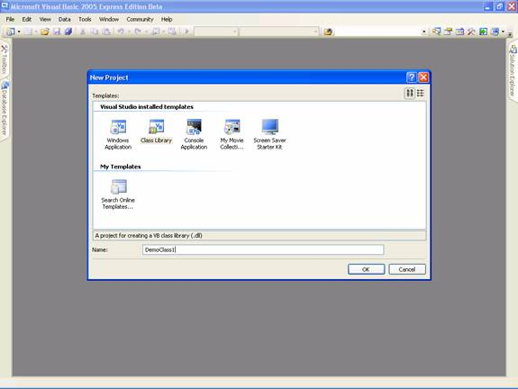

Codes for the new DemoClass1

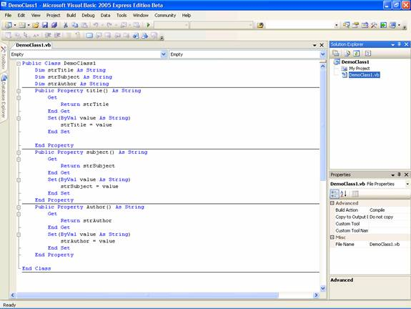

Introduction and Implementing Inheritance
The usefulness of inheritance is depnding on the choice of its usage. You can use inheritance if the derived class is a kind of base class but not has a relationship with the base class. Such a situation empowers you to reuse the code from the base class. It is also more useful if the hierarchy is very shallow. The developer can effect global changed to the derived class by changing the base class.

Understanding Inheritance
Inheritance is an important feature of any OOP Language. Let us examine the following lines of code:

Public Class DemoForm

Inherits System.Windows.Forms.Form

…………

End Class

Note the use of public in the above code. You can use any of the four access specifiers namely Public, Private, Protected, and private, while declaring the classes. This usage depends upon the need of the program to make the other classes capable of inheriting from this class.
Note the use of public in the above code. You can use any of the four access specifiers namely Public, Private, Protected, and private, while declaring the classes. This usage depends upon the need of the program to make the other classes capable of inheriting from this class.
In the above code we have created a new class DemoForm based on the class System.Windows.Forms.Form. The new class DemoForm is the derived class and the class Form is the base class.

Some of the points of interest about inheritances are given below:

- In Visual Basic .NET only single inheritance is permitted; that is, any derived class can have only one base class
- You can inherit all classes except those marked with keywork NotInheritable.
- You can restrict certain items in base class from being exposed by using access specifiers. Access type of a derived class must be equal or more restrictive than its base class for the inheritance to succeed.
Inherits keyword is used before the base class to specify the base class. MustInherit modifier is used to specify that the class is intended for use as a base class only.

The derived class inherits all the methods defined in the base class by default. You may come across some instances that a particular method needs to behave differently in the derived class. In such a case, the method can be overridden in the derived class. In this case you have to specify a new implementation of the method in the derived class. This is possible only if the method in the base class is marked with keywork overridable.

The method in the derived class should be declared as overrides. Declaring a method as NotOverridable prevents you from overriding the method in a derived class. Public mehtods are NotOverridable by default. You can also declare a method as MustOverride which makes it mandatory for you to override the method in a derived class. Any method that is declared as MustInherit should not contain any body in the method statement.

You can refer to any method in the base class by using the keyword MyBase as illustrated in the code fragment given below.

Public Class BaseClass1

Public Overridable Sub someMethod()

'… your code

End Sub

End Class

Class DerivedClass1

Inherits BaseClass1

Public Overrides Sub someMethod()

'The codes for the Sub …

End Sub

Public Sub baseClassMethod()

MyBase.someMethod()

End Sub

End Class

Public Class Form1

Private Sub Form1_Load(ByVal sender As System.Object, ByVal e As System.EventArgs) Handles MyBase.Load

Dim DerivedClass As New DerivedClass1

DerivedClass.someMethod()

DerivedClass.baseClassMethod()

End Sub

End Class

In the above illustration calling the sub someMethod calls the overridden method in the derived class. However the statement MyBase.someMethod calls the Sub defined in the base class. MyBase keyword can be used to access the immediate base class and its inherited members. Private members of the base class cannot be accessed using MyBase keyword.

It is not an object and therefore cannot be assigned to variables or passed on procedure or used for Is comparison. However MyBase keyword cannot be used to access a Sub declared as MustOverride in the base class.MyBase cannot be used in modules and to access base class members that are marked as friend if the base class is in a different assembly.

MyClass keyword
This keyword allows you to call an overridable method implemented in your clas and make sure that implementation of the method in the specified class is called instead of the overridden method in the derived class.Like MyBase MyClass is also a keyword and not a class. MyClass keyword can be used to refer the containing class and its inherited members.

MyClass can be used to qualify the shared members and it cannot be used in standard modules. In case the method has no implementation in the derived class MyClass keyword can be used to refer the method in the base class and therefore the effect of such usage is the same as the use of MyBase.

Implementing Inhertance
Class BaseClass1

Sub Method1()

MessageBox.Show("This is a method in the base class.")

End Sub

Overridable Sub Method2()

MessageBox.Show("This is another method in the base class.")

End Sub

End Class

Class DerivedClass2

Inherits BaseClass1

Public Field2 As Integer

Overrides Sub Method2()

Messagebox.Show("This is a method in a derived class.")

End Sub

Protected Sub TestInheritance()

Dim C1 As New BaseClass1()

Dim C2 As New DerivedClass2()

C1.Method1() ' Calls a method in the base class.

C1.Method2() ' Calls another method from the base class.

C2.Method1() ' Calls an inherited method from the base class.

C2.Method2() ' Calls a method from the derived class.

End Sub

End Class

When you run the procedure TestInheritance, you see the following messages:
"This is a method in the base class."
"This is another method in the base class."
"This is a method in the base class."
"This is a method in a derived class."

When to use inhertance
The usefulness of inheritance is depnding on the choice of its usage. You can use inheritance if the derived class is a kind of base class but not has a relationship with the base class. Such a situation empowers you to reuse the code from the base class. It is also more useful if the hierarchy is very shallow. The developer can effect global changed to the derived class by changing the base class.

Sponsored Links

VB.NET 2005 Tutorials
- VB.NET 2005 Free Training
- Shared Assembly
- The .NET Framework Architecture Part 1
- Tracing VB.NET Windows Application
- The .NET Framework Architecture Part 2
- VB.NET Windows Application Testing
- Implementing Inheritance
- The File Types Editor
- Visual Studio.NET Namespaces
- Differences between VB.NET 1.0 and VB.NET 2.0
- Visual Studio Windows Forms Designer
- Introducing VB.NET Windows Forms
- Event Handling In Visual Basic .NET
- Exploring the Forms Designer generated code
- Building Graphical Interface elements
- Microsoft .NET Creating Installation Components
- Application Class and Message Class
- Visual Studio Adding Controls to Windows Form
- Common Controls and Handling Control Events
- Implementing Class Library Object

Home Tutorials VB.NET 2005

Implementing Inheritance

Category: VB.NET 2005
Comments (1)

Introduction and Implementing Inheritance
The usefulness of inheritance is depnding on the choice of its usage. You can use inheritance if the derived class is a kind of base class but not has a relationship with the base class. Such a situation empowers you to reuse the code from the base class. It is also more useful if the hierarchy is very shallow. The developer can effect global changed to the derived class by changing the base class.

Understanding Inheritance
Inheritance is an important feature of any OOP Language. Let us examine the following lines of code:

Public Class DemoForm

Inherits System.Windows.Forms.Form

…………

End Class

Note the use of public in the above code. You can use any of the four access specifiers namely Public, Private, Protected, and private, while declaring the classes. This usage depends upon the need of the program to make the other classes capable of inheriting from this class.
Note the use of public in the above code. You can use any of the four access specifiers namely Public, Private, Protected, and private, while declaring the classes. This usage depends upon the need of the program to make the other classes capable of inheriting from this class.
In the above code we have created a new class DemoForm based on the class System.Windows.Forms.Form. The new class DemoForm is the derived class and the class Form is the base class.

Some of the points of interest about inheritances are given below:

- In Visual Basic .NET only single inheritance is permitted; that is, any derived class can have only one base class
- You can inherit all classes except those marked with keywork NotInheritable.
- You can restrict certain items in base class from being exposed by using access specifiers. Access type of a derived class must be equal or more restrictive than its base class for the inheritance to succeed.
Inherits keyword is used before the base class to specify the base class. MustInherit modifier is used to specify that the class is intended for use as a base class only.

The derived class inherits all the methods defined in the base class by default. You may come across some instances that a particular method needs to behave differently in the derived class. In such a case, the method can be overridden in the derived class. In this case you have to specify a new implementation of the method in the derived class. This is possible only if the method in the base class is marked with keywork overridable.

The method in the derived class should be declared as overrides. Declaring a method as NotOverridable prevents you from overriding the method in a derived class. Public mehtods are NotOverridable by default. You can also declare a method as MustOverride which makes it mandatory for you to override the method in a derived class. Any method that is declared as MustInherit should not contain any body in the method statement.

You can refer to any method in the base class by using the keyword MyBase as illustrated in the code fragment given below.

Public Class BaseClass1

Public Overridable Sub someMethod()

'… your code

End Sub

End Class

Class DerivedClass1

Inherits BaseClass1

Public Overrides Sub someMethod()

'The codes for the Sub …

End Sub

Public Sub baseClassMethod()

MyBase.someMethod()

End Sub

End Class

Public Class Form1

Private Sub Form1_Load(ByVal sender As System.Object, ByVal e As System.EventArgs) Handles MyBase.Load

Dim DerivedClass As New DerivedClass1

DerivedClass.someMethod()

DerivedClass.baseClassMethod()

End Sub

End Class

In the above illustration calling the sub someMethod calls the overridden method in the derived class. However the statement MyBase.someMethod calls the Sub defined in the base class. MyBase keyword can be used to access the immediate base class and its inherited members. Private members of the base class cannot be accessed using MyBase keyword.

It is not an object and therefore cannot be assigned to variables or passed on procedure or used for Is comparison. However MyBase keyword cannot be used to access a Sub declared as MustOverride in the base class.MyBase cannot be used in modules and to access base class members that are marked as friend if the base class is in a different assembly.

MyClass keyword
This keyword allows you to call an overridable method implemented in your clas and make sure that implementation of the method in the specified class is called instead of the overridden method in the derived class.Like MyBase MyClass is also a keyword and not a class. MyClass keyword can be used to refer the containing class and its inherited members.

MyClass can be used to qualify the shared members and it cannot be used in standard modules. In case the method has no implementation in the derived class MyClass keyword can be used to refer the method in the base class and therefore the effect of such usage is the same as the use of MyBase.

Implementing Inhertance
Class BaseClass1

Sub Method1()

MessageBox.Show("This is a method in the base class.")

End Sub

Overridable Sub Method2()

MessageBox.Show("This is another method in the base class.")

End Sub

End Class

Class DerivedClass2

Inherits BaseClass1

Public Field2 As Integer

Overrides Sub Method2()

Messagebox.Show("This is a method in a derived class.")

End Sub

Protected Sub TestInheritance()

Dim C1 As New BaseClass1()

Dim C2 As New DerivedClass2()

C1.Method1() ' Calls a method in the base class.

C1.Method2() ' Calls another method from the base class.

C2.Method1() ' Calls an inherited method from the base class.

C2.Method2() ' Calls a method from the derived class.

End Sub

End Class

When you run the procedure TestInheritance, you see the following messages:
"This is a method in the base class."
"This is another method in the base class."
"This is a method in the base class."
"This is a method in a derived class."

When to use inhertance
The usefulness of inheritance is depnding on the choice of its usage. You can use inheritance if the derived class is a kind of base class but not has a relationship with the base class. Such a situation empowers you to reuse the code from the base class. It is also more useful if the hierarchy is very shallow. The developer can effect global changed to the derived class by changing the base class.

Inheritance and .NET Framework

In .NET Framework the inheritance is implemented with additional functionality. Any class created in any of the programing language in the Framework can be inherited in another language. Thus cross language inheritance is also implemented in this Framework.
The System.Object class serves as a common base class for all objects in the .NET framework, that ensures interoperability of objects developed using Visual Studio .NET. New classes implicitly inherit the System.Object class; therefore it is never necessary to explicitly name this class with an Inherits statement. Among the methods that objects inherit from System.Object, one of the most useful is Object.GetType, which is used to return the exact type of the current object.

Visual Studio.NET Namespaces
The .NET Framework class library has thousands of classes which are needed for developing and deploying solutions. In order to organize all those classes for ease of use .NET Framework uses namespaces. This Gives the Classes their own space and prevents conflicts between the various names in these classes. For instance if two classes contain a method Paint(), then to avoid conflicts in names we can place these classes in two different namespaces. Thus namespaces allow classes to be grouped in a consistent, hierarchical manner.

The writing convention is that the word after the right–most dot is the name of the type and the string up to the dot is the name of the namespace. We shall see an example of this in the following statement.

System.Windows.Forms.Button

In the above statement the name of the namespace is System.Windows.Form and the type name is Button.
A namespace can contain classes, structures, enumerations, delegates, interfaces, and other namespaces. Namespaces can be nested and can have any number of members. The typical namespaces begin with Microsoft or System. The new namespace My is added in .NET 2005. If there is a conflict in the namespace in such a way that even fully qualified Object name is also not usable, then the classes cannot be used.
You can create a namespace by using the Namespace … End Namespace block. With in the namespace Block, you can create classes, enumerations, structures, delegates, interfaces, or other namespaces. It is not imperative that all the code should be kept in one single file. A namespace can span multiple files and even multiple assemblies.

Namespace VBTutorial

Class Class1

…….

End Class

Namespace Lesson2

Class Class2

…..

Public Sub Teach()

End Sub

End Class

End namespace

End Namespace

In order to access the methods teach defined in class2 you have to instantiate the class Class2.
Dim lessonObj as new VBTutorial.Lesson2.Class2

lessonObj.Teach()

Alternatively you can use the following lines of code:

Imports VBTutorial.Lesson2
Dim lessonObj as new Class2
lessonObj.Teach()

Let us quickly see some of the namespaces defined in .NET

System.ComponentModel | Liending and design time implementation of components
System.Data | Data Access
System.Data.SQLClient | SQL Server data access
System.Data.OLEDB | OLE DB data access
System.Data.SML | XML processing
System.Diagnostics | Provides debugging and tracing services
System.Messaging | Microsoft Message Queue management
System.Net | Programmable access to network protocol
My.Computer | Gives access to local computer
My.User | Gives access to the local user logged in

Using The System.Windows.Forms.Form class
System.Windows .Forms.Form class is the foundation class for all forms to be created. All the forms that are created in VB .NET are also inheriting from this base class. This class provides for all the facilities needed for the form. Additional functionality can be added by separate codes.

In the .NET Framework, a number of new features have been added to the Form Class and the Controls. We shall see some of the new features quickly. For most detailed information is available in the Microsoft website. We will see some of the members that have been added to Windows Forms Classes within the .NET Framework:

Application
Application.Activating event : Gives notification that this application is to become the active application

Button
This comes with added members like BorderColor property that gets or sets the color of the border of the button and the BorderSize property that gets or sets the size in pixels of the border of the button.

ComboBox
This control comes with additional members that make the control more functional. AutoCompleteCustomSource property that gets or sets a custom StringCollection to use when the AutoCompleteSource property is set to custom source. Beginupdate method maintains the performance as the items are added to the combo box. EndUpdate method is also included that resumes painting the ComboBox control after the BeginUpdate method suspends the painting.

Form
The .NET Framework gives us a complete, object-oriented, extensible set of classes that helps us to develop solutions using rich Windows applications. Windows Forms can also be used as the user interface in the solution. The forms are objects that expose properties that spell their appearance, methods which define their behavior and event which defines the interaction with the user. You can set these properties of the form and also write codes to respond to its events. A form can be a standard window, dialog boxes, display background for other graphical objects, or multiple document interfaces.

Flash method is added which gives visual notification to the user of events that happen in you your application. StopFlash method which stops the activity that is described in the flash method. RestoreBounds property gets or sets the location and size of the form in its normal window state.

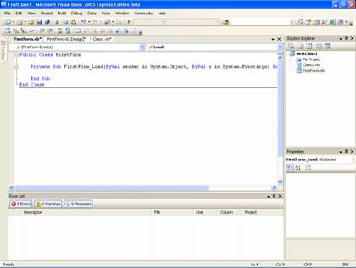

Designing a Form using Windows Forms Designer Window

New form is created with default options when you start a Windows Application. You can add additional forms to the projects by clicking New from the File Menu. In the text box for name type NewForm.vb and click ok to create a new form. Alternatively you can right-click the project in the solution explorer and choose add form the menu and choose the option Windows Form

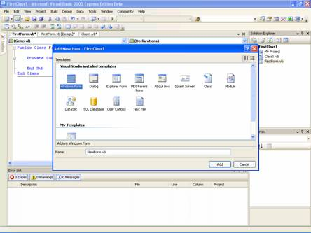

Below is the screen shot of showing the new MyForm
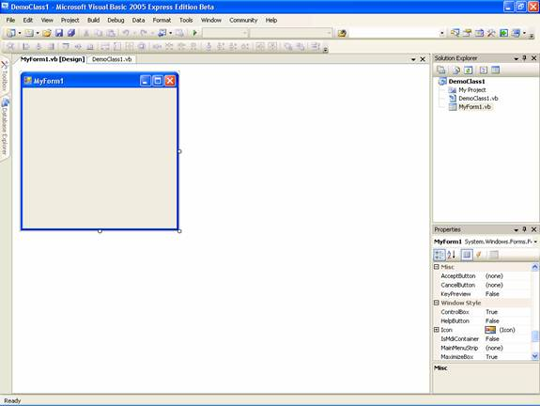

Exploring the Forms Designer generated code
As you create a new project in the Visual Basic, the IDE generally automatically adds lots of lines of code on its own. Visual Basic 2005 comes with an option to skip over this behavior of the Visual Basic IDE. The default option comes with this behavior enabled.

These codes are introduced with an aim that the user can continue to use the form without bothering about write codes to instantiate the form with a function new() and also the code includes the declaration and instantiation of all the controls that have been dragged and dropped on to the form. As a developer you may need to add controls like text boxes, grid controls, database controls and also need to bind data to some control at design time.

Much of these activities can be done at design time and visually without adding any line of code. The Visual Basic IDE is equipped with inbuilt facility that generates codes for these features. The more interesting part is not just that. You can actually add functionality to the form by adding codes to these functions like new() which is the first function to be executed and can be used to perform additional tasks at the start time of the application or even before the form load takes place.

This code is stored in a new file Form1.Designer.vb. Let us take a closer look at this now. These codes that we are going to see have been taken from one of the demos of this tutorial.

<Global.Microsoft.VisualBasic.CompilerServices.DesignerGenerated() > _

Partial Public Class Form1

Inherits System.Windows.Forms.Form

'Form overrides dispose to clean up the component list.

<System.Diagnostics.DebuggerNonUserCode()> _

Protected Overloads Overrides Sub Dispose(ByVal disposing As Boolean)

If disposing AndAlso components IsNot Nothing Then

components.Dispose()

End If

MyBase.Dispose(disposing)

End Sub

'Required by the Windows Form Designer

Private components As System.ComponentModel.IContainer

'NOTE: The following procedure is required by the Windows Form Designer

'It can be modified using the Windows Form Designer.

'Do not modify it using the code editor.

<System.Diagnostics.DebuggerStepThrough()> _

Private Sub InitializeComponent()

Me.Button1 = New System.Windows.Forms.Button

Me.Button2 = New System.Windows.Forms.Button

Me.Button3 = New System.Windows.Forms.Button

Me.Button4 = New System.Windows.Forms.Button

Me.Button5 = New System.Windows.Forms.Button

Me.Button6 = New System.Windows.Forms.Button

Me.Button7 = New System.Windows.Forms.Button

Me.SuspendLayout()

'Button1

Me.Button1.Location = New System.Drawing.Point(13, 238)

Me.Button1.Name = "Button1"

Me.Button1.Size = New System.Drawing.Size(75, 23)

Me.Button1.TabIndex = 0

Me.Button1.Text = "Line"

'Button2

Me.Button2.Location = New System.Drawing.Point(98, 238)

Me.Button2.Name = "Button2"

Me.Button2.Size = New System.Drawing.Size(75, 23)

Me.Button2.TabIndex = 1

Me.Button2.Text = "Ellipse"

'Form1

'

Me.AutoScaleDimensions = New System.Drawing.SizeF(6.0!, 13.0!)

Me.AutoScaleMode = System.Windows.Forms.AutoScaleMode.Font

Me.ClientSize = New System.Drawing.Size(612, 273)

Me.Controls.Add(Me.Button2)

Me.Controls.Add(Me.Button1)

Me.Name = "Form1"

Me.Text = "Painting Shapes and Fill Objects"

Me.ResumeLayout(False)

End Sub

Friend WithEvents Button1 As System.Windows.Forms.Button

Friend WithEvents Button2 As System.Windows.Forms.Button

End Class

Definitions
InitializeComponent: This method helps to persist the property values that you have set in the Designer.

Public Sub New():The class constructor. You can put include some code that you want at the start up. However the best location for this code is the forms Load event.

Security in Windows Form:
The .NET Framework provides a superior security features in the application by introducing new features. The code access security allows you to permit varied degrees or trust to the code depending on where the code originates and also other factors that define the identity of the code. Security permissions are implemented to ensure security. Code can request the permissions it needs.

The .NET Framework security system determines whether such requests are honored. Requests are honored after verifying the code's evidence and only relevant requests are granted those permissions. The permission given to the code never exceeds the current security settings. However, code will be granted less permission based upon a request.
The identity of the code forms the basis for granting the runtime permissions, also the level of trust the code is granted is determined by the security policy.

Code can demand that its callers have specific permissions. If you place a demand for certain permission on your code, all code that uses your code must have that permission to run.

Using Application Class
Visual Basic 2005 introduces a speedy way to access many important classes relating to the Computer on which the application is running, the user running it, the application itself, its forms and any associated web services. The best part of it all is that you can access it all using the new My object. The new My object has added features that help the programmer to gain access to some functionality that was really hard to achieve.

My.Application Object contains information about running application, such as the title, working directory, version, and the common language runtime (CLR) version in use. It also gives access to environment variables, allow you to easily write to the local application log or to a custom log, and so on.

You can access the Application information easily as can be seen in the following lines of code

My.Application.AssemblyInfo.DirectoryPath
My.Application.AssemblyInfo.ProductName
My.Application.Log.WriteEntry(“Application Starting”, EventLogEntryType.Information, Nothing)

The above lines of code will retrieve this information from the assembly which can used by the application on run time.

The following table gives the properties and methods of the My.Application Object

ApplicationContext Gives access to the context associated with the current thread.

AssmblyInfo Allows easy access to data from the AssemblyInfo.vb file, including CompanyName, ProductName, Title and Version.

ChangeCurrentCulture Allows Change the culture in which the current thread is running, which affects such things as string manipulation and formatting

ChangeCurrentUICulture Allows changing the culture that the current thread uses for retrieving culture-specific resources

CommandLineArgs Return a collection of command-line arguments

CurrentCulture Returns a collection of command-line arguments

CurrentDirectory Returns the folder where the application resides

CurrentUICulture Returns the culture that the current thread is using for retrieving culture-specific resources

DoEvents Causes all messages in the message queue to be processed

GetEnvironmentVariable Returns a specific environment variable on the local maching\e

IsNetWorkDeployed Returns True if the application was network-deployed else returns False.

Log Allows writing to application log on the local machine

MainForm A read-write property that allows setting or getting the form that the application will use as its main form

Run Sets up and starts the VB Startup/Shutdown Application model

SplashScreen Lets setting or getting the application's splash screen

Using the MessageBox class
Message boxes are often used objects. They are derived form Form Class, displayed modally and used to take user’s acknowledgement and also inform the user or alert the user of any thing that needs to be informed or alerted.

You cannot create a new instance of the System.Windows.Forms.MessageBox class. To display a message box, call the static method System.Windows.Forms.MessageBox.Show. The title, message, buttons, and icons displayed in the message box are determined by parameters that you pass to this method.

The following example shows how to use a System.Windows.Forms.MessageBox to inform the user of a missing entry in a System.Windows.Forms.TextBox.

This example assumes that the method is called from an existing form with a System.Windows.Forms.Button and a System.Windows.Forms.TextBox on it.

Protected Sub button1_Click(sender As Object, e As System.EventArgs)
If textBox1.Text = "" Then
MessageBox.Show("You must enter a name.", "Name Entry Error", MessageBoxButtons.OK, MessageBoxIcon.Exclamation)
Else
' Code to act on the data entered would go here.
End If
End Sub

Setting and Adding Properties to a Windows Form
In this tutorial we wil leran about Setting and Adding Properties to a Windows Form, Using the Visual Designer to set Windows Form Properties, Setting Windows Forms Properties programatically and Using Visual Inheritance along with the sample project and screen shots.

Using the Visual Designer to set Windows Form Properties
The properties of the Widows properties can be edited in the properties window visually. Both the inherited properties and also those added in the current class can be edited using the property window. If this window is not visible, you can click on the menu view and choose property window. Alternatively you can click F4 to invoke this window.

This window can be docked to a side and can be hidden or pinned to the desk. If it is hidden then if the mouse hovers over the title bar of the property window it then becomes visible. We and see how the properties of a text box and a grid control can be edited in the illustration:

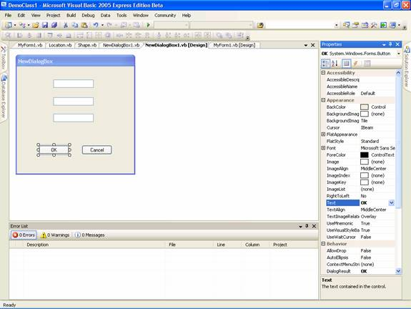

In the above screen shot, see the button titled OK and all the properties of the button are available so that it can changed.
We can also see another illustration involving grid box control: The screen shot below displays properties that can be changed.

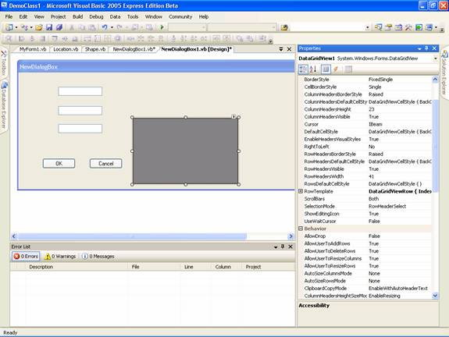

Setting Windows Forms Properties programmatically

You may have a clear idea of value of the properties and the controls at design time and they can be edited using the method explained above. However most of the time the value of the property of several items cannot be identified at design time and they have to be set at run time based on several considerations. Visual Basic provides facility to edit and initialize or substitute the value of the properties programmatically. Le us see an illustration.
Start a new project and add a form to the project. This form will be the starting form by default. Add two text boxes and a command button to the form and place them as shown below:

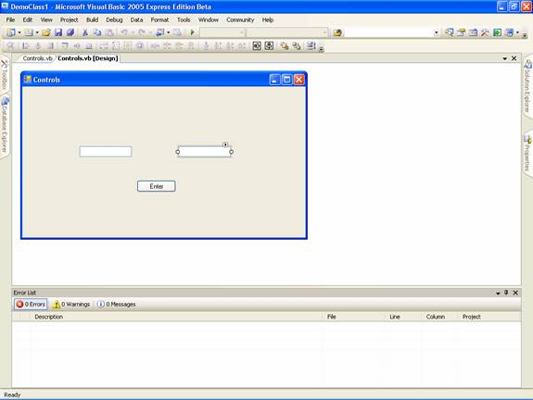

Now you can proceed to add the codes for the program by double clicking the form. You will see the controls.vb file opened. Add the following codes to the form as given below:
Code
Public Class Controls

Dim lblFirst As New System.Windows.Forms.Label
Dim lblSecond As New System.Windows.Forms.Label

Private Sub Controls_Load(ByVal sender As System.Object, ByVal e As System.EventArgs) Handles MyBase.Load
Me.lblFirst.Visible = True
Me.lblSecond.Visible = True
Me.lblFirst.Text = "Enter your First Name"
Me.lblSecond.Text = "Enter your Last Name"
Me.lblFirst.Size = New System.Drawing.Size(88, 24)
Me.lblSecond.Size = New System.Drawing.Size(88, 24)
Me.lblFirst.Location = New System.Drawing.Point(110, 75)
Me.lblSecond.Location = New System.Drawing.Point(300, 75)
Me.Controls.Add(Me.lblFirst)
Me.Controls.Add(Me.lblSecond)
End Sub

Private Sub btnOk_Click(ByVal sender As System.Object, ByVal e As System.EventArgs) Handles btnOk.Click
Dim firstNm As String
Dim secondNm As String
firstNm = Me.TextBox1.Text
secondNm = Me.TextBox2.Text
addNames(firstNm, secondNm)
End Sub

Public Sub addNames(ByVal firstNm As String, ByVal SecondNm As String)
Me.lblFirst.Text = firstNm
Me.lblSecond.Text = SecondNm
Me.TextBox1.Text = ""
Me.TextBox2.Text = ""
Me.lblFirst.Font = New System.Drawing.Font("Micorsoft Sans Serif", 8.25!, System.Drawing.FontStyle.Bold, Drawing.GraphicsUnit.Point, CType(0, Byte))
Me.lblSecond.Font = New System.Drawing.Font("Micorsoft Sans Serif", 8.25!, System.Drawing.FontStyle.Bold, Drawing.GraphicsUnit.Point, CType(0, Byte))
End Sub

End Class

Introduction to Event Handling
One of the most useful capabilities of the OOP Languages is their inbuilt ability to be aware of a large number of events like MouseOver, MouseClick, and so on so that we can write codes to react to any event that we are interested. This is made possible by the rich set of classes that have been built in the .NET Framework

The events handling is very simple as we have seen in the previous example where buttonClicked event is handled by the following code:

Private Sub btnOk_Click(ByVal sender As System.Object, ByVal e As System.EventArgs) Handles btnOk.Click

The Handles keyword is used to tell the program to look for the specific event. The sub or the function that handles the event will be called immediately when the event occurs. This is a simple implementation. In some cases you may have to raise an application event which will be caught by the event handler. Please see the following code fragment to understand this.

Public Event TimeExpired(ByVal Status As String)

RaiseEvent TimeExpired("Your time has run out")

The first line declares the event Time expired and the second statement raises the event. In order that this code works you need to make a reference to the System namespace. The Event statement should be located outside any procedure or Sub and at the class level. The RaiseEvent statement should be available inside some procedure in the application. Events must be raised within the scope of the class or module or structure where they are declared. Thus you cannot raise an event declared in the base class from within a derived class. The object that raised the event is the sender or the source of the event. Some of the examples of these kinds of objects are forms, controls etc.

An event handler can be any procedure that is called when the corresponding event occurs. You cannot use a function as an event handler as it would necessitate the function to return a value to the source object. The event handler cannot be made use of unless you first associate the procedure with the event by using the keyword Handles or AddHandler statement.

While handles clause is used with design time activity AddHandler and RemoveHandler statements are more flexible and they allow you to dynamically connect or disconnect the events with one or more event handlers at run time. You are also relieved from adding one more line of code using withEvents.

Let us see an example of event handling using Handles clause.

Dim withEvents AnEvent as new EventRaised()
Sub EventEgs()
AnEvent.RaiseEvents()
End Sub

Sub AnEvent_EventHandler() Handles AnEvent.EventOne, AnEvent.EventTwo
MsgBox(“Received Event”)
End Sub

Class EventRaised
Public Event EventOne()
Public Event EventTwo()
Sub RaiseEvents()
RaiseEvent EventOne()
RaiseEvent EventTwo()
End Sub
End Class

There are some limitations in using this kind of solution as listed below:

• You cannot use a WithEvents variable as a object variable. That is, you cannot declare it as Object — you must specify the class name when you declare the variable.

• You cannot use WithEvents to declaratively handle shared events, since they are not tied to an instance that can be assigned to a WithEvents variable. Similarily, you cannot use WithEvents or Handles to handle events from a Structure. In both cases, you can use the AddHandler statement to handle those events.

• You cannot create arrays of WithEvents variables.

• WithEvents variables allow a single event handler to handle one or more kind of event, or one or more event handlers to handle the same kind of event.

Building graphical interface elements by using the System.Drawing namespace
In this tutorial we will learn about Graphics Object, The Windows Forms Coordinate System, Drawing Text on a Form, Drawing Shapes and Working with images.

Understanding The Graphics Object
Graphics handling in Visual Basic .NET is based on GDI+ (Graphics Device Interface). A graphics device interface allows you to display graphics on a screen or a printer without having to handle the details of a specific display device. All that you need to do is to make calls to methods supported by the GDI+ classes and those methods make the corresponding calls to individual device drivers as needed to handle the screen or printer.

To create a graphics object
Receive a reference to a graphics object as part of the System.Windows.Forms.PaintEventArgs in the System.Windows.Forms.Control.Paint event of a form or control. This is usually how you obtain a reference to a graphics object when creating painting code for a control.

-or-
Call the System.Windows.Forms.Control.CreateGraphics method of a control or form to obtain a reference to a System.Drawing.Graphics object that represents the drawing surface of that control or form. Use this method if you want to draw on a form or control that already exists.

-or-
Create a System.Drawing.Graphics object from any object that inherits from System.Drawing.Image. This approach is useful when you want to alter an already existing image.

Let quickly see an example:

Click here for the Sample Code

You can manage the state of the Graphic Object easily as can be seen in the following code fragment

Click here for the Sample Code

The above code generates the output as shown below:

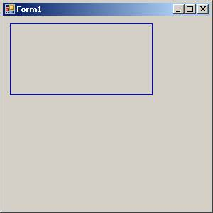

Understanding The Windows Forms Coordinate System

GDI+ uses three coordinate spaces: world, page, and device. World coordinates are the coordinates used to model a particular graphic world and are the coordinates you pass to methods in the .NET Framework. Page coordinates refer to the coordinate system used by a drawing surface, such as a form or control. Device coordinates are the coordinates used by the physical device being drawn on, such as a screen or sheet of paper.

When you make the call myGraphics.DrawLine(myPen, 0, 0, 160, 80), the points that you pass to the System.Drawing.Graphics.DrawLine method—(0, 0) and (160, 80)—are in the world coordinate space. Before GDI+ can draw the line on the screen, the coordinates pass through a sequence of transformations. One transformation, called the world transformation, converts world coordinates to page coordinates, and another transformation, called the page transformation, converts page coordinates to device coordinates.

Transforms and Coordinate Systems
Suppose you want to work with a coordinate system that has its origin in the body of the client area rather than the upper-left corner. Say, for example, that you want the origin to be 100 pixels from the left edge of the client area and 50 pixels from the top of the client area. The following illustration shows such a coordinate system.

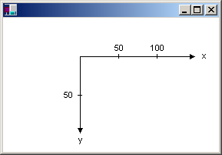

When you make the call myGraphics.DrawLine(myPen, 0, 0, 160, 80), you get the line shown in the following illustration.

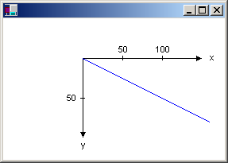

The coordinates of the endpoints of your line in the three coordinate spaces are as follows:
World
(0, 0) to (160, 80)
Page
(100, 50) to (260, 130)
Device
(100, 50) to (260, 130)
The code snippet to draw the line shown in the above picture is given below:
myGraphics.TranslateTransform(100, 50)
myGraphics.DrawLine(myPen, 0, 0, 160, 80)

Visual Studio Adding Controls
In this tutorial let's discuss about Adding Controls to a Windows Form, Adding Controls using Windows Forms Designer, Adding Controls Dynamically and Setting properties of Controls. Sample source codes used in this tutorial are included.

Forms are containers for control objects. All controls have properties, methods and events that can be used to customize their functionality. Controls can be manipulated in the designer mode and code can be added to dynamically add controls at run time.

Adding Controls to a Windows Form

Controls are basically groups of classes that help the Visual Basic developer create interfaces for his applications. All controls are members of an object collection called System.Windows.Forms.Control.ControlCollection . These control objects are assigned to the property System.Windows.forms.Control.Controls. These controls can be manipulated by using methods available in the class named System.Windows.Forms.Control.ControlCollection.

Controls are of two kinds in Visual Basic.NET

1. Controls defined in the .NET Framework

2. Derived Controls.

ButtonBase, ListControl, ScrollableControl, Menu,TextBoxBase, ScrollBar are some of the controls defined in the .NET Framework. Contorls like Button, TextBox are some of the derived controls.

Adding Controls using Windows Forms Designer
The Visual Studio IDE displays the forms that are designed in Visual Basic.NET. The programmer can modify all the editable properties exposed by the Form class. Controls can then be dragged from the toolbar and dropped and arranged on the form. The form itself can be physically resized using the mouse. The form is generally displayed at the center of the window of the IDE, while the properties window is displayed to the right and the tool box on the left of the form. Please see the screenshot below.

To add controls you have to just drag and drop them in the window form. To visually arrange just drag the controls, the Visual studio provides guide lines. The guideline is shown as the blue vertical line in the following screenshot:

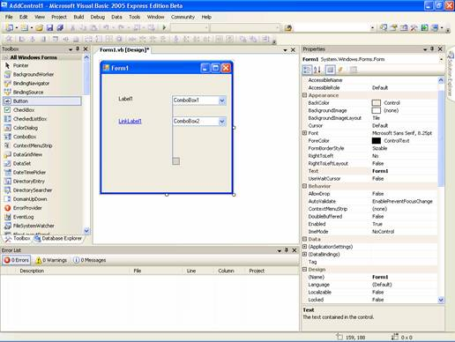

Controls can also be resized and aligned as a group by selecting them altogether. This helps the designer align and resize the controls uniformly. In instances where controls are stacked one over another, the designer can push the controls into position by using the options available in the format menu. The space between the controls can also be set using these options.

Adding Controls Dynamically
As stated above, controls can be added at runtime dynamically. The form’s Control Collections methods are used to perform these operations. ADD method adds a control while REMOVE removes the control.

A sample of the code used to add or remove a control is given below for your understanding. The example below adds label controls to the form. If radio button 1 is checked and Add control button is clicked then label 1 is added else label 2 is added. If the labels are displayed, then the REMOVE method is used to remove the controls depending on whether radio button 1 or 2 is checked.

Click here for Sample Code

The screen shots for this example are given below. Add this code to your form and create the radio buttons and the buttons1, 3 and 3 with the captions as ADD Control, Remove Control and Exit and see what happens.

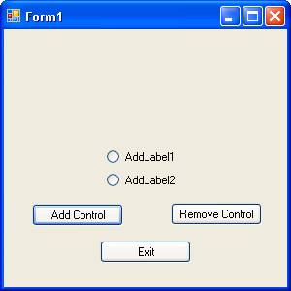

Setting properties of Controls
All controls have default property values or no values assigned to them. However designers would like to customize controls to tailor them to their specific needs. In this section we shall see how a control’s property value can be altered or user defined at design time or reset dynamically at runtime.

Property values can be set at design time by editing their value directly in the property dialog box. The property value displayed in the property window may be inherited from a base class or may be declared in the instant class.

However, design time settings do not give the designer granular control over the object. Runtime settings of property values enable the designer to manipulate the objects more dynamically and effectively. Moreover, in instances where it is not possible to judge which property is to be edited or what value is to be given at design time, it is better to use the runtime resetting to manipulate the object. To understand this better, let us work on at a small sample application:

- Open a new project and add a form Form11.
- From the tool box drag and drop a OpenFileDialog and a PictureBox
- Drag two button controls and one label control also
In the respective property sheet change the do the property editing as given below

- OpenFileDialog
  - Change the name to fd1
  - Set the initialDirectory to a directory where you have
  - Stored pictures (Optional)
- PictureBox Change the name to pb1
- Command Button Change the text to “Add Picture”
- Command Button 2 Change the text to “Exit”
- Label1 Change the text to “Choose a picture to display”
- and optionally change the font style and color

Your form will look like the screenshot given below:

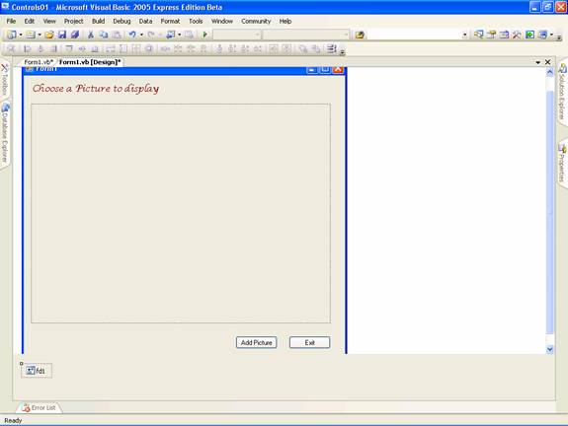

Now double click on the button “Add Picture” to add following codes to the click event to the button

Click here for Sample Code

You can also add codes to filter the files and choose some default extensions. Now you are ready to test the application. Press F5 to execute the program. You will see the dialog box as shown below:

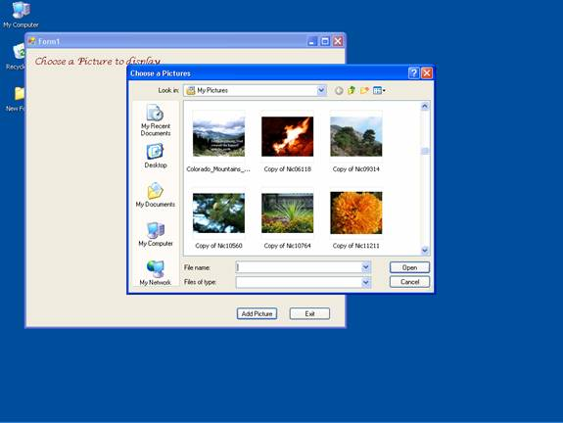

Choose any of the picture file that you want and click open. The image will be added to the Windows form. The text in the label will change color and content. See the screenshot below.

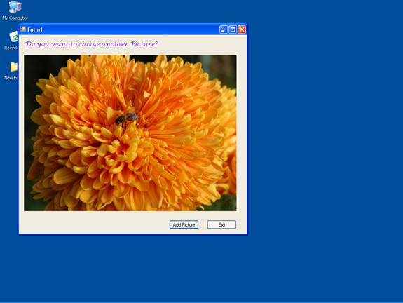

Common Controls and Handling Control Events
In this tutorial we will be learning how to use common control like Control Hierarchy, Label and LinkLabel, TextBox and RichTextBox, PictureBox, GroupBox and Panel, Button, CheckBox and RadioButton, ListBox, CheckedListBox and ComboBox, DomainUpDown and NumericUpDown, MonthCalendar and DateTimePicker, TreeView and ListView, Timer, TrackBar and ProgressBar, HScrollBar, VScrollBar, TabControl and Handling Control Events.

All controls are governed by the Control Class “System.Windows.Forms” Namespace. This class handles the entire basic window handle (HWND) functionality such as the creation and destruction of windows handles. When Control and Rich Control are integrated VB.NET provides for greater functionality.

A number of properties are shared by all controls in a class. Any change in such shared properties impacts on all controls in the class. Some of the shared properties are listed below.

DefaultBackColor: Read-only. Returns what the background color of the control would be if the background color were set explicityly
DefaultFont: Read-only. Returns what the font of the control would be if the font were set explicitly
DefaultForeColor: Read-only. Returns what the foreground color of the control would be if the fore ground color is changed.

Public Shared Properties
Public shared properties are distinct from properties that are shared by controls of a class in that the value of the property is not shared across the controls in a class. Any change in the property of a control does not result in a change in the properties of the controls in the class. Even when two instances of an object are created, each can have a distinct value assigned to a property. Examples of public instance properties are listed below for your understanding.

AccessibilityObject | Specified the AccessibleObject assigned to the control.
BackColor | Specifies the background color
Cursor | Specifies the cursor that is displayed when the mouse pointer moves over the control
Focused | Read-only. Returns whether the control currently as the input focus.
Size | Specifies the size of the control
Anchor | Specifies which edges of the control are bound to the edges of its container
Dock | Specifies to which edge of the container the control is docked. When specified, the resizing of the control is handled automatically. Controls that are “dockable” require code analyzing window movements coupled with the setting of this property
Font | Specifies the current font of the control
Location | Specifies the coordinates of the upper-left corner of the control relative to the upper-left corner of the controls container
Name | Specifies the name of the control. This value is typically used to refer to the control in code
Size | Specifies the height and width of the full control
TabIndex | Specifies this control’s place in the tab order for all controls within the same container
TabStop | Specifies whether the control can receive focus via the tab key
Visible | Specifies whether the control is visible
Enabled | Specifies whether the control is enabled. This also covers items such as receiving focus

Configuring the order of tabs
A user is required to move across a form in a prescribed order. The tab order of the control determines the way in which the cursor moves in the form and takes the user through the various options created for his use. This is a very important property for the application designer as it determines the sequence of user input if any.

Click on the control in the form and edit the TabIndex property and change its value. The value for this property is given in integers. This will be enabled only if the TabStop Property is set to true. Let us see an example for this feature.

- Create a new project in the visual Studio IDE and add a form.
- Drag and add 18 Command Buttons to this form and arrange them in a matrix.
- Pick any 6 of them and select them.
- Set the property enabled to false.
- This can also be done at runtime as shown in the example.
- Position two buttons separately as shown in the from.
- You can also add two labels one at the top and the other at the bottom.
- For each of the remaining Buttons do the following changes:
  - From the first button on the top left change their name in order and give them a new name (First, Second … Tenth)
  - You will find that the TabIndex value would have already been set as per the order of their placement in the form.
  - Change their values so that the label named first will have the value 1 and the label that has the name Tenth will have a value 10.

At the bottom of the form you will have one label control and two command buttons. Set the name value for the label as null and that of the first command button to “Reverse Order!”. Let the name of the second command button be “Exit”. Now your form will look like the screenshot given below.

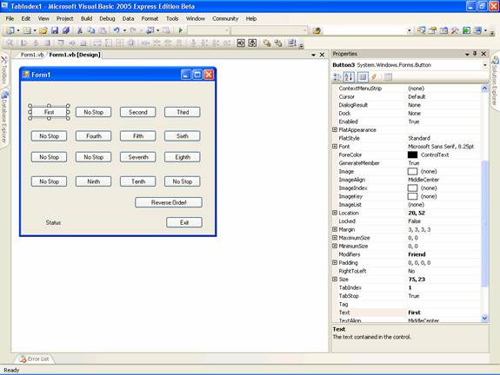
You have to add the following lines of code to the project:

Click here for Sample Source Code
Execute the project by pressing F5. This example illustrates the purpose of the properties and also the method used to assign the properties at run time. Please note that the property TabStop is not available to all properties. For example the controls like Label and LinkLabel do not expose this property.

Dialog Boxes in Visual Basic .NET
Most Windows applications request for user input. Dialog boxes are one means of requesting users for specific kinds of inputs. Therefore, VB.NET allows its designers to create a number of different types of dialog boxes. Standard Dialog boxes are included in classes that fall within the purview of the CommonDialog.

- FileDialog
- ColorDialog
- FontDialog
- PageSetupDialot
- PrintDialog

Let us now briefly study the features of the CommonDialog boxes

OpenFileDialogClass
This class provides users with the file selection capability. The properties and methods of this dialog boxes are given below:

Property or Method | Description
ShowDialog | Displays the dialog
MultiSelect | Sets/unsets the selection of multiple files
ShowReadOnly | Sets/unsets the read-only check box checked
Filter | Sets the type of files that will appear in the dialog box
FilterIndex | Sets the index of the filter selected in the dialog box

SaveFileDialog Class
The SaveFileDialog class offers you the standard window that we see while saving the file. The methods and properties of this dialog box are given below:

Property or Method | Description
ShowDialog | Displays the message
CheckFileExists | Checks for the existence of file specified
FileName | Determines the file name selected by the user
Filter | Condition for files to be shown in the dialog box
FilterIndex | Determine the index of the filter selected in the dialog box

The ColorDialog Class
This dialog box shows the color palette for allowing user to select a color and add that color to the palette. The properties of the Class are given below:

Property or Method | Description
ShowDialog | Displays the dialog box
Color | Determines the color selected by the user
AllowFullOpen | Specifies if the user can add custom colors to the box
SolidColorOnly | Determines if the user can use dithered colors

The following screenshot shows the usage of the color palette:

Create a new Visual Basic Windows Applications project in the Visual Studio IDE . To the form Form1 add a ColorDialogBox. Add two Buttons and name them as given below:

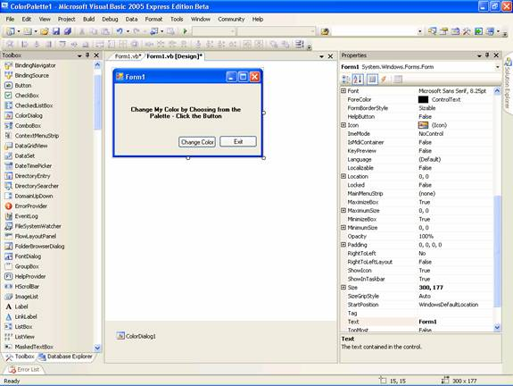

Now in the code behind form add the following codes:

Public Class Form1
Private Sub Button1_Click(ByVal sender As System.Object, ByVal e As System.EventArgs) Handles Button1.Click
Me.ColorDialog1.ShowDialog()
Label1.ForeColor = Me.ColorDialog1.Color
End Sub
Private Sub Button2_Click(ByVal sender As System.Object, ByVal e As System.EventArgs) Handles Button2.Click
Me.Close()
End Sub
End Class

Press F5 to execute the program

The three screenshots below illustrate how different common dialog boxes are displayed..
“Change Color” button opens the ColorDialog box. You can choose any color from the palette and click Ok. (The codes for event handling of Ok and Cancel button in the ColorDialogBox are not given in this program. You may however write it as shown earlier, if you want to see the impact of your program.) The next screenshot will show the changed fore color of the label1:

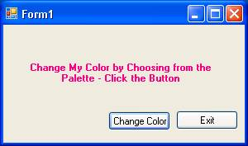

Creating a Custom Dialog Box
- In a new project which already has a form Form1, add another form and name it as FixeDialog.
- Set the Text property of this form as “Add Text”.
- Add a label control, a text box control and two command buttons.
- Change the text property of the label to “Enter Your Text!” and name the first button OK and the other as Cancel.
- In the property sheet of the form set the FormBorderStyle property to FixedDialog
- Set the ControlBox property as false. This is done to remove minimize, maximize and close buttons.
- Enter the following codes for the Dialog Form:
Click here for the Sample Code

Now press F5 to execute the program. The Following sequence of three screenshot will illustrate the working of the form:

The first screenshot shows the initial screen of the program:

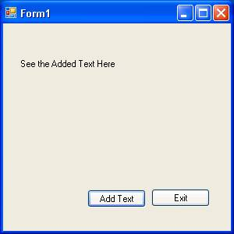

The following screenshot shows the custom dialog box opened with the new text typed in the text box:

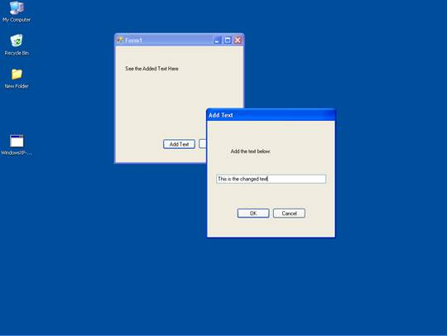

The final screenshot shows the changed label text as shown below:

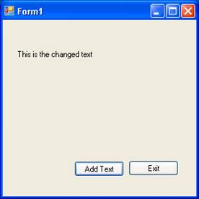

DomainUpDown and NumericUpDown Controls

Category: VB.NET 2005
Comments (4)

DomainUpDown and NumericUpDown Controls

DomaiUpDown
The windows Forms System.Windows.DomainUpDown control looks like a combination of a text box and a pair of buttons for moving up or down through a list. This control displays and sets a text string from a list of choices.

You can select the string by clicking up and down buttons to navigate through a list. Alternatively you can press the UP and DOWN Arrow keys or just type a string that matches an item in the list. You can use this control to select items from an alphabetically sorted list of names. This controls functions like ListBox but it takes up less space comparatively.

We shall look at an example that instantiates an object of DomainUpDown Control programmatically and add values to it.
1. In Visual Basic express start a new Windows Project and give a name as DomainUpDownDemo.
2. Add a text box, a CheckBox and two Buttons.
3. Now add the following code to the form.

Public Class Form1

Protected WithEvents domainUpDown1 As DomainUpDown

Private myCounter As Integer = 1

Private Sub MySub()

domainUpDown1 = New System.Windows.Forms.DomainUpDown()

Controls.Add(domainUpDown1)

End Sub

Private Sub button1_Click(ByVal sender As System.Object, ByVal e As System.EventArgs) Handles Button1.Click

domainUpDown1.Items.Add((TextBox1.Text.Trim() & " - " & myCounter))

myCounter = myCounter + 1

TextBox1.Text = ""

End Sub

Private Sub checkBox1_Click(ByVal sender As System.Object, ByVal e As System.EventArgs) Handles CheckBox1.CheckedChanged

If domainUpDown1.Sorted Then

domainUpDown1.Sorted = False

Else

domainUpDown1.Sorted = True

End If

End Sub

Private Sub domainUpDown1_SelectedItemChanged _

(ByVal sender As System.Object, ByVal e As System.EventArgs) Handles domainUpDown1.SelectedItemChanged

MessageBox.Show(("SelectedIndex: " & domainUpDown1.SelectedIndex.ToString() & _

ControlChars.Cr & "SelectedItem: " & domainUpDown1.SelectedItem.ToString()))

End Sub

Private Sub Form1_Load(ByVal sender As System.Object, ByVal e As System.EventArgs) Handles MyBase.Load

MySub()

End Sub

Private Sub Button2_Click(ByVal sender As System.Object, ByVal e As System.EventArgs) Handles Button2.Click

Me.Close()

End Sub

End Class

In the above code you have declared the domainUpDown1 as a variable of DomainUpDown class. In MySub procedure we are instantiating the control with the key word new. The statement “Control.Add(domainUpDown1)” adds the control to the form.

The Button1 Click event reads the value from TextBox, appends a number to it and adds the string to the domainUpDown1 object. Press F5 to execute the program. This following window will be shown. Type values into the TextBox and click the button “Add Strings” to add the values to the domainUpDown1 object.

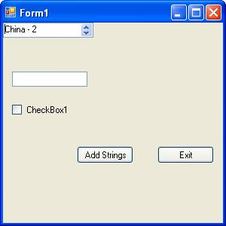

The event handler for the donainUpDown1 object gives the message box that is shown below:

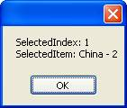

This control can be used in the place of the ListBox control where less space is needed.

NumericUpDown
This Windows Forms System.Windows.Forms.NumericUpDown control looks like a combination of a text box and a pair of arrows that the user can click to adjust a value. The control displays and sets a single numeric value from a list of choices.

The user can increment and decrement the number by clicking up and down buttons, by pressing the UP and DOWN ARROW keys, or by typing a number. Clicking the UP ARROW key moves the value toward the maximum; clicking the DOWN ARROW key moves the value toward the minimum. An example where this kind of control might be useful is for a volume control on a music player. Numeric up-down controls are used in many Windows control panel applications.

The following Demo illustrates the use of this control.
1. In the Visual Studio IDE create a new windows project and give the name NumericUpDownDemo.
2. To the Form1 add a NumericUpdownControl, a list box and a button.
3. Right click the form and choose View Codes from the context sensitive menu.
4. Now add the following codes to the Form1.

Public Class Form1

Private Sub Button1_Click(ByVal sender As System.Object, ByVal e As System.EventArgs) Handles Button1.Click

Me.Close()

End Sub

Private Sub NumericUpDown1_ValueChanged(ByVal sender As System.Object, ByVal e As System.EventArgs) Handles NumericUpDown1.ValueChanged

Label1.Text = "The current Value of the counter is : " & NumericUpDown1.Value

End Sub

End Class

Press F5 to execute the program. When you click the UP and Down Arrow in the NumricUpDown1 object, the text on the Label will show the value of the counter. This is shown in the screen shot below:

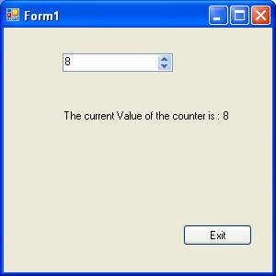

You can also set the number of decimal places that will appear after the decimal point. The default is zero. You can also set the thousands separator. This control can also be set up to display hexadecimal value by setting the value of System.Windows.Forms.NumericUpDown.Hexadecimal property true.

.NET Common Windows Form Controls part 2
In this tutorial we will learn about Common Windows Forms Controls in Visual Basic .NET 2005. In this part 2 of this article, We will be learning the controls like Control MonthCalendar and DateTimePicker, TreeView and ListView, Timer, TrackBar and ProgressBar, HScrollBar and VScrollBar,

MonthCalendar
MonthCalendar is a very useful tool that has been added to the .NET Framework. Let us see how this works with an example. In a new project add a textbox and a command box to the form and also date time picker. In the code window add the following code:

Click here for Sample Code

The first screenshot shows the screen with the date time picker.

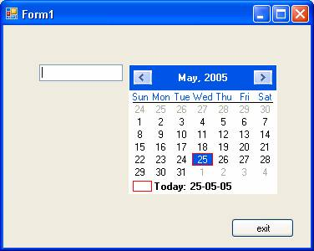

This screenshot shows the selected value in the textbox and the date time picker is hidden.

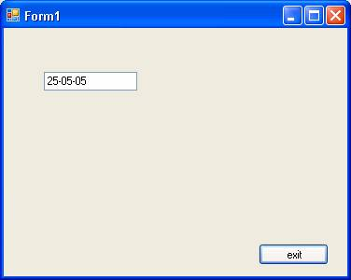

DateTimepicker
This control allows the user to select dates and times. Some of the important property of this class is given as below:

Property/evnets | Description
MaxDateTime | Sets the maximum date value of the date time picker control
MinDateTime | Sets the minimum date value of the date time picker control
Format | Gets/Sets the format of the date and time
MaxDate | Gets/Sets the maximum selectable date and time
MinDate | Gets/Sets the minimum selectable date and time
Value | Gets/Sets the date and time value
Closeup | When the drop-down calendar disappears
DropDown | When the drop down calendar appears
FormatChanged | When the format property value changes
ValueChanged | When the value property changes

The Windows Form’s DateTimePicker control allows the user to select a single item from a list of dates or times. When used to represent a date, it appears in two parts: a drop-down list with a date represented in text, and a grid that appears when you click on the down-arrow next to the list. The grid looks like the MonthCalendar control, which can be used for selecting multiple dates.

An alternative to the grid, useful for editing times instead of dates, is the up and down buttons that appear when the ShowUpDown property is set to true. When the ShowCheckBox property is set to true, a check box is displayed next to the selected date in the control. When the check box is checked, the selected date-time value can be updated. When the check box is empty, the value appears unavailable.

The following example explains the use of the DateTimePicker and the DateTimePicker1.ValueChanged event.

- To a new project add to the Form1 a DateTimPicker control from the toolbox.
- Double click on the control to open the editor for the DateTimePicker1.ValueChanged event.
- Add the codes given below:
Click here for Sample Code

The output shows the various values that are extracted from the DateTimePicker. The following four screenshots show the sequence of events in executing the program.

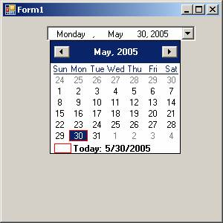

The values are shown as the caption.

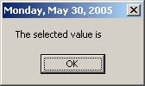

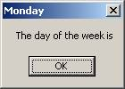

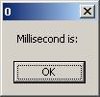

Creating Menu and Menu Items
In this tutorial we will learn about Creating Menu and Menu Items - Main Menu, Context Menu, StatusBar and ToolBar.

Main Menu
Windows users are familiar with Menu objects. The MainMenu control represents the container for the menu structure of the form. Menus are made up of MenuItem objects that represent the individual parts of a menu. You can add submenus to menus that will pop up when the user clicks an arrow in the menu item, display check marks, create menu separators, assign shortcut keys to menu items , even draw the appearance of menu items yourself.

MenuItems in a MDI application work in a special way. When an MDI child window appears, its menu is merged with the MDI parent window. You can also specify how this menu is to be added to the MDI parent window with the MergeOrder and MergeType properties.

Context Menu
Another popular type of menu is the context menu. The context menus are invoked by right clicking on another control. We can use context menus to display menus that will be specific for that control. You can achieve this by setting the ContextMenu property of the control with the name of the menu created separately.

StatusBar
A StatusBar is usually seen at the bottom of the window and they provide the user with some additional information-- such as-- the page number they are editing. You can also add panels to the status bar so that different groups of information are shown in different parts of the bar. The ShowPanels property enables you to determine if the panels will be shown or not.

ToolBar
Toolbars are seen below the menus and are full of buttons. The buttons that appear in the tool bar can appear in many ways depending upon the options chosen. They can appear as standard push buttons, toggle buttons, drop-down buttons that can display a drop down menu and buttons that display images.

Toolbars are usually docked along the top of its parent Window. They can actually docked to any side of the window. Toolbars can display tool tips when the user points the mouse pointer at a toolbar button. The toolbars allow the users to access the most often used options to be grouped displayed dynamically depending up on the control that is currently active.

Creating Menu and Menu Items
In this tutorial we will learn about Creating Menu and Menu Items - Main Menu, Context Menu, StatusBar and ToolBar.

Main Menu
Windows users are familiar with Menu objects. The MainMenu control represents the container for the menu structure of the form. Menus are made up of MenuItem objects that represent the individual parts of a menu. You can add submenus to menus that will pop up when the user clicks an arrow in the menu item, display check marks, create menu separators, assign shortcut keys to menu items , even draw the appearance of menu items yourself.

MenuItems in a MDI application work in a special way. When an MDI child window appears, its menu is merged with the MDI parent window. You can also specify how this menu is to be added to the MDI parent window with the MergeOrder and MergeType properties.

Context Menu
Another popular type of menu is the context menu. The context menus are invoked by right clicking on another control. We can use context menus to display menus that will be specific for that control. You can achieve this by setting the ContextMenu property of the control with the name of the menu created separately.

StatusBar
A StatusBar is usually seen at the bottom of the window and they provide the user with some additional information-- such as-- the page number they are editing. You can also add panels to the status bar so that different groups of information are shown in different parts of the bar. The ShowPanels property enables you to determine if the panels will be shown or not.

ToolBar
Toolbars are seen below the menus and are full of buttons. The buttons that appear in the tool bar can appear in many ways depending upon the options chosen. They can appear as standard push buttons, toggle buttons, drop-down buttons that can display a drop down menu and buttons that display images.

Toolbars are usually docked along the top of its parent Window. They can actually docked to any side of the window. Toolbars can display tool tips when the user points the mouse pointer at a toolbar button. The toolbars allow the users to access the most often used options to be grouped displayed dynamically depending up on the control that is currently active.

VB.NET Validation Controls
In this tutorial you will learn about User Input Validation, Required Field Validators, Comparison Validators, Range Validators, Regular Expression Validator, Custom Validators, ErrorProvider, Enabling Controls Based On Input and Other Properties of Validation.

User Input Validation
While any application can be designed with sound logic and good technology and can deliver high performance with accuracy, some errors could still creep into it. This could be due to wrong inputs by users. While the programmer may have taken care of all the exceptions it could cause a loss of business goodwill if a customer is confronted with an error message after he has input data into a number of fields. All of us are familiar with warnings like “Please enter a valid ZIP” or “Please Enter Your First Name!” and so on!

Thus some client side validations ensure that correct data is sent to the application. We can ensure such validations using validation controls. .NET Framework provides several controls for different types of validations.
The validation Controls that are available in .Net Framework are given below:

Control
Description
RequiredFieldValidator
Ensures that the user enters data in the associated data-entry control
CompareValidator
Uses comparison operators to compare user-entered data to a constant value or the value in another data-entry control
RangeValidator
Ensures that the user-entered data is in a range between given lower and upper bounds
RegularExpressionValidator
Ensures that the user entered data matches a regular expression pattern
CustomValidator
Ensures that the user-entered data passes validation criteria that you set yourselfRequired Field Validators
This is one of the simplest controls to use. This validating control makes sure that the users have entered data into a data-entry control. For example, you may want to make sure that users enter their mail id or their credit card number before they proceed to submit the form. The RequireFieldValidator control will ensure that the user will not be able to complete the form submission with null value for the field associated with this control.

The InitialValue property of this control has an initial value set to an empty String (“”) by default. The control raises an error message if this value does not change when validation occurs.
The other controls do not perform validation if the data entry field is empty and make it appear that the validation succeeded when no validation check has been performed. Therefore, it is imperative that a validation check be performed before other checks are activated.

Comparison Validators
This control is used to validate the value entered in to one data entry control by comparing it with the data entered in to another control. The ControlToValidate property sets the field to be validated. The ControlToCompare property specifies the control to compare with. You can also validate the data from constant value by setting the property ValueToCompare. When you set both the ControlToCompare and ValueToCompare then ControlToCompare takes precedence.
The Operator property sets the type of comparison that will be performed.
Table showing the values for Operator property:

Value | Description  Equal  Checks if the comared values are equal  NotEqual  Checks if the compared values are not equal  GreaterThan  Checks for greater than relationship  GreaterThanEqual  Checks for greater than or equal relationship  LessThan  Checks for Less than relationship  LessThanEqual  Checks for less than or equal relationship  DataTypeCheck  Compares the data types between the value entered into the data-entry control that is validated and the data type specified by the Type propertyThe type property can have any of the following values:  - String  - Integer  - Double  - Date  - Currency  Range Validators  A range validator test is used to check if the value entered in the data-entry control is within a specified range of values. The property ControlToValidate is set to the control that contains the data which is to be validated. The property MinimumValue sets the minimum value of the range. The property MaximumValue sets the maximum value of the range. The property Type sets the date type of the values to be compared. All the types of comparisons discussed above are still valid for this also.  Regular Expression Validator  RegularExpressionValidator control is used to check if the value in a data-entry control matches a pattern defined by a regular expression. You can check even the format of the text entered. Regular expressions are generally made up of test with embedded codes that start with a backslash (\). For instance a simple expression for checking for either a uppercase or lower case alphabet is given by the expression “ \b[A-ZA-z]+\b.  Custom Validators  This control allows the developer freedom to define his own validations. The property ClientValidationFunction property sets the name of function or script that will do the validation. This function takes two parameters. The first argument source identifies the source control to validate. The second argument arguments hold the data to validate.  The Causes Validation Property  CausesValidation is one of the public instance properties of the control class, which specifies whether all controls which require validation gets it when the control gets focus. It returns true if the control causes validation to be performed on any controls requiring validation when it receives focus and false otherwise.  Validating event occurs when the control is validating at the time when the control loses the focus if the control’s CausesValidation property is true. Any code executed in response to this event can be used to throw exception if any is found. Validated Event occurs when the control has completed validation. This event occurs if no exception was thrown in the validating event. Clearing up the error provider messages can be done here.

.NET Exceptions
In this tutorial you will learn about Exceptions, Common Exceptions, Handling Exceptions - Try Block, Catch Block, Throw Statement, Finally Block, Salient points about error handling Custom Exceptions - Managing Unhandled Exception

Exceptions
Abnormal conditions can become obstacles in the execution of very good programs. These conditions may force the program to breakdown, or halt or just go into a limbo. The Network connection may snap or a printer may run out of paper. No programmer can foresee these problems, yet he must give the user an option to gracefully save the work done up to the point and exit the program. The Exception Management Application Block provides a simple yet extensible framework for handling exceptions in VB.NET.

What is an Exception?
Programs are designed to execute normally in predefined conditions. However, the program may occasionally be confronted with an abnormal situation which it is not built to handle. Such a situation will result in an “exception” to the norm. Programs will have to be told what it has to do when it encounters such abnormal conditions. The process of anticipating and providing for handling such extraordinary situations is known as exception handling. In .Net Framework 2005 we have a facility to break, correct the code and continue in case of exception. This facility was withdrawn in the earlier releases of .Net Framework.

An exception may occur due to a logical or a syntax error. Where syntax errors may be caught by the complier, logical errors are likely to be missed Therefore, you may have a program that may be trying to delete a file that does not exist or it may be trying to divide by zero or it may just be a null pointer error or a System IO exception. The program must be told what to do and how to do it. Some of these code level bugs come to light only at the time of execution or under extreme conditions. Most programmers as a matter of caution create exceptions and raise them on some predefined conditions to monitor the working of the program. They ensure that they provide for exception handling for the most commonly encountered problems and situations. Microsoft .NET framework 2005 has made this task of the programmer easier by building into the application the Exception Assistant.

An example of an exception handler code is illustrated below for your understanding:

Click here for Sample Code

In the above example a class has been instantiated and the SecondMethod is called. In the above code two variables a and b are passed on to the SecondMethod and a process is initiated in the SUB. Once this process is complete the SUB FirstMethod is called. The expected condition here is that the value of ‘n’ should not be zero. If at this point the value of “n” is set to zero the program will breakdown or terminate.

The Exception Assistant helps the programmer troubleshoot exceptions and also helps him understand more about the exceptions.

Some of the most common exceptions are listed below:

- Code Access Security Exceptions
- MicroSoft.Tools.CannotRemoveControlException
- System.AccessViolationException
- System.ArrayTypeMismatchExceptionSystem.Data.OleDb.OleDbException
- System.Data.ConstraintException
- System.Data.InvalidExpressionExcepton
- System.Data.NoNull.AllowedException
- System.Data.OdbcExcepton
- System.Data.OracleClient.OracleException
- System.DivideByZeroException
- System.DuplicateWaitObjectException
- System.IO.DirectroyNotFoundException
- System.IO.EndOfStreamException
- System.IO.FileNotFoundException
- System.IO.IOException
- System.IO.PathTooLongException
- System.IO.InternalBufferOverflowException
- System.NotSupportedException
- NullReferenceException
- System.ObjectDisposedException
- System.OperationCalnceledException
- System.OutOfMemoryException
- System.OverflowException
- System.Security.SecurityException
- System.StackOverFlowException
- System.UnauthorizedException

Handling Exceptions
Visual Basic supports both Structured and unstructured exception handling. If an exception occurs in a method that is not equipped to handle it, the exception is propagated back to the calling method, or the previous method. If the previous method also has no exception handler, the exception is propagated back to that method's caller, and so on. The search for a handler continues up the call stack, which is the series of procedures called within the application. If it fails to find a handler for the exception, an error message is displayed and the application is terminated.

The On Error statement is used specifically for unstructured exception handling. In unstructured exception handling, On Error is placed at the beginning of a block of code. It then has "scope" over that block; it handles any errors occurring within the block. If the program encounters another On Error statement, that statement becomes valid and the first statement becomes invalid.

In the Structured Exception Handling, the blocks of code are encapsulated with each block having one or more associated handlers. Each handler specifies some form of filter condition on the type of exception it handles. When an exception is raised by code in a protected block, the set of corresponding handlers is searched in order, and the first one with a matching filter condition is executed. A single method can have multiple structured exception handling blocks, and the blocks can also be nested within each other.

Using the Try...Catch...Finally statement, you can protect blocks of code that have the potential to raise errors. You can nest exception handlers, and the variables declared in each block will have local scope.

Creating and Managing Components Part 2
In Section 2 of Creating and Managing Components You will learn about Hosting a control inside Internet Explorer, HTMLAnchor Control, HTMLButton Control, HTMLGeneric Control, Creating Components by extending the Control class, Creating a custom control and Creating components by extending the Component class.

Hosting a control inside Internet Explorer
ASP .NET server controls are group of new controls provided by .NET. They are of different kinds. HTML Server controls, Web Server controls and Validation controls are the other types. These controls derive from System.Object -> System.Web.UI.Control -. HtmlControl.

.

.

.

.
.
.

Some of the controls are listed below:

Control | Related HTML Tag
HtmlAnchor | Allows access to program against the < a > tag
HTMLButton | Allows access to program against the< button > tag
HTMLForm | Allows access to program against the < form > tag
HTMLGeneric | Allows access to HTML tags that are not represented by any HTML server control specifically
HTMLImage | Allows access to program against the < img > tag

These controls are hosted in the browser by using codes which are discussed below:

HTMLAnchor Control
This control allows access to program the HTML tag. An example is shown below:

Aspx file code:

Click here for Sample Code

Code behind page code:

Click here for Sample Code

You can now see the control hosted in the browser:

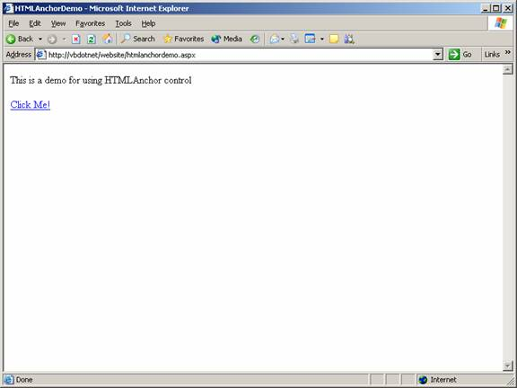

HTMLButton Control
HTMLButton Control allows the user program the HTMLtag. This is the tag used to place clickable buttons within HTML documents. This is achieved by the following code:

The code that is written in the aspx page:

Click here for Sample Code

The code that is written in the code behind page:

Click here for Sample Code

The page when viewed in a browser looks like the screenshot below:

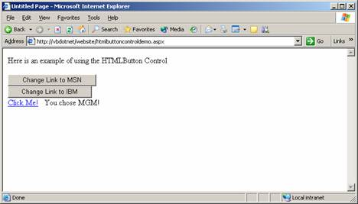

HTMLGeneric Control
HTMLGeneric control allows the user program the HTML tags that are not represented by any of the specified controls. Some of the examples are < span >, < div >, < body > and so on. The following demo illustrates the use of HTMLGeneric Control to access the HTML tag.

The codes that are given in the aspx page are given below:

Click here for Sample Code

The codes that are given in the code behind page are given below:

Click here for Sample Code

The view of the page in the browser is shown below:

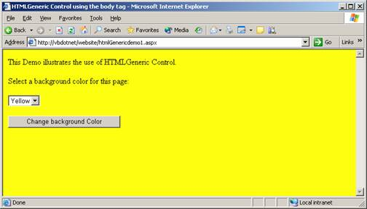

Creating Components by extending the Control class
Components can be created by extending a control class. This feature enables the application developer in numerous ways. He can create customized components for his application using the basic functionality of the component as his starting point.
To start with, a library of derived controls can be created out of predefined controls. These controls can then be customized by adding specific functionalities. The features of the base class can also be extended by adding few properties that are essential to the application being developed.

Creating a custom control
1. Create a new control library project in the visual studio.
2. Right-click on the solution explorer and add a new custom control.
You will see a screen like the one you see below:

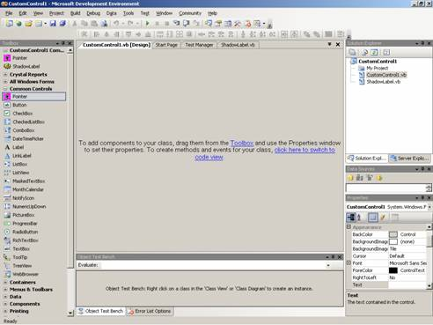

Controls can be dragged and dropped for customization. For the purposes of study, let us drag and drop a label control. The codes for this control will be displayed in the code window. Now add the following code to the class:
Code
Public Class ShadowLabel
Private m_ShadowColor As Color = Color.Black

Protected Overrides Sub OnPaint(ByVal e As System.Windows.Forms.PaintEventArgs)

'Add your custom paint code here
Dim brFText As SolidBrush = New SolidBrush(Me.ForeColor)
Dim brRText As SolidBrush = New SolidBrush(Me.ShadowColor)
Dim gSurface As Screenshots = e.Screenshots
Dim rectForeGr As RectangleF = gSurface.VisibleClipBounds
Dim rectBackGr As RectangleF = gSurface.VisibleClipBounds
rectBackGr.Offset(2, 2)
gSurface.DrawString(Me.Text, Me.Font, brFText, rectForeGr)
gSurface.DrawString(Me.Text, Me.Font, brRText, rectBackGr)
brFText.Dispose()
brRText.Dispose()
gSurface.Dispose()
MyBase.OnPaint(e)
End Sub

Protected Overrides Sub onTextChanged(ByVal e As EventArgs)

Me.Refresh()
MyBase.OnTextChanged(e)

End Sub
Public Property ShadowColor() As Color
Get
Return m_ShadowColor
End Get
Set(ByVal value As Color)
m_ShadowColor = value
End Set
End Property

End Class

VB.NET Creating and Managing Components Part 1
In this tutorial you will learn about Components, Best practices in using Components, Creating Components by extending the UserControl Class, Testing the Control, Creating and implementing Events, Extending a control through Visual Inheritance and Inheriting from a UserControl.

A component is a reusable piece of code in binary form. This code can be reused by inheritance. No class is being inherited. It follows that a containment relationship is defined between the application using the component and the component that is being used. This is different from the relationship that exists between a derived class and a base class.

Components have to interact with each other. They need information about each other. This is achieved by loading the components within self-contained packages called assembly. An assembly contains information about the files on which the component depends and the location of these files. The CLR can use this information to determine the dependencies of a component. The assemblies that are required during the execution of an application are called dependencies.

A class becomes a component when it follows defined standards of interaction. These standards are provided by the IComponent interface. All components derive from Component class. The Component class in turn implements IComponent interface.

Best practices in using components
- The name of the component to be short and meaningful.
- The access level for constructors should be implemented as private or public based on the usage is either by the same assembly or different assembly.
- The base class of all components is Component class. You can also implement IComponent interface to create a component.
- The namespace structure in an assembly should be according to the internal organization of the component. It is preferable to keep all the components together in separate Namespace.
- The component will have two type of initialization namely, type initialization and instance initialization.
- Type initialization is achieved by using a shared constructor and this is done only once in the lifetime of the application.
- Instance initialization is achieved by using the constructors which are not shared.
- A component like any other class must implement as many interfaces as needed. They are capable of being called in multiple ways.(polymorphism).

Creating components by extending the UserControl Class
Objects help users control the flow of applications. Objects like buttons and ComboBoxes are controls. Controls can be defined as visual components that are used across applications. Controls that are customized by users are called UserControls. User Controls can have multiple child controls and provide the user with a single interface.

Let us now create a user control.

Open the Visual Studio IDE and select the menu File, Choose New – Project to open a new project Dialog Box

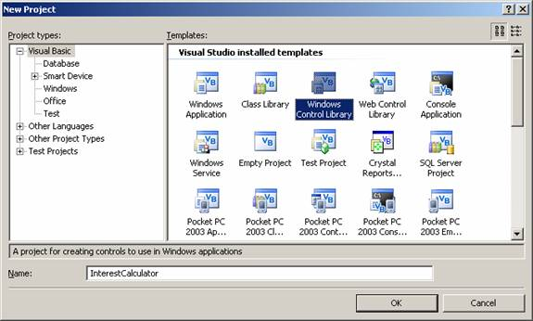

Choose Windows Control Library from the items displayed. Type the name of the project as InterestCalculator. Click on OK.

In the solution Explorer window, right-click UserControl1 and select View Code

You can also change the default name UserControl1 to any name of your choice

The class inherits from the UserControl class by default. If you need to inherit from another existing control, edit the statement Inherits System.Windows.Forms.UserControl to refer to your class.

Save the project.

Enter the following code in to the windows.

Click here for Sample Code

Testing the Control
The control is always used in a container. Therefore you need a windows form to test the control. The Steps for doing this are as follows.

Build the control by clicking Build menu.

Create a new windows application project

In the solution explorer window of the new project, right –click the Reference node. Select Add reference to open the Add reference dialog box.

Add the project with your custom control to the selected Components section in the AddReference DialogBox. To close the Add Reference dialog box.

Add the control to you toolbar

In the dialog box that you have opened select .NET Framework Component tab from the Add Reference Dialog Box.

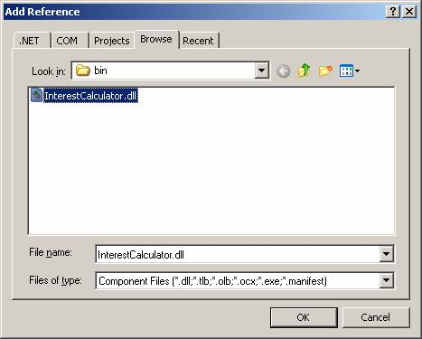

Choose the ToolBox Item

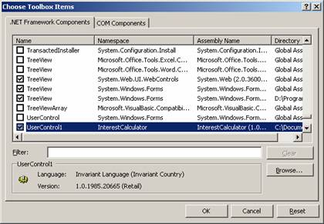

Creating and Managing .NET Assemblies
Single-file and multi-file assemblies, Combining modules written in different languages, Creating a multi-file assembly, End Namespace, Static and dynamic assemblies, Private and shared assemblies, Sharing an assembly, Satellite and Resource-only assemblies, Compiling Satellite Assemblies, Compiling Satellite Assemblies With Strong Names, Obtaining the Public Key, Delay Signing an Assembly, Re-signing an Assembly, Installing a Satellite Assembly in the Global Assembly Cache, Resources in Applications, Creating and Localizing Resources and Packaging and Deploying Resources

Single-file and multi-file assemblies
A single-file assembly is the simplest of all the assemblies. It contains type information and implementation along with the manifest. This can be created using command-line compilers or Visual Studio 2005. The default file extension for the assembly is .exe. We shallsee how a single-file assembly is created.
Go to the command prompt for Visual Studio.

Type the .

The compiler name depends on the language used in code module and the module name is the module that you want to compile into an assembly.

Visual Basic compiler command to compile MyModule.vb is : vbc MyModule.vb C# compiler command to compile MyModule.cs is: csc MyModule.cs

You can use the option /t:library to create a library assembly.

Multi-file assemblies can be created using command line compilers or Visual Studio 2005 with Managed Extensions for C++. This requires that one file should contain the assembly manifest. The assembly that starts an application must also contain an entry point, such as a Main or WinMain method.

Let us now illustrate this point.. Consider an application that you need to compile which contains two code modules namely Personnel.vb and admin.vb. In this, the module admin.vb creates the InAdmin namespace that is referenced by the code in personnel.vb. The personnel.vb contains the main method, which is the application entry point. In this scenario you will compile the two code modules, and then create a third file that contains the assembly manifest, which is used to launch the application. The assembly manifest references both personnel and admin module. Thus the point to be noted is that the multi-file assembly must contain only one entry point. We shall briefly see some of the reasons why we need to create multi-file assembly:

Combining modules written in different languages:
To manage the availability of the assemblies over the network, only the most used modules are downloaded and the least used module is downloaded only when needed.

To combine the modules developed by multiple programmers:

1. The user has the choice to sign the file that contains the assembly manifest or the choice to give the file a strong name and put it in the global assembly cache.

Creating a multi-file assembly
The first step is to compile all the files that contain namespaces referenced by other modules in the assembly into code modules. The default extension for code module is .netmodule. Next compile all other modules using the necessary compiler options to indicate the other modules that are referenced in the code.

Then, use the assembly linker ( Al.exe) to create the output file that contains the assembly manifest. This file contains reference information for all modules or resources that are part of the assembly. Finally, in a new windows project add the following codes to the Form:

Click here for Sample Code

End Namespace
Save and build the application. Now use the command vbc with the option/t:module to compile the code. The command prompt window is shown below. The Form1.netmodule file is also displayed here.

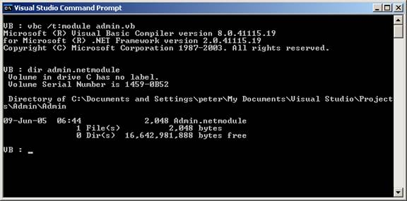

Specifying the module parameter with the /t: compiler option indicates that the file should be compiled as a module rather than as an assembly.

Click here for Sample Code

Specify the /t:module option because this module will be added to an assembly in a future step. Specify the /addmodule option because the code in Client references a namespace created by the code in Admin.netmodule. The compiler produces a module called personnel.netmodule that contains a reference to another module, admin.netmodule.

The Visual Basic compilers support directly creating multi-file assemblies using the following two different syntaxes.

Two compilations create a two-file assembly:

vbc /t:module Admin.vb

vbc personnel.vb /addmodule:Admin.netmodule

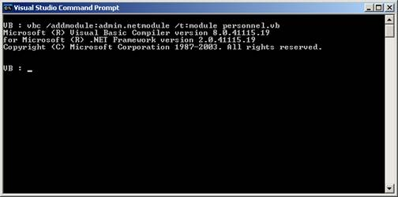

Sponsored Links

VB.NET 2005 Tutorials
- VB.NET 2005 Free Training
- Shared Assembly
- The .NET Framework Architecture Part 1
- Tracing VB.NET Windows Application
- The .NET Framework Architecture Part 2
- VB.NET Windows Application Testing
- Implementing Inheritance
- The File Types Editor
- Visual Studio.NET Namespaces
- Differences between VB.NET 1.0 and VB.NET 2.0
- Visual Studio Windows Forms Designer
- Introducing VB.NET Windows Forms
- Event Handling In Visual Basic .NET
- Exploring the Forms Designer generated code
- Building Graphical Interface elements
- Microsoft .NET Creating Installation Components
- Application Class and Message Class
- Visual Studio Adding Controls to Windows Form
- Common Controls and Handling Control Events
- Implementing Class Library Object

Home Tutorials VB.NET 2005

.NET Assemblies

Category: VB.NET 2005
Comments (1)

Table of Contents
.NET Assemblies
.NET Assemblies - Page 2
.NET Assemblies - Page 3

.NET Assemblies
Page 1 of 3

Creating and Managing .NET Assemblies
Single-file and multi-file assemblies, Combining modules written in different languages, Creating a multi-file assembly, End Namespace, Static and dynamic assemblies, Private and shared assemblies, Sharing an assembly, Satellite and Resource-only assemblies, Compiling Satellite Assemblies, Compiling Satellite Assemblies With Strong Names, Obtaining the Public Key, Delay Signing an Assembly, Re-signing an Assembly, Installing a Satellite Assembly in the Global Assembly Cache, Resources in Applications, Creating and Localizing Resources and Packaging and Deploying Resources

Single-file and multi-file assemblies
A single-file assembly is the simplest of all the assemblies. It contains type information and implementation along with the manifest. This can be created using command-line compilers or Visual Studio 2005. The default file extension for the assembly is .exe. We shallsee how a single-file assembly is created.
Go to the command prompt for Visual Studio.

Type the .

The compiler name depends on the language used in code module and the module name is the module that you want to compile into an assembly.

Visual Basic compiler command to compile MyModule.vb is : vbc MyModule.vb C# compiler command to compile MyModule.cs is: csc MyModule.cs

You can use the option /t:library to create a library assembly.

Multi-file assemblies can be created using command line compilers or Visual Studio 2005 with Managed Extensions for C++. This requires that one file should contain the assembly manifest. The assembly that starts an application must also contain an entry point, such as a Main or WinMain method.

Let us now illustrate this point.. Consider an application that you need to compile which contains two code modules namely Personnel.vb and admin.vb. In this, the module admin.vb creates the InAdmin namespace that is referenced by the code in personnel.vb. The personnel.vb contains the main method, which is the application entry point. In this scenario you will compile the two code modules, and then create a third file that contains the assembly manifest, which is used to launch the application. The assembly manifest references both personnel and admin module. Thus the point to be noted is that the multi-file assembly must contain only one entry point. We shall briefly see some of the reasons why we need to create multi-file assembly:

Combining modules written in different languages:
To manage the availability of the assemblies over the network, only the most used modules are downloaded and the least used module is downloaded only when needed.

To combine the modules developed by multiple programmers:

1. The user has the choice to sign the file that contains the assembly manifest or the choice to give the file a strong name and put it in the global assembly cache.

Creating a multi-file assembly
The first step is to compile all the files that contain namespaces referenced by other modules in the assembly into code modules. The default extension for code module is .netmodule. Next compile all other modules using the necessary compiler options to indicate the other modules that are referenced in the code.

Then, use the assembly linker ( Al.exe) to create the output file that contains the assembly manifest. This file contains reference information for all modules or resources that are part of the assembly. Finally, in a new windows project add the following codes to the Form:

Click here for Sample Code

End Namespace
Save and build the application. Now use the command vbc with the option/t:module to compile the code. The command prompt window is shown below. The Form1.netmodule file is also displayed here.

Specifying the module parameter with the /t: compiler option indicates that the file should be compiled as a module rather than as an assembly.

Click here for Sample Code

Specify the /t:module option because this module will be added to an assembly in a future step. Specify the /addmodule option because the code in Client references a namespace created by the code in Admin.netmodule. The compiler produces a module called personnel.netmodule that contains a reference to another module, admin.netmodule.

The Visual Basic compilers support directly creating multi-file assemblies using the following two different syntaxes.

Two compilations create a two-file assembly:

vbc /t:module Admin.vb

vbc personnel.vb /addmodule:Admin.netmodule

One compilation creates a two-file assembly:

vbc /out:Admin.netmodule Admin.vb /out:Personnel.exe Personnel.vb

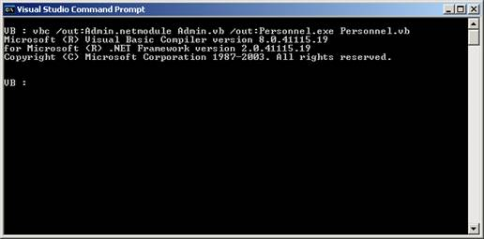

The Assembly Linker (Al.exe) can be used to create an assembly from a collection of compiled code modules.
To create a multi-file assembly using the Assembly Linker
1. At the command prompt, type the following command:
al < module name > < module name > … /main:< method name > /out:< file name > /target:< assembly file type >

VB.NET 2005 Tutorials: Simple Data Binding
In Section 1 of Data Binding you will learn about definition of Data Binding Bindable Entities, The Architecture of Data Binding, Bind Data to the User Interface and Simple Data Binding

Data Binding
The process of binding a control to a data source is called data binding. Visual Studio 2005 includes several new features to assist in developing applications that access data. The Data Source Configuration Wizard simplifies connecting the application to data in databases, Web services, and user-created objects. The new Data Sources window provides a centralized view of the data available to the project, and it reduces the complexity of data binding by allowing the user drag items from the window onto forms to create data-bound controls. Filling datasets, running queries, and executing stored procedures can be accomplished using the new Visual Studio-generated TableAdapter object. The new local data feature allows the user include Microsoft SQL Express and Microsoft Access database files, directly in to the application.

Windows Forms can take advantage of two types of data binding: simple binding and complex binding. Each offers different advantages. We will look at them a little later in this lesson.

Bindable Entities:
Binding data to form controls allows the user access data from databases as well as data in other structures, such as arrays and collections which support IList interface. The data providers for other objects in .NET Frameworkare listed below:

- Array or collection that implement IList interface.
.
- ADO .NET objects
  - DataColumn object. The users can simple-bind a control (such as a TextBox control's Text property) to a column within a data table.
.
  - DataTable object. The user can complex-bind a control to the information contained in a data table (such as binding the DataGrid control to a data table) using the default view of the DataTable.
.
  - DataView object. The users can simple- or complex-bind to the data within a data view. However this provides a fixed snapshot of the data.
.
  - DataSet object. The users can simple- or complex-bind to the data within a dataset using the default view.
.
  - DataView Manager Object. It functions like DataView, with a difference that this snapshot comes with relationships that exists between the tables as seen in a DataSet.

The Architecture of Data Binding
- Create Connection Object. The connection that the users create, forms the basis for all other activities. In doing so the user creates a connect string and also a connection object that provides connection to the database.
.
- Create DataSet and DataAdapter. Then the user proceeds to set the Data Binding property of the text box. At this stage the Visual Studio creates a DataSet and a DataAdaptor. The “Select ... “ statement for creating the DataSet is also autogenerated based on the selections the user has made in the Data Source configuration wizard.
.
- Call the fill method of the DataAdapter to fill the dataset. This also adds a line of code that fills the dataset using the data adapter and the connection object . At the end of it all the data from the selected data source is available for the control when the form loads.
Having said all that, let us now see how simple binding and complex binding of data to controls is accomplished.

Bind Data to the User Interface

Simple Data Binding
Simple data binding is the ability of a control to bind to a single data element--such as a value in a column in a dataset table. This is the type of binding typical for controls typically display a single value such as a System.Windows.Forms.TextBox control or System.Windows.Forms.Label control. In fact, any property on a control can be bound to a field in a database. Let us create a sample to understand the concept better.

1. Create a new Windows Application project in Visual Basic 2005 IDE .

2. Press Ctrl + Alt + S to open the Data Explorer if it is not seen docked to the top left hand side corner of the window. The screenshot below shows the Database Explorer.

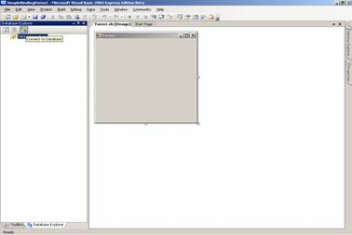

3. Click on the “Connect to Database” icon on the left window pane, to open the dialog box. Choose option Database. In the dialog box “Choose Data Source”, select Microsoft SQL Server Database File and click continue as shown below:

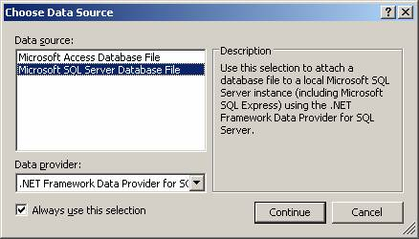

4. The “Add Connection” dialog box opens. Click on the Browse button to choose the Database file. Now click on “Test Connection”. The user will get a message box saying “Connection Successful”. Click on OK to add the database.

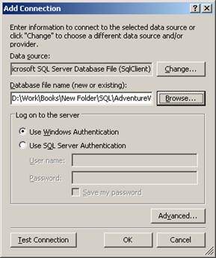

5. The user will see a new connection added in the database explorer:

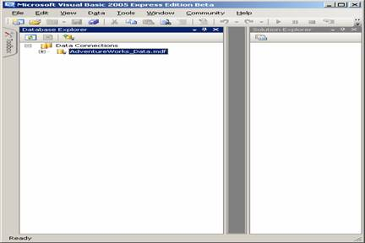

6. Add a TextBox to the form and also a button which we will use for closing the application. The window will look like the screenshot shown below:

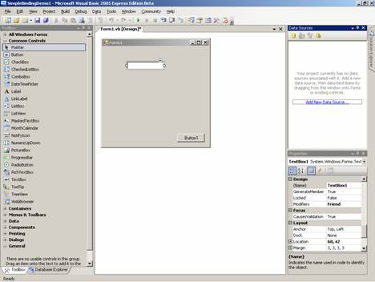

7. Add a BindingNavigator from the toolbox to the form. In the property window set the value for property ‘Dock as Bottom’. Set the Text property of the Button1 to Exit. Add the following code to the click event of the button.
Me.Close()
The window will look like the screenshot shown below:

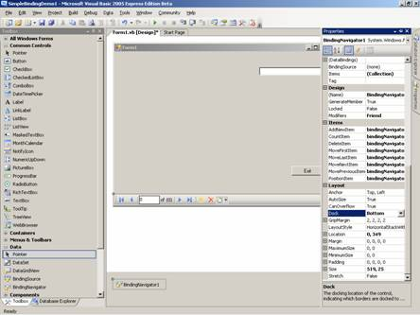

Complex Data Binding
Complex data binding is the ability of a control to bind to more than one data element, typically more than one record in a database, or to more than one of any other type of bindable data elements. Examples of controls that support complex binding are the DataGridView, ListBox, and ErrorProvider controls.

Binding to a ComboBox or ListBox
In this section let us create a complex binding by using a ComboBox and a ListBox. As in the preceding section the user must add a database connection to the project and to generate DataSets. Then he must proceed to create a new Windows Application Project by name ComplexDataBindingDemo. After creating the Data Connection to the SQLServer Database, from the ToolBox, he must drag and drop a DataGrid control and a list box on the form Form1. At this point the user’s window should look like the following screenshot:

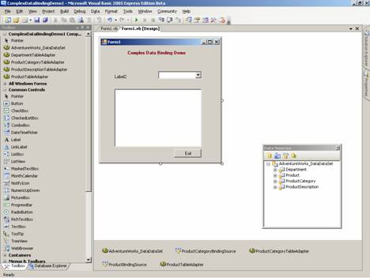

Here also the user will have to go through all the steps involved to set up the data providers and also bind them to the control. After doing this the user will have to set the value to the DataSource property of the controls to the data set. Now in some controls like ListBox and ComboBoxes the user will come across two properties viz, display member and value member. In a typical situation he will be needing the descriptive value of the column to be displayed while the use of the values like ProductId etc need to be passed as values to further queries. The user will have to set these values also.

The following screenshots will show the output for ComplexBinding using a combo box, list box and a DataGrid.

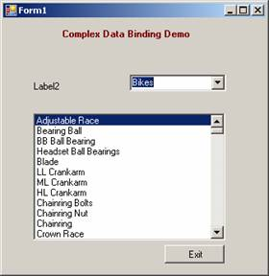

Binding to a DataGrid

A DataGrid is a very useful Control. A number of improvements have been made to this control in .NET Framework 2005. Binding Data to DataGrid is simple. As a first step, The user has to set the value for the property Advanced Binding and DataSource.

1.2.3.4.5.

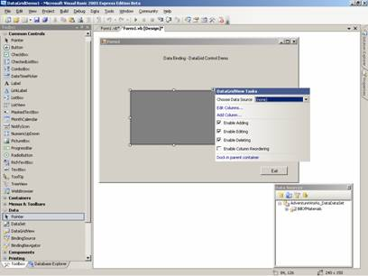

The following screenshot shows the final appearance of the DataGrid

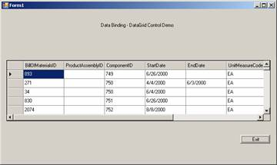

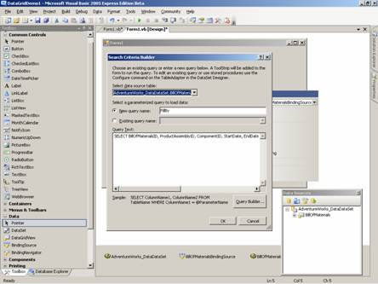

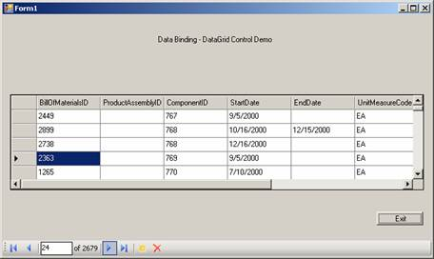

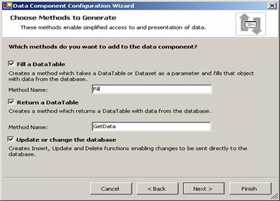

Using the Data Form Wizard

Building a Single-Table Data Form
Adding a single table to a form using a wizard makes for ease of application development. The following example demonstrates the building of a form to display single table using a DataGrid.

Building a Multiple-Table Data Form
In most applications the user needs to create forms that display data in format that shows the master detail relationship. For an example if we have a ComboBox Control bound to a column in a Lookup table and the user needs to show data in a DataGrid which is filtered by the selected column in the ComboBox Control, then this kind of form is said to be a Master Detail form. Now we shall go through another example that illustrates this.

Transform and Filter Data

Using Server Explorer
Server Explorer or Database Explorer is displayed in a window usually docked to the top left hand side of the window. If it is not visible it can be invoked by pressing the keys Ctrl + Alt + S simultaneously. This window shows all the data connections existing in the project. It also displays an icon for creating a new connection. The process of using the Wizard for creating a new connection has already been discussed earlier in this lesson.

Adding a Data Connection
By default, Server Explorer/Database Explorer displays data connections and links to servers that the user has previously used.

Server Explorer displays database connections beneath the Data Connections node. After a connection is established, the user can design programs to open connections and retrieve and manipulate the data provided.

To add a data connection in Server Explorer

1. On the Tools menu, select Connect to Database.

The Data Link Properties dialog box opens. On the Provider tab of the Data Link Properties dialog box, choose an OLE DB provider.

2. On the Connection tab of the Data Link Properties dialog box, provide the information requested. The input fields displayed vary, depending upon the provider selected on the Provider tab.

For example, if the user must select the OLE DB Provider for Oracle, the Connection tab displays fields for server name and login. If the user select the OLE DB Provider for SQL Server, the Connection tab displays fields for server name, type of authentication, and database.

3. Click OK to establish the data connection.

The Data Link Properties dialog box closes, and the new data connection appears beneath the Data Connections node, named for the server and database accessed.

For example, if the user must create a data connection to a database called Nwind on a server named Server1, a new connection named Server1.Nwind.dbo appears beneath the Data Connections node.

Drag-and-Drop From Server Explorer
Server Explorer/Database Explorer is the server management console for Visual Studio .NET. The user can deploy the Server Explorer/Database Explorer to open data connections and to log on to servers and explore their databases and system services. The user can drag nodes from Server Explorer/Database Explorer and drop them onto the Dataset Designer. This creates new data components that are preconfigured to reference the item dropped. When the users drag certain resources from Server Explorer and drop them onto Visual Studio designers, the integrated development environment (IDE) automatically creates new components that reference the resources selected. For example, if the user drags a message queue from Server Explorer onto a Windows project, the IDE automatically creates a System.Messaging.MessageQueue component preconfigured to reference that particular queue. The user can then write code that accesses and manipulates data from that queue via this new component.

Sponsored Links

VB.NET 2005 Tutorials
- VB.NET 2005 Free Training
- Shared Assembly
- The .NET Framework Architecture Part 1
- Tracing VB.NET Windows Application
- The .NET Framework Architecture Part 2
- VB.NET Windows Application Testing
- Implementing Inheritance
- The File Types Editor
- Visual Studio.NET Namespaces
- Differences between VB.NET 1.0 and VB.NET 2.0
- Visual Studio Windows Forms Designer
- Introducing VB.NET Windows Forms
- Event Handling In Visual Basic .NET
- Exploring the Forms Designer generated code
- Building Graphical Interface elements
- Microsoft .NET Creating Installation Components
- Application Class and Message Class
- Visual Studio Adding Controls to Windows Form
- Common Controls and Handling Control Events
- Implementing Class Library Object

Home Tutorials VB.NET 2005

.NET Data Form Wizard

Category: VB.NET 2005
Comments (3)

Table of Contents
.NET Data Form Wizard
.NET Data Form Wizard - Page 2

.NET Data Form Wizard
Page 1 of 2
In this tutorial you will learn about Using the Data Form Wizard - Building a Single-Table Data Form, Transform and Filter Data, Using Server Explorer, Drag-and-Drop From Server Explorer, What the user Can and Cannot Drag from Server Explorer, Filtering Data, Filtering With DataViews, Filtering At the Server, Transforming Data with Lookups and Master Detail.

Using the Data Form Wizard

Building a Single-Table Data Form
Adding a single table to a form using a wizard makes for ease of application development. The following example demonstrates the building of a form to display single table using a DataGrid.

Building a Multiple-Table Data Form
In most applications the user needs to create forms that display data in format that shows the master detail relationship. For an example if we have a ComboBox Control bound to a column in a Lookup table and the user needs to show data in a DataGrid which is filtered by the selected column in the ComboBox Control, then this kind of form is said to be a Master Detail form. Now we shall go through another example that illustrates this.

Transform and Filter Data

Using Server Explorer
Server Explorer or Database Explorer is displayed in a window usually docked to the top left hand side of the window. If it is not visible it can be invoked by pressing the keys Ctrl + Alt + S simultaneously. This window shows all the data connections existing in the project. It also displays an icon for creating a new connection. The process of using the Wizard for creating a new connection has already been discussed earlier in this lesson.

Adding a Data Connection
By default, Server Explorer/Database Explorer displays data connections and links to servers that the user has previously used.

Server Explorer displays database connections beneath the Data Connections node. After a connection is established, the user can design programs to open connections and retrieve and manipulate the data provided.

To add a data connection in Server Explorer

1. On the Tools menu, select Connect to Database.

The Data Link Properties dialog box opens. On the Provider tab of the Data Link Properties dialog box, choose an OLE DB provider.

2. On the Connection tab of the Data Link Properties dialog box, provide the information requested. The input fields displayed vary, depending upon the provider selected on the Provider tab.

For example, if the user must select the OLE DB Provider for Oracle, the Connection tab displays fields for server name and login. If the user select the OLE DB Provider for SQL Server, the Connection tab displays fields for server name, type of authentication, and database.

3. Click OK to establish the data connection.

The Data Link Properties dialog box closes, and the new data connection appears beneath the Data Connections node, named for the server and database accessed.

For example, if the user must create a data connection to a database called Nwind on a server named Server1, a new connection named Server1.Nwind.dbo appears beneath the Data Connections node.

Drag-and-Drop From Server Explorer
Server Explorer/Database Explorer is the server management console for Visual Studio .NET. The user can deploy the Server Explorer/Database Explorer to open data connections and to log on to servers and explore their databases and system services. The user can drag nodes from Server Explorer/Database Explorer and drop them onto the Dataset Designer. This creates new data components that are preconfigured to reference the item dropped. When the users drag certain resources from Server Explorer and drop them onto Visual Studio designers, the integrated development environment (IDE) automatically creates new components that reference the resources selected. For example, if the user drags a message queue from Server Explorer onto a Windows project, the IDE automatically creates a System.Messaging.MessageQueue component preconfigured to reference that particular queue. The user can then write code that accesses and manipulates data from that queue via this new component.

To create a new component using Server Explorer

1. Open the project, form, or class to which the user want to add a component in a designer.

2. In Server Explorer, select the item the user want to use.

3. Drag the item from Server Explorer to the designer surface, or right-click the item and click Add to Designer.

.

.

What the user Can and Cannot Drag from Server Explorer
The following table lists items that the user can drag from Server Explorer, and describes the components created when the user drop them onto a Visual Studio project, form, or class designer.

Node type | Draggable items | Result
Servers | Event log categories, message queues, performance counters, and services
Event Logs | Event log categories | An System.Diagnostics.EventLog component appears, pointing to the category selected. For more information, see Logging Application, Server, and Security Events.
Message Queues | Individual message queues | A System.Messaging.MessageQueue component appears, pointing to the queue selected. For more information, see Using Messaging Components.
Performance Counters | Individual counters and instances | A System.Diagnostics.PerformanceCounter component appears, pointing to the counter (and instance) selected. For more information, see Introduction to Monitoring Performance Thresholds.
Services | Individual services | A System.ServiceProcess.ServiceController component appears, preconfigured to interact with the service selected. For more information, see Introduction to Communicating with Existing Services.

The user cannot drag any data items from Server Explorer. The user also can create blank components by dragging items from the Toolbox.

Access and Manipulate SQL Server data - Using Ad Hoc Queries

Consuming and Manipulating Data
Modern day enterprises deal with online transaction processing databases that need to store huge volumes of data as well as carryout database operations such as UPDATE, ADD, and DELETE or retrieve data for viewing and decision making. The emergent need is to device a software that connects to the database and allows the user perform all these operations and more. Visual Basic.Net coupled with SQL server provides for a system that is dynamic and efficient. In this lesson we shall be studying how we can connect to SQL server and manipulate data.

Access and Manipulate SQL Server Data
The data stored in an SQL server becomes accessible if the data source is defined in the system or the user connects to the database using an application with a connection and object and a connect string. VB.NET, as we saw in the earlier lessons allows the user create statements dynamically and execute queries implicitly. In this section we shall use queries explicitly to manipulate data in the SQL Server database using the DataCommand object.

Before actually launching onto manipulation of data, the user must instantiate the SqlCommand.

Dim sqlCommand1 As New SqlCommand()

This object exposes the following method that can be used to query the database.

Methods  Description  BeginExecuteNonQuery  Initates the asynchronous execution of the T-SQL statement or stored procedure. Usually used for execution commands such as SELECT, DELETE, UPDATE, and SETstatements.  BeginExecuteReader | Initiates the asynchronous execution of the Transact-SQL statement or stored procedure. This should receive one or more result sets from the Server.  BeginExecuteXmlReader  Initiates the asynchronous execution of the Transact-SQL statement or stored procedure  ExecuteReader | executes commands that return rows.
ExecuteNonQuery  Executes commands such as Transact-SQL INSERT, DELETE, UPDATE, and SET statements.  ExecuteScalar  Retrieves a single value (for example, an aggregate value) from a database.  ExecuteXmlReader | Builds an Xml Object.

The DataReader object can also be used to access data. The dataReader is usually declared in Visual Basic using the following command:

Dim MyReader As New SqlDataReader.

The select statement is the simplest method of accessing data from the database. The user can direct the system to select the columns and display the data in the console.

VB.NET uses the classes contained in System.Data.SqlClient. These classes have to be referenced before they can be used. Let us understand how this is done by working out an example.

(a) Create a new windows application in Visual Basic 2005 Express.

(b) Double click on the Form1(design) to go to the codes page.

(c) Import the Namespace System.Data.SqlClient, using the following statement.

Imports System.Data.SqlClient

(d) Define a ConnectString that the Connection Object will use to establish the connection with the database. The value for the ConnectString will specify the server, initial database and the type of database connection and the UserName and the password.(see code below).

(e) Define a query which is a string variable.

(f) Add some query that will be returning rows from the database.

(g) Define a datacommand, SqlCommand object whose constructor will take two parameters viz., the query and the connection object.

(h) At this stage the connection is established and available.

(i) Use the SqlDataReader to retrieve the data and write to console.

The following code shows the implementation of the data access using the SELECT statement to retrieve and display data on the console

Click here to view sample code

The data output extracted is shown below:

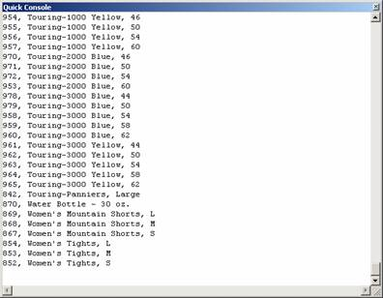

The INSERT Statement
The insert statement is used to add new data rows to the table. Create the SqlAdapter object as above. Now call the ExecuteNonQuery method of the SqlAdapter. This method executes queries in instances where the query statement is either an insert, update or a Delete method.

Let us understand how to insert data by working out an example.

1. Start a new windows application and to the form Form1

2. Add one label and one TextBox and two buttons.

3. Add the codes as in the case of previous demo.

4. The method InsertData will have two arguments, one for the connect string and the other for the ProductCategory name.

5. Add an insert data command.
Code
Imports System.Data.SqlClient
Public Class Form1
Private ConnString As String

Private Sub Form1_Load(ByVal sender As System.Object, ByVal e As System.EventArgs) Handles MyBase.Load

'CnStr ="Data Source=.\SQLEXPRESS;AttachDbFilename="C:\Program Files\Microsoft SQL Server\MSSQL.1\MSSQL\Data\AdventureWorks_Data.mdf";Integrated Security=True;User Instance=True"
End Sub
Public Sub InsertMyData(ByVal myConnString As String, ByVal NameStr As String)
Dim mySelectQuery As String = "SELECT ProductCategoryId, Name FROM Production.ProductCategory"
Dim myInsertQuery As String = "INSERT into Production.ProductCategory(Name) VALUES('" & NameStr & "')"
Dim myConnection As New SqlConnection(myConnString)
Dim myCommand As New SqlCommand(mySelectQuery, myConnection)
Dim myCommand2 As New SqlCommand(myInsertQuery, myConnection)
Dim retvalue As Integer
myConnection.Open()
retvalue = myCommand2.ExecuteNonQuery()
Console.WriteLine(retvalue)
Dim myReader As SqlDataReader
myReader = myCommand.ExecuteReader()
' Always call Read before accessing data.
While myReader.Read()
Console.WriteLine((myReader.GetInt32(0) & ", " & myReader.GetString(1)))
End While
' always call Close when done reading.
myReader.Close()
' Close the connection when done with it.
myConnection.Close()

End Sub 'ReadMyData

Private Sub Button1_Click(ByVal sender As System.Object, ByVal e As System.EventArgs) Handles Button1.Click
Dim NameStr As String
Dim id As Integer

NameStr = Me.TextBox1.Text
ConnString = "Data Source= .\SQLEXPRESS;Initial Catalog = C:\ADVENTUREWORKS_DATA.mdf;Integrated Security=True;User Instance=True;"
InsertMyData(ConnString, NameStr)
End Sub

Private Sub Button2_Click(ByVal sender As System.Object, ByVal e As System.EventArgs) Handles Button2.Click
Me.Close()
End Sub
End Class

Working with Disk Files

Temporary storage of data as in the illustrations above is not the optimal solution. Persistent data storage is a file having a collection of bytes and is stored as data streams. All read write operations to these data steams can be done with ease in the circumstances. In the following illustration we shall see how read write operations can be performed on persistent data storage.

Browsing For Files

The System.IO.Directory class can be used for typical operations such as copying, moving, renaming, creating and deleting directories. This is a static class and therefore is efficient in the performance of single operations. This class can be used to perform operations relating to browsing for files, The System.IO.FileInfo.Name method of this class used to see the files in the directory. The System.IO.Directory.GetDirectories or System.DirectoryInfo.GetDirectories methods enable users see the sub directories in a the directory. Let us understand the issue by the following example.

- Create a new windows application in the Visual Basic Express and
- Give the name of the project as FileBrowse1.
- To the form Form1 add two Labels, a TextBox , a CheckBox, and two Buttons.
- Arrange the controls and name them as shown in the screenshot shown below:
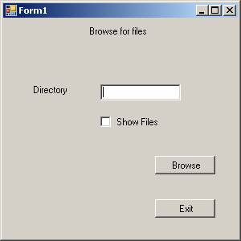

Now add the necessary code to the application. The code for the application is shown below:

Click here to veiw sample code

Now press F5 to execute the application. In the window type the directory name that we want to browse and also use the check box to specify if we want to view the file names or not. Now click the button Browse to view the file names and the directory names. The outputs generated for both with and without the check box selected are shown below:

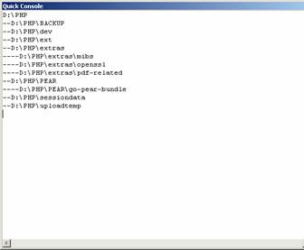

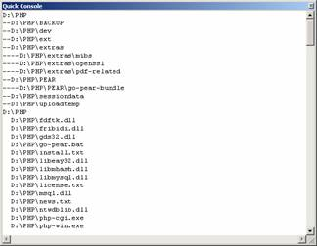

Streams
Stream is the abstract base class of all streams. A stream is an abstraction of a sequence of bytes, such as a file, an input/output device, an inter-process communication pipe, or TCP/IP socket. The stream class and its derived classes provide generic view of these different types of input and output, isolating the programmer from the specific details of the operating system and the underlying devices.

Streams are concerned with three fundamental operations:

1.2.3.Depending on the underlying data source or repository, streams might support only some of the several capabilities. An application may query a stream for its capabilities by using the System.IO.Stream.CanRead, System.IO.Stream.CanWrite, and System.IO.Stream.CanSeek properties.

Using FileStream Class
The FileStream class gives the user the capability to read from, write to, open, and close files on a file system. This class also can be used to manipulate other file related handlers like pipes, standard input, and standard output. The user can also specify read and write operations to be either Synchronous or asynchronous.

Some of the functions ofthe FileStream class are given below:

- Determine if a file exists.

The following example will illustrate some of the file operations. The two programs that are included will perform functions like reading the directory path, creating a file and listing it and also writing to a file and reading from a file.

1. Create a new Windows Application in Visual Basic Express.

2. Add a Label and three buttons and arrange them as shown in the screenshot below:

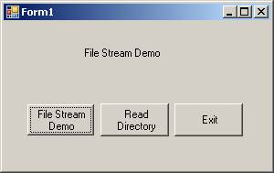

Add to the form the following code and save the project.

Click here to view sample code

Νοω πρεσσ Φ5 το εξεχυτε τηε φιλε. Τηε ουτπυτσ γενερατεδ βψ τηε προγραμ αρε σηοων βελοω:
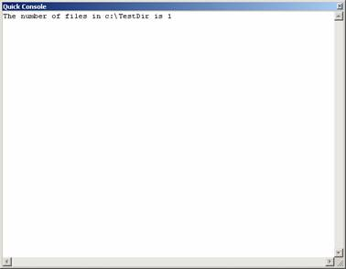

.
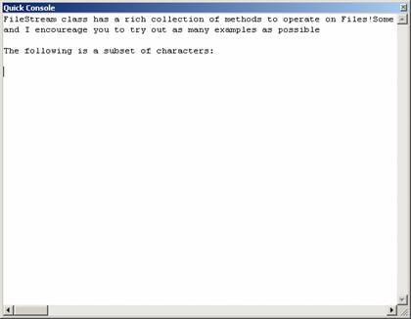

Access and Manipulate SQL Server data - Using Stored Procedures

Using Stored Procedures
Stored procedures are an important aspect in all database programs. VB.NET applications are no exceptions to this rule. Stored procedures enable users change the business logic without actually tinkering with the application. SQL Server 2005's (formerly code named Yukon) integration with the .NET CLR makes it possible for developers to author stored procedures, triggers, user defined functions, and create other database objects using a managed language such as VB.NET. This excellent feature provides a number of benefits, including increased productivity, significant performance gains, and the ability to leverage the features of .NET Code Access Security to prevent assemblies from performing certain operations.

Creating a Stored Procedure
Stored procedures for SQL Server 2005 databases can now be written in managed code. SQL Stored procedures can be created by adding Stored Procedure items to SQL Server projects. Once the stored procedure created in managed code, is deployed it can be executed like any other stored procedure. Let us understand this process by working on an example.

1. Create a new Project and

2. Choose Windows application.

3. In the solution explorer right click and add new item.

4. Choose Stored Procedure in the dialog box.
Code
Imports System
Imports System.Data
Imports System.Data.Sql
Imports System.Data.SqlServer
Imports System.Data.SqlTypes

Partial Public Class StoredProcedures

<SqlProcedure()> _
Public Shared Sub InsertPrCategoryName(ByVal CategoryName As SqlString)
Dim InsertPrCategoryCommand As SqlCommand = SqlContext.GetCommand()
InsertPrCategoryCommand.CommandText = "INSERT into Production.ProductCategory(Name) VALUES('" & NameStr & "')"
InsertPrCategoryCommand.ExecuteNonQuery()
End Sub

End Class

Access and Manipulate Data - The ADO .NET Object Model

The ADO .NET Object Model
ADO .NET renders very good support for working with disconnected data. ADO .NET 2.0 comes with additional features that enhance the performance of common database tasks. The data source window provides a centralized window for creating and configuring related objects required to access a date source. Smart tags added to the controls provide fast access to common development tasks. However all the functionalities of the ADO .NET 1.1 have also not been discarded.

.

.

.

Data Providers and Their Objects
ADO .NET is offers a highly sophisticated system to support data centric application development. The data binding in Windows Forms enables users access data from databases as well as other structures like arrays and collections. Users can bind to a wide variety of structures, from simple arrays to complex data rows and views. However, any bindable structure must support IList interface. Any object that supports IList should be capable of being bound. We shall see some of the objects that provide data.

- DataColumn object – This is the building block of the DataTable. A number of such objects make up a table. Each DataColumn object has a DataType property that determines the kind of data that the column is holding. A control can be bound simply such as a TextBox to a column within a data table
.
- Data Table – A DataTable object is the representation of a table, with rows and columns, in ADO .NET. A DataTable can be considered to a collection of two kinds viz., DataColumn objects and DataRows object. You can complex-bind a control to the information contained in a data table. Controls like DataGrid are used for this purpose
.
- DataView object – A DataView object is a customized view of a single data table that may be filtered or sorted. A data view is the data snapshot used by complex-bound controls. You can simple-bind or complex-bind to the data within the DataView. This is not an updating data source
.
- DataSet object – A DataSet is a collection of tables, relationships and constraints. You can simple-bind or complex bind to the data within the dataset.
.
- DataViewManager Object – A DataViewManager object is a customized view of the whole DataSet. It is an extended form of a DataView with realations included and with multiple tables.

The DataSet Objects
DataSets in ADO .NET are objects that store data in a memory cache, allowing access to the data even with the application disconnected from the databases. The structure of a System.Data.DataSet is similar to that of a relational database. It is organized in a hierarchical object mode of tables, rows, columns, constraints, and relationships.

A DataSet can be typed or untyped. Typed DataSets derive its table and column structure from a schema ( .XSD) file and is easier to program. Either a typed or untyped dataset can be used in applications. ADO .NET gives better support to typed datasets. A DataSet is located in System.Data NameSpace. DataSets are memory structures that do not contain any data by default. DataSets will have to be filled with data. This can be done in several ways.

1) If the DataSet was created using design-time tools, you can call the fill method of a TableAdapter. TableAdapters are created with a default Fill method but you can change the name.

2) By calling the Fill method of DataAdapter

3) Manually populate the DataSets by creating DataRow objects and call the AddNew method

4) Read an XML Document or stream into the dataset.

5) Copy the contents of one DataSet with another.

6) Copy the contents of one DataTable into a DataSet

A DataSet can store not only the data but also information about the data such as original, modified, inserted and deleted. Update of the underlying data-store is also possible. This can be done by calling the Update method of the TableDataAdapter or DataAdapter

A DataSet is typically a disconnected data-store. It does not support the idea of a current record. All the records in the DataSet are available at any time. You can access any row at any time directly. If the data is bound to one or more controls you can use the BindingNavigator to traverse the records. Some of the features of the DataSets that are based on XML.

1. The structure of a DataSet can be defined in an XML schema

2. You can generate a typed DataSet class using the schema information

3. You can read an XML document or stream into a DataSet using the ReadXml file method of DataSet and write to an XML file by calling the WriteXML method of DataSet.

4. You can create an XML view of the contents of a DataSet or DataTable.
Within a DataSet, table and column names are by default case insensitive. In contrast XML documents are case sensitive. The results of a data filter operation may return different data depending up on how the data is interpreted within the DataSet. You can have sufficient control over this by setting the DataSets CaseSensitive property. All tables in the dataset inherit the value of this property by default. This property can be overridden for each individual table by setting the tables CaseSensitive property.

A DataSet is not aware of any or all data relationships that exist in the database. The user can create DataRealtion objects that describe the relations between the tables in the DataSet. Objects of type UniqueConstraint, ForeignKeyConstraint are used to implement constraint.

Access and Manipulate Data - Using DataSets
In this tutorial you will learn about Using DataSets, Populating a DataSet From a Database, Moving Around in DataSets and Retrieving Data, Using Strongly Typed DataSets, DataSets With Multiple Tables.

Populating a DataSet from a Database
As already discussed DataSets do not contain any data when they are created. The user must fill the data in to the DataSet separately. We have already seen that there are several methods of filling a DataSet with data. DataSets can be created using the Visual Studio Design in which case TableAdapters are also created

Filling a DataSet using a TableAdapter
1. Create a new project in Visual Basic IDE.
2. On the Database Explorer click the icon for creating new data connection and
3. Choose the SQL Server file.
4. Establish the connection and you should be seeing the database objects on the window.
5. In the solution Explorer click on the project name and
6. Choose add an item option.
7. In the dialog box that opens choose DataSet item and
8. Name it as ds and click ok.
9. You will see the DataSet item added to the solution and also
10. A blank screen will be seen.
11. From the Database explorer drag and drop the table ProductCategory.
12. Choose ‘not’ in the message box that asks your permission to add the datafile as a project data.
13. Now right click on the Form1 and
14. Choose the option to see the code window.
15. Type the following codes to fill the DataSet

Dim ProductCategoryTableAdapter As New
dsTableAdapters.ProductCategoryTableAdapter()
Dim ProductCategoryDataSet As New ds
ProductCategoryTableAdapter.Fill(ProductCategoryDataSet.ProductCategory)

You can also populate a DataSet using a SqlDataAdapter or an OleDbDataAdapter . The method of doing this is same in both the cases.

We shall now see how a DataSet is filled by using a SqlDataAdapter. You have to

1. Create a SqlConnection object. SqlDatAdapter object.

2. The SqlConnection object needs connection string as an argument and the SqlDataAdapter requires the SQL Statement and Connection Object as an argument.

3. The ConnectString gives details about the Database Server, Initial Catalogue, connection type, userid and password.

4. A typical connection string could look like this:

"data source=sql.domain.no; initial catalog=xxxxx; User ID=xxxxx;pwd=xxxxx; Integrated Security=SSPI”

Code for filling the DataSet is given below:

Dim SQLStr As String
Dim ConStr As String
SQLStr = "SELECT Name FROM production.ProductCategory"
ConStr = "data source=sql.domain.no; initial catalog=xxxxx; User ID=xxxxx;pwd=xxxxx; Integrated Security=SSPI"
Dim sqlConn As New System.Data.SqlClient.SqlConnection(ConStr)
Dim ds As New DataSet
Dim SQLAdapter As New System.Data.SqlClient.SqlDataAdapter(SQLStr, ConStr)
SQLAdapter.Fill(ds)

New rows can be added manually to the data set as in the case of a data-entry. In this case the user has to first create a DataSet, a DataTabale, and a DataRow. Then he must populate the DataRow manually by supplying the value for each row and then add these rows to the DataSet. It should be remembered that there is no underlying data store that supplies data in this case. The code for the activity is given below:

Dim dsNew As New DataSet
Dim t As New DataTable
Dim tr As DataRow = dsNew.Tables("T").NewRow
tr("Name") = "Aviation Gears"
dsNew.Tables("T").Rows.Add(tr)

You can also populate a DataSet by reading from an WML file. The code listing is given below:

Dim dsXML As New DataSet()
dsXML.ReadXml("XmlFilePath and Name")

The user can also create a new DataSet and merge it with any existing DataSet. This opetaion is illustrated by the code given below:

Dim dsXML As New DataSet()
Dim dsCopy As New DataSet
dsXML.ReadXml("XmlFilePath and Name")
dsCopy.Merge(dsXML, True, MissingSchemaAction.AddWithKey)

Moving Around in DataSet and Retrieving Data
In the above sections we have seen how to create a DataSet, how to populate it etc. In the following sections we shall see how to retrieve data from a DataSet. Remember, we stated that there is no current row in a DataSet? So any row can be accessed directly by just mentioning its position? Let us add to this the fact that a DataSet can contain as many tables as required and the user can also create objects that show the relationships that exist and the constraints that are imposed on them. Thus a DataSet can be a very complex data store. Let us understand the process of navigating the DataSet by the following example.
You can write code to go to the first record of the table, go one record forward or backward and also go to the last record. We shall use the BindingContext to do this. Look at the following code:

Click here to view sample code

Retrieving data from DataSets is easy. The data in the DataSet can be displayed in a grid and a script can be written to enable the user browse through the data. The sample code illustrates this.

Imports system.Data
Public Class Form1
Dim ProductDataSet As ds

Private Sub DataLoad()
Dim ProductTableAdapter As New dsTableAdapters.ProductTableAdapter()
ProductDataSet = New ds
ProductTableAdapter.Fill(ProductDataSet.Product)
End Sub
The code that is given below will make navigation within the data set.
Code
Private Sub Form1_Load(ByVal sender As System.Object, ByVal e As System.EventArgs) Handles MyBase.Load
Me.DataLoad()
Me.DataGridView1.DataSource = ProductDataSet.Tables("Product")
Me.showCurr()
End Sub

Private Sub showCurr()
'Shows the current position of the record in binding context
Dim curPos As String
curPos = (Me.BindingContext(ProductDataSet, "Product").Position + 1).ToString _
& " of " & Me.BindingContext(ProductDataSet, "Product").Count.ToString
Label2.Text = curPos
End Sub

Private Sub moveNext()
Dim curPos As String
Me.BindingContext(ProductDataSet, "Product").Position = _
(Me.BindingContext(ProductDataSet, "Product").Position + 1)

curPos = (Me.BindingContext(ProductDataSet, "Product").Position + 1).ToString _
& " of " & Me.BindingContext(ProductDataSet, "Product").Count.ToString
Label2.Text = curPos
End Sub
Private Sub movePrevious()
Dim curPos As String
Me.BindingContext(ProductDataSet, "Product").Position = _
Me.BindingContext(ProductDataSet, "Product").Position - 1)

curPos = (Me.BindingContext(ProductDataSet, "Product").Position + 1).ToString _
& " of " & Me.BindingContext(ProductDataSet, "Product").Count.ToString
Label2.Text = curPos
End Sub
Private Sub moveFirst()
Dim curPos As String
Me.BindingContext(ProductDataSet, "Product").Position = 0
curPos = (Me.BindingContext(ProductDataSet, "Product").Position + 1).ToString _
& " of " & Me.BindingContext(ProductDataSet, "Product").Count.ToString
Label2.Text = curPos
End Sub
Private Sub moveLast()
Dim curPos As String
Me.BindingContext(ProductDataSet, "productCatogory").Position = _
Me.BindingContext(ProductDataSet, "Product").Count - 1
curPos = (Me.BindingContext(ProductDataSet, "Product").Position + 1).ToString _
& " of " & Me.BindingContext(ProductDataSet, "Product").Count.ToString
Label2.Text = curPos
End Sub

Using XML Data

XML Basics
In this section we shall see some of the features of XML with reference to the .NET Framwork. Some prior knowledge of xml is required for understanding this section. The following assemblies implement the core XML standards.:

1) System.Xml -Basci Xml Input and Output with XmlReader and XmlWriter, Dom with XmlNode and its subclasses, many utility classes
2) System.Xml.Schema - Constraint of XML via XML Schema with XmlSchemaObject and its sub classes
3) System.Xml.Serialization – Serialization to plain XMLSerializer
4) System.Xml.Xpath - Navigation of XML via XPathand XPath document, xPathDocument, XpathExpression, and XpathNavigator
5) System.Xml.Xsl - Transformation of XML document via a XSLTwith XSLTRansformation.

Most of the classes that help users work with XML are found in System.Xml NameSpace. Microsoft provides a XML parser (MSXML) while implementing DOM as against another standard based on simple API for XML which is known as SAX implementation. XMLReader is used to read XML documents and XMLWriter is used to write XML documents. Users can navigate inside the XML document by using SMLDocument and XMLNode. Users can use XMLSchema for working with XMLSchemas. XmlConvert which provide encoding and decoding features. XMLTransform class is used as a stylesheet. The most familiar object known be the DataSet.

The .NET Framework provides facilities using which users can read a xml file and store the information in a DataSet. Users can also navigate through the document and write the contents of a DataSet as a disk xml file.

Using XmlDocument Class
This class implements the W3C Document Object Model (DOM) Level 1 Core and the Core DOM Level 2. The DOM is an in-memory (cache) tree representation of an XML document and enables the navigation and editing of this document. Because XmlDocument implements the System.Xml.XPath.IXPathNavigable interface it can also be used as the source document for the System.Xml.Xsl.XslTransform class. The System.Xml.XmlDataDocument class extends XmlDocument and allows structured data to be stored, retrieved, and manipulated through a relational System.Data.DataSet. This class allows components to mix XML and relational views of the underlying data. The following example illustrates the creation of XmlDocument and also the process of using the Xpath to navigate through the xml document and extract information from the xml file. The lines of code for the program are given below:

Click here to view sample code

In the above code an object of the class XmlDocument was created. A namespace was created using the XmlNamespaceManager class. XmlNodeList was used to traverse the document and extract the information from the file.

The following screen shot show the output of the program.

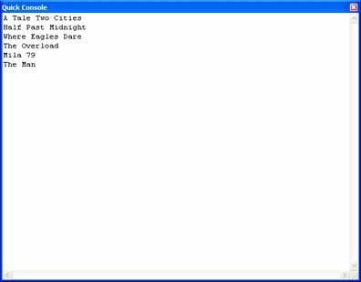

The xml File contents are given below:

Click here to view sample code

Treating XML as Relational Data
A relational database consists of a set of tables, where each table is a set of records. A record in turn is a set of fields and each field is a pair field-name/field-value. All records in a particular table have the same number of fields with the same field-names.

The Introduction:
The description of the database above suggests a simple nesting of fields inside records inside tables inside databases. Here is an example of a single database with two tables:

Click here to view sample code

The format is verbose, since XML is verbose. On the other hand, it compresses well with standard compression tools. It is also easy to print the database (or a part of it) with standard XML browsers and a simple style sheet.

The database:
A relation can be modeled as a hierarchy with a depth of four levels: the database consists of a set of tables, which in turn consist of records, which in turn consist of fields.

We can model the database with a document node and its associated element node:

name "url">
<name>
table1
table2
...
tablen
</name>

The name is arbitrary. The url is optional, but can be used to point to information about the database. The order of the tables is also arbitrary, since a relational database defines no ordering on them. Each table of the database is represented by an element node with the records as its children:

<name>
record1
record2
...
recordm
name>

The name is the name of the table. The order of the records is arbitrary, since the relational data model defines no ordering on them. A record is also represented by an element node, with its fields as children:

<name>
field1
field2
...
fieldm
name>

The name is arbitrary, since the relational data model doesn't define a name for a record type. However, in XML it cannot be omitted. One scheme is to re-use the name of the table, or, if the table has a name that is a plural, to use the singular form (`persons' -> `person', `parts' -> `part'). The order of the fields is again immaterial. A field is represented as an element node with a data node as its only child:

<name type="t">
d
name

If d is omitted, it means the value of the fields is the empty string. The value of t indicates the type of the value (such as string, number, boolean, date). [Should we give a complete list?] If the type attribute is omitted, the type is assumed to be `string.’ Null values are represented by the absence of the field. Note that this is different from leaving the field empty, which indicates that the field contains a string of length zero. Null values have special properties in relational databases. For example, two fields both with null values are not equal (in contrast to two fields with zero-length strings, which are).

Handle Data Errors

Handling Database Errors
Data Centric applications can generate many errors, the source of which lie outside the .NET application. These errors are usually generated by the database. For instance there may be a activity of insert row. If you are inserting a new row with out giving value for a row that has a not null constraint specified, then the Insert will fail. These types of errors are to be handled like any other errors by using the Try .. Catch Block. However the best practice will be to do the validations in the data-entry screens, in such a way that the errors are avoided.

The code given below shows how we can handle an error occurring when the UPDATE method of the data adapter is executed:

Sub UpdateDatabase()

Try

Me.CustomersTableAdapter.Update(Me.NorthwindDataSet.Customers)

MsgBox("Update successful")

Catch dbcx As Data.DBConcurrencyExceptionDim response As Windows.Forms.DialogResultresponse = MessageBox.Show(CreateMessage(CType(dbcx.Row, NorthwindDataSet.CustomersRow)), "Concurrency Exception", MessageBoxButtons.YesNo)ProcessDialogResult(response)

Catch ex As Exception

MsgBox("An error was thrown while attempting to update the database.")

End Try

End Sub

A message box will pop up when an error Occurs. The user can also improve the error handling method, by tweaking up the code as under:

Click here to view sample code

A message box will be used to display the different versions of the record to the user and will allow the user to choose whether to overwrite the record with the changes or cancel the edit. Once the user selects an option on the message box, the response is passed to the ProcessDialogResult method. The options given are either to overwrite the current record in the database with the proposed change or abandon the local changes and refresh the data table with the record currently in the database. If the user chooses yes, the Merge method of DataTable is called with the PreserveChanges argument set to true. This will cause the update attempt to be successful, because the original version of the record now matches the record in the database.

Handling Multi-User Errors
Concurrency violations are to be handled in the way described below:

The UPDATE the database command has to be executed from within a Try ….. Catch block. When the exception is raised, the catch statement’s Row property is to be inspected to determine the cause of the violation. At this point the code to resolve the issue is generally based on the business policy. Let us see the following lines of Code:

Try

SqlDataAdapter1.Update(myDataset)

Catch ex As DBConcurrencyException

Dim customErrorMessage As String

customErrorMessage = "Concurrency violation" & vbCrLf

customErrorMessage += CType(ex.Row.Item(0), String)

MessageBox.Show(customErrorMessage)

'Replace the above code with appropriate business logic

Finding and Sorting Data in DataSets
In this tutorial you will learn about Finding and Sorting Data in DataSets - Filtering on Row State and Version, Sorting and Data View Manager.

Finding and Sorting Data in DataSets
Using the table's Select method or the RowFilter property of a data view, the user can filter records in a data table to make available only the required records. This is useful when the user wants to work with different subsets of the records in a dataset table. To specify filter criteria, the user can use the same expression syntax used to create column expressions. The filter expression is evaluated as a Boolean expression; if the expression returns true, the record is included. A filter expression might look like the following:

Price > 10.00

Filtering on Row State and Version
A dataset can maintain different versions of records in tables. When records are first filled in, the dataset contains the original version of the record. If record is changed, the dataset maintains a different version — the current version — that reflects the changes. A property on the record indicates whether the record is unmodified, updated, new, or deleted

A common use for filters is to specify only the current versions of records in the data table. If records have been changed, there are two versions of a record--the current version reflecting the change and the original version representing the record before any changes were made. Records are also flagged according to their status: new, unchanged, deleted, or modified. A deleted record, for example, still exists in the data table, but its row-state flag has been set to deleted.

Sorting
Sorting is similar to filtering, in that you specify a sort expression. A typical sort expression is simply the name of the column to sort by. For example, to sort by the OrderDate column, the user msut specify the sort expression OrderDate. However, the user can sort by the value of any expression, including calculated values. If table's Select method is called, the sort expression is passed as a parameter. If DataViews are being used, the sort expression is to be specified as the value of the view's Sort property.

Data View Manager
Individual DataViews can be defined to sort or filter the data in each DataSet table. If the DataSet contains multiple tables, an alternative is to create a DataView manager (a DataViewManager object). The DataView manager works something like a dataset-wide data view. It provides a single object that manages a collection of DataViews, each of which is associated with a specific table in a dataset. To use a DataView manager, the user must create and configure it in code. There is no design-time object that can be added to a form or component. This means that controls are bound to the DataView manager in code, as there is no design-time component to bind them to.

The following project will illustrate the filtering and sorting of the data.

1. Create a new Windows application project.
2. Add three labels, one DataGridView, one ComboBox and a button to the Form
3. And arrange them as shown in the screenshot below
4. Now go to the codes page and add the following codes.

Click here to veiw sample code

1.2.3.4.5.6.7.8.9.10.The DataGridView before Sorting:

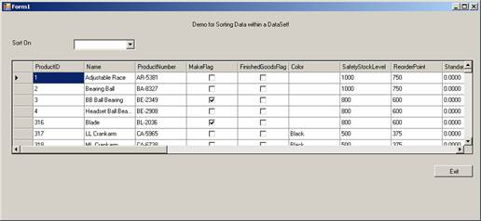

The DataGridView after sorting on Name:

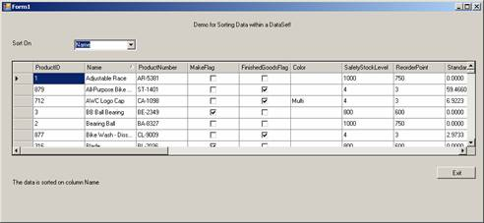

In the same way table data can be filtered. In this case all the instructions given for the above case holds good. The only change is in the EventHandler for the ComboBox. Instead of writing code for sorting, the activity for filtering will be defined. The Additional lines of code for this demo is given below:

Sub ComboBox2_SelectedIndexChanged(ByVal sender As System.Object, ByVal e As System.EventArgs) Handles ComboBox2.SelectedIndexChanged

Dim filtStr As String

filtStr = Me.ComboBox2.Text

Label3.Text = "The Data is Filtered for all Names starting with alphabet " & filtStr

dv.RowFilter = "Name like '" & filtStr & "*'"

End Sub

Now press F5 to execute the program. The screenshot given below shows the initial Screen.

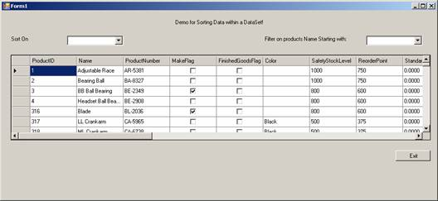

The Screenshot Below shows the Screen With filtered data:

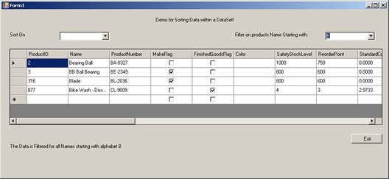

Editing Data With ADO .NET
In this tutorial you will learn about Editing Data With ADO .NET - Updating Data, Adding Data, Typed data set, Untyped data set, Deleting Data, Editing with a DataGrid.

Updating Data
The SqlDataAdapter’s update method is called whenever the changes made to a DataSet has to be applied to the underlying table. The SqlDataAdapter is instantiated using eh SELECT statement and the compiler generates the statements for UPDATE, INSERT and DELETE. The changes made to the DataSet are then applied to the Database. However considerations for automatic update will fail if there is no primary key assigned to the data in the Database. The update is also likely to fail if the AcceptChanges method of the DataSet is called before the Update method of the SqlDataAdapter is called. The dataset maintains the row versions like Deleted rows, modified rows, inserted row and so on. When the UPDATE method is called this version information is used to update the relevant changes to the database. The AcceptChanges method removes all the versions and hence the UPDATE will fail. AcceptChanges is usually called after Update method.

The Update method of the Adapter will be called within a Try Catch block. When two tables are updated in a dataset, the following sequence is advised as a best practice:

(a) Update Child table – Delete records. The code sample is given below

(b) Dim DeletedChildRecords as DataTable = _

(c) DSet.Table.GetChanges(DataRowState.Deleted) DataAdapter.Update(DeletedChildRecords)

(d) Parent Table – Insert, Update, and delete records

(e) Child Table – Insert and update records.

Adding Data
Adding new rows to the DataSet can be performed in any one of the following methods:

Typed data set
Dim newCustomersRow as DataSetClass.Customers.CustomersRow

newCustomersRow = DataSetInstance.Customers.NewCustomersRow()

newCustomersRow.CustomerID = "ALFKI"

newCustomersRow.CompanyName = "Alfreds Futterkiste"

DataSetInstance.Customers.Rows.Add(newCustomersRow)

Untyped data set
Dim newCustomersRow As DataRow = DataSet1.Tables("Customers").NewRow()

newCustomersRow("CustomerID") = "ALFKI"

newCustomersRow("CompanyName") = "Alfreds Futterkiste"

DataSet1.Tables("Customers").Rows.Add(newCustomersRow)

Deleting Data
In order to retain the information that the dataset needs to send updates to the data source, the System.Data.DataRow.Delete method is used to remove rows in a data table. For example, if the application uses a TableAdapter (or DataAdapter), the adapter's Update method will delete rows in the database that have a RowState of DataRowState.Deleted.
If the application does not need to send updates back to a data source, then it is possible to remove records by directly accessing the data row collection DataRowCollection.Remove

To delete records from a data table call the DataRow.Delete method of a DataRow. This method does not physically remove the record; instead, it marks the record for deletion.

If the count property of a DataRowCollection is obtained, the resulting count includes records that have been marked for deletion. To get an accurate count of only records that are not marked for deletion, the user can loop through the collection looking at the RowState property of each record (records marked for deletion have a RowState of DataRowState.Deleted).

The following line of code is used to delete nth row.

DataSetXX.TableYYY.Rows(n).Delete()

Editing with a DataGrid
A DataGrid can be edited using the BeginEdit and EndEdit methods of the DataGrid. The following illustration clarifies the concepts of editing a DataGrid.

1. Identify the current cell by its ColumnNumber and RowNumber properties and call the method BeginEdit of the DataGrid .
2. Create the DataTable and DataRow Objects.
3. Assign the edited values to the DataRow.
4. Accept changes by calling the AcceptChanges method of DataRow.
5. Call the EndEdit method of the DataGrid.
Code
Private Sub EditGrid(dataGrid1 As DataGrid)
' Get the selected row and column through the CurrentCell.
Dim colNum As Integer
Dim rowNum As Integer
colNum = dataGrid1.CurrentCell.ColumnNumber
rowNum = dataGrid1.CurrentCell.RowNumber
' Get the selected DataGridColumnStyle.
Dim dgCol As DataGridColumnStyle
dgCol = dataGrid1.TableStyles(0).GridColumnStyles(colNum)
' Invoke the BeginEdit method to see if editing can begin.
If dataGrid1.BeginEdit(dgCol, rowNum) Then
' Edit row value. Get the DataTable and selected row.
Dim myTable As DataTable
Dim myRow As DataRow
' Assuming the DataGrid is bound to a DataTable.
myTable = CType(dataGrid1.DataSource, DataTable)
myRow = myTable.Rows(rowNum)
' Invoke the Row object's BeginEdit method.
myRow.BeginEdit()
myRow(colNum) = "New Value"
' You must accept changes on both DataRow and DataTable.
myRow.AcceptChanges()
myTable.AcceptChanges()
dataGrid1.EndEdit(dgCol, rowNum, False)
Else
Console.WriteLine("BeginEdit failed")
End If
End Sub 'EditGrid

Web Services - SOAP, WSDL, Disco and UDDI

Understanding Web Services
Interconnectedness engendered by the World Wide Web has created a pressure to create applications that are interoperable and distributable over the network. The direction of effort is towards creating applications that connect to each other regardless of the language or platform in which the application was created.

Web services are externally exposed systems that allow applications to talk to each other and share information over a network. The web service standards are built upon other standards such as HTTP or XML and are not reliant upon any proprietary systems. The Web service is itself a collection of methods that can be called from a remote location so that these methods accept and return parameters and provide for a wide variety of functionalities that can be used internally in the application that is exposed to the public.

The concept behind web services is not new. The ad hoc methods of tying applications together have merely given place to organized methods of communications between applications. Standardized specifications have also lowered costs and shortened development timelines.

Prior to the emergence of Visual Studio.NET in the market a number of technologies attempted to cater to the needs of the Web based world. Let us briefly look at the various technologies that tried to address these issues.

SOAP
Simple Object Access Protocol (SOAP) is a protocol that uses the XML to describe the data and Hyper Text Transfer Protocol (HTTP) to transmit application data. The Web Service and the client application must agree upon a common protocol to facilitate communication. SOAP is a standard communication protocol for interchanging information in a structured format in a distributed environment. Messaging is an example of information exchange between a client and a web service. The calls made by a client application to a web method and the data returned by a web method to the client are the messages that are actually exchanged. A SOAP packet is created when a web client makes a call to the web method. This message contains the name of the web method and the parameters that are needed for making a call to the web method in XML format. The Web method is invoked based on the information available in the SOAP Packet

The System.Runtime.Serialization.Formatters.Soap namespace contains the System.Runtime.Serialization.Formatters.Soap.SoapFormatter class, which can be used to serialize and de-serialize objects in the SOAP format. When building applications that uses the types in this namespace, a reference must be made to the System.Runtime.Serialization.Formatters.Soap.dll assembly. The COM+ SOAP service permits the publishing of a component as a XML Web Service. Clients can continue to access the component using previous methods, but the component is also accessible using WSDL (Web Services Description Language) and SOAP. We will see more of SOAP usage later in the lesson.

Disco and UDDI
The Web Service Discovery Tool (DISCO) is used to discover the URLs of XML Web Services located on a Web server and saves documents related to each XML service on a local disk. The DISCO takes the URL and discovers and produce publishes discovery documents (.wsdl, .xsd, .disco and .dicomap files) as arguments. Some of the options available for use with this tool are:

/d[omain]:domain | Specifies the domain name to use when connecting to a proxy server that requires authentication
/nosave | Does not save the discovered document or results
/nologo | Suppresses the Microsoft startup banner display  /o[ut]:directoryName  Specifies the output directory in which to save the discovered documents. Current directory is the default one.
/p[assword]:password
Specifies the password to use when connecting to a proxy server

/proxy:url
Specifies the URL of the proxy server to use for HTTP requests.

The following command is an example of how the tool can be used to search a specified URL for the discovery of documents. The documents are then saved to the current directory. It will throw an error message if it cannot find discoverable documents at the URL specified.

disco http://www.vbdotnetlearning.com/selflearningservie.disco

To specify a directory to save the documents you can use the /out option as shown below:

disco /out:VBtutorial http://www.vbdotnetlearning.com

Universal Description, Discovery and Integration (UDDI) is a platform independent framework functioning like a directory that provides a mechanism to locate and register web services on the internet. The web service provider makes the web service available to the consumer by describing the web service using a WDSL document and then registering the Web service in the UDDI Directory. The UDDI Directory contains pointers to the Web service and the WDSL document for the Web service. After this is done the Client Applications can discover the Web service using the UDDI Directory. The UDDI specification calls for three elements as given below:

WSDL
Web Service Discovery Language (WSDL) is a markup language that describes the web service. In order to use this Web service, the Client application developers need to know the methods exposed by the Web service and the parameters to be passed to these methods. It is imperative that access to these methodologies is available at development time and it is just this need that WSDL addresses. A typical WSDL document provides the following information to the developer:

VB.NET 2005 Tutorials: Instantiating - Invoking Web Services, and Creating Proxy Classes with WSDL

Using the Web Services Discovery Tool (disco.exe)
Now that we have created a web service, we will use the disco.exe tool to discover it. To direct the tool to locate the service the syntax to be used is as under. This command has to be entered in the .NET framework command prompt.

disco /nosave http:vbdotnet/service.asmx

The output is also generated on to this screen.

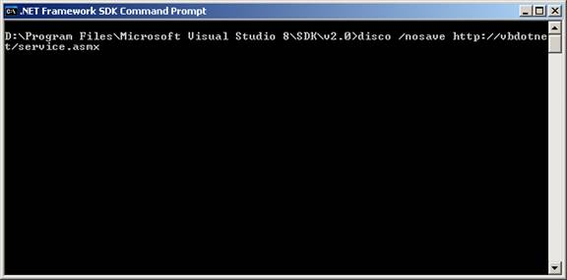

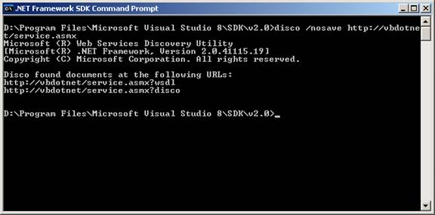

The results can be saved to a directory on the user’s computer. The process of saving is illustrated below.

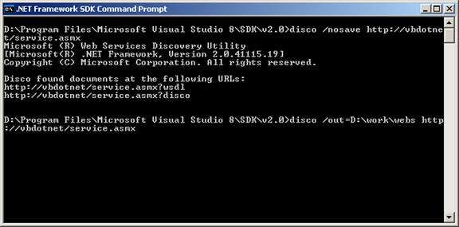

The result produced is shown below:

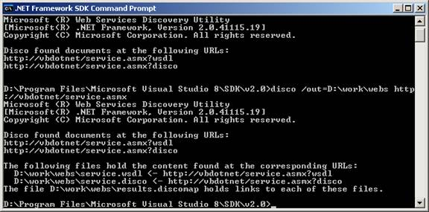

Instantiating and Invoking Web Services

Creating Proxy Classes with the Web Services Description Language Tool (wsdl.exe)
The .NET Framework provides wsdl.exe tool to parse Web service descriptions and generate proxy classes, which can be used by a consumer to call methods on a Web service. The out put generated can be of any of the forms given below:

.wsdl files
.xsd files
.disco files
.discomap files.

Note that the outputs are generated by disco tool. Both disco.exe and wsdl.exe are located in the same place. Just like the disco tool, wsdl.exe is also a command line application. The format for the command is given below:

Wsdl [options] {URL | Path }

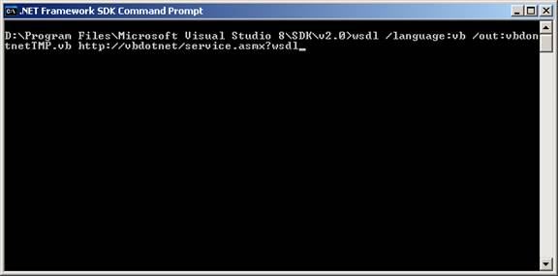

The application responds by writing to the disc file and the result is shown below:

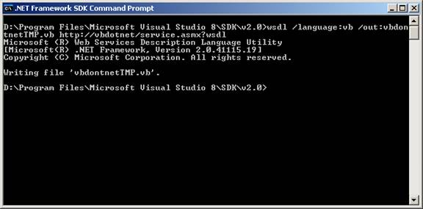

The lines of code generated by the console application wsdl.exe are given below:
Code
'------------------------------------------------------------------------------
' <autogenerated>
' This code was generated by a tool.
' Runtime Version:2.0.41115.19
'
' Changes to this file may cause incorrect behavior and will be lost if
' the code is regenerated.
' </autogenerated>
'------------------------------------------------------------------------------

Option Strict Off
Option Explicit On

Imports System
Imports System.ComponentModel
Imports System.Diagnostics
Imports System.Web.Services
Imports System.Web.Services.Protocols
Imports System.Xml.Serialization

'
'This source code was auto-generated by wsdl, Version=2.0.41115.19.
'

'''<remarks/>
<System.Diagnostics.DebuggerStepThroughAttribute(), _
System.ComponentModel.DesignerCategoryAttribute("code"), _
System.Web.Services.WebServiceBindingAttribute(Name:="ServiceSoap", [Namespace]:="http://vbdotnet/")> _
Partial Public Class Service
Inherits System.Web.Services.Protocols.SoapHttpClientProtocol

Private FahrenheitToCelsiusOperationCompleted As System.Threading.SendOrPostCallback

Private CelsiusToFahrenheitOperationCompleted As System.Threading.SendOrPostCallback

'''<remarks/>
Public Sub New()
MyBase.New
Me.Url = "http://vbdotnet/service.asmx"
End Sub

'''<remarks/>
Public Event FahrenheitToCelsiusCompleted As FahrenheitToCelsiusCompletedEventHandler

'''<remarks/>
Public Event CelsiusToFahrenheitCompleted As CelsiusToFahrenheitCompletedEventHandler

'''<remarks/>
<System.Web.Services.Protocols.SoapDocumentMethodAttribute("http://vbdotnet/FahrenheitToCelsius", RequestNamespace:="http://vbdotnet/", ResponseNamespace:="http://vbdotnet/", Use:=System.Web.Services.Description.SoapBindingUse.Literal, ParameterStyle:=System.Web.Services.Protocols.SoapParameterStyle.Wrapped)> _
Public Function FahrenheitToCelsius(ByVal Fahrenheit As Double) As Double
Dim results() As Object = Me.Invoke("FahrenheitToCelsius", New Object() {Fahrenheit})
Return CType(results(0),Double)
End Function

'''<remarks/>
Public Function BeginFahrenheitToCelsius(ByVal Fahrenheit As Double, ByVal callback As System.AsyncCallback, ByVal asyncState As Object) As System.IAsyncResult
Return Me.BeginInvoke("FahrenheitToCelsius", New Object() {Fahrenheit}, callback, asyncState)
End Function

'''<remarks/>
Public Function EndFahrenheitToCelsius(ByVal asyncResult As System.IAsyncResult) As Double
Dim results() As Object = Me.EndInvoke(asyncResult)
Return CType(results(0),Double)
End Function

'''<remarks/>
Public Overloads Sub FahrenheitToCelsiusAsync(ByVal Fahrenheit As Double)
Me.FahrenheitToCelsiusAsync(Fahrenheit, Nothing)
End Sub

'''<remarks/>
Public Overloads Sub FahrenheitToCelsiusAsync(ByVal Fahrenheit As Double, ByVal userState As Object)
If (Me.FahrenheitToCelsiusOperationCompleted Is Nothing) Then
Me.FahrenheitToCelsiusOperationCompleted = AddressOf Me.OnFahrenheitToCelsiusOperationCompleted
End If
Me.InvokeAsync("FahrenheitToCelsius", New Object() {Fahrenheit}, Me.FahrenheitToCelsiusOperationCompleted, userState)
End Sub

Private Sub OnFahrenheitToCelsiusOperationCompleted(ByVal arg As Object)
If (Not (Me.FahrenheitToCelsiusCompletedEvent) Is Nothing) Then
Dim invokeArgs As System.Web.Services.Protocols.InvokeCompletedEventArgs = CType(arg,System.Web.Services.Protocols.InvokeCompletedEventArgs)
RaiseEvent FahrenheitToCelsiusCompleted(Me, New FahrenheitToCelsiusCompletedEventArgs(invokeArgs.Results, invokeArgs.Error, invokeArgs.Cancelled, invokeArgs.UserState))
End If
End Sub

'''<remarks/>
<System.Web.Services.Protocols.SoapDocumentMethodAttribute("http://vbdotnet/CelsiusToFahrenheit", RequestNamespace:="http://vbdotnet/", ResponseNamespace:="http://vbdotnet/", Use:=System.Web.Services.Description.SoapBindingUse.Literal, ParameterStyle:=System.Web.Services.Protocols.SoapParameterStyle.Wrapped)> _
Public Function CelsiusToFahrenheit(ByVal Celsius As Double) As Double
Dim results() As Object = Me.Invoke("CelsiusToFahrenheit", New Object() {Celsius})
Return CType(results(0),Double)
End Function

'''<remarks/>
Public Function BeginCelsiusToFahrenheit(ByVal Celsius As Double, ByVal callback As System.AsyncCallback, ByVal asyncState As Object) As System.IAsyncResult
Return Me.BeginInvoke("CelsiusToFahrenheit", New Object() {Celsius}, callback, asyncState)
End Function

'''<remarks/>
Public Function EndCelsiusToFahrenheit(ByVal asyncResult As System.IAsyncResult) As Double
Dim results() As Object = Me.EndInvoke(asyncResult)
Return CType(results(0),Double)
End Function

'''<remarks/>
Public Overloads Sub CelsiusToFahrenheitAsync(ByVal Celsius As Double)
Me.CelsiusToFahrenheitAsync(Celsius, Nothing)
End Sub

'''<remarks/>
Public Overloads Sub CelsiusToFahrenheitAsync(ByVal Celsius As Double, ByVal userState As Object)
If (Me.CelsiusToFahrenheitOperationCompleted Is Nothing) Then
Me.CelsiusToFahrenheitOperationCompleted = AddressOf Me.OnCelsiusToFahrenheitOperationCompleted
End If
Me.InvokeAsync("CelsiusToFahrenheit", New Object() {Celsius}, Me.CelsiusToFahrenheitOperationCompleted, userState)
End Sub

Private Sub OnCelsiusToFahrenheitOperationCompleted(ByVal arg As Object)
If (Not (Me.CelsiusToFahrenheitCompletedEvent) Is Nothing) Then
Dim invokeArgs As System.Web.Services.Protocols.InvokeCompletedEventArgs = CType(arg,System.Web.Services.Protocols.InvokeCompletedEventArgs)
RaiseEvent CelsiusToFahrenheitCompleted(Me, New CelsiusToFahrenheitCompletedEventArgs(invokeArgs.Results, invokeArgs.Error, invokeArgs.Cancelled, invokeArgs.UserState))
End If
End Sub

'''<remarks/>
Public Shadows Sub CancelAsync(ByVal userState As Object)
MyBase.CancelAsync(userState)
End Sub
End Class

'''<remarks/>
Public Delegate Sub FahrenheitToCelsiusCompletedEventHandler(ByVal sender As Object, ByVal args As FahrenheitToCelsiusCompletedEventArgs)

'''<remarks/>
Partial Public Class FahrenheitToCelsiusCompletedEventArgs
Inherits System.ComponentModel.AsyncCompletedEventArgs

Private results() As Object

Friend Sub New(ByVal results() As Object, ByVal exception As System.Exception, ByVal cancelled As Boolean, ByVal userState As Object)
MyBase.New(exception, cancelled, userState)
Me.results = results
End Sub

'''<remarks/>
Public ReadOnly Property Result() As Double
Get
Me.RaiseExceptionIfNecessary
Return CType(Me.results(0),Double)
End Get
End Property
End Class

'''<remarks/>
Public Delegate Sub CelsiusToFahrenheitCompletedEventHandler(ByVal sender As Object, ByVal args As CelsiusToFahrenheitCompletedEventArgs)

'''<remarks/>
Partial Public Class CelsiusToFahrenheitCompletedEventArgs
Inherits System.ComponentModel.AsyncCompletedEventArgs

Private results() As Object

Friend Sub New(ByVal results() As Object, ByVal exception As System.Exception, ByVal cancelled As Boolean, ByVal userState As Object)
MyBase.New(exception, cancelled, userState)
Me.results = results
End Sub

'''<remarks/>
Public ReadOnly Property Result() As Double
Get
Me.RaiseExceptionIfNecessary
Return CType(Me.results(0),Double)
End Get
End Property
End Class

Creating Web Service

Category: VB.NET 2005
Comments (1)

Creating Web Service Project
In this tutorial you will learn about Creating a Web Service Project.

Creating Web Services

Creating a Web Service Project
Purpose: To create an XML Web service project and thereby separate the functionality of the web service from the web site:

1. On the File menu, point to New, and then click Web Site.

2. In the New Web Site dialog box, select the ASP.NET Web Service icon.

3. Enter the address of the Web server on which you will develop the XML Web service. Use http//localhost to create the new site as shown in the screenshot below:

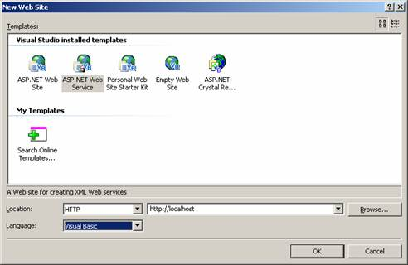

If the web service project is being created within an already existing website then the user will be prompted to confirm whether the files at the location will have to be overwritten. Since our project is new, this dialog will not appear on our example.
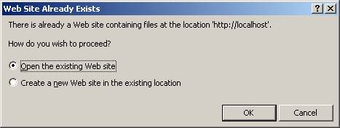

If your web site is not configured for asp.net 2.0 then the user will have one more dialog like the one shown below:

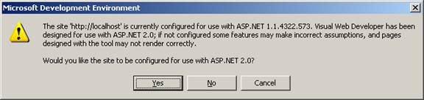

The user may choose yes in both cases or make a decision based on facts. For the current project the user will click YES.
Visual Studio automatically creates the necessary files and references to support an XML Web services. Right click on the solution in the solution explorer and choose new item on the context menu. In the dialog box that appears choose WebService. This shown below:

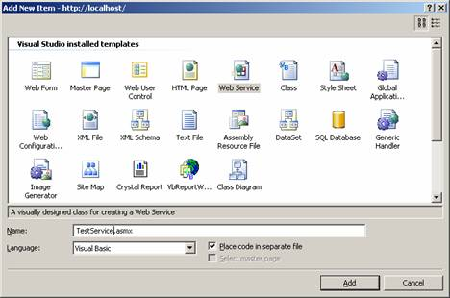

The Web service is created and the code for this is given below:

WebService Language="VB" CodeBehind="~/Application_Code/TestService.vb" Class="TestService" % >

The CodeBehind file that contains the codes for the Web Service is automatically created by the Visual Studio. The codes generated are given below:

Click here to view sample code

Public methods codes can be added to methods within the Web service class to expose the functionality of some activity to other applications.

Once this is done the Web service has been successfully created and the user can browse the URL. The screenshot below will appear on the user’s computer monitor.

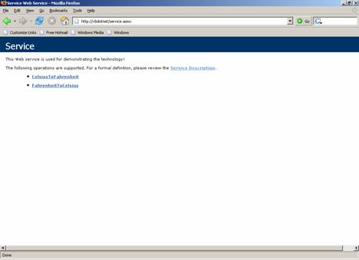

The description of the service will be as under:

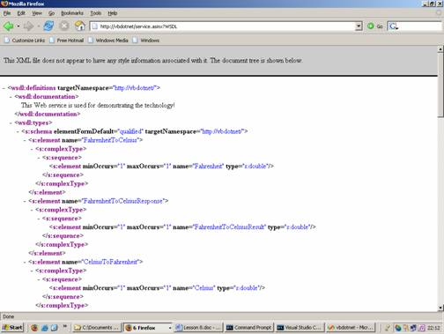

The SOAP request and post information is shown below:

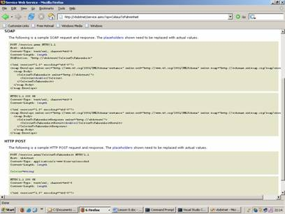

VB.NET 2005 Tutorials : Web Reference, ASP.NET Web Application and XML Web Service

Using Web Reference
A Web reference is a generated proxy class that locally represents the exposed functionality of an XML web service. The proxy class defines methods that represent the actual methods exposed by an XML web service. When the client application creates an instance of the proxy class, it is capable of calling the XML Web service methods as if the XML Web service were a locally available component. The programming language the proxy class is generated, is dependent upon the programming language of the active project to which the Web reference is added. However if you created a proxy using the tool wsdl.exe, you have the option to provide the program language.

At design time, the added reference enables the developer use the statement completion in the code editor using the IntelliSense. The actual implementation of the methods in the proxy class is comprised of code to package and send SOAP request message and to receive and un package any returned SOAP response message.

At run time, a call to a method of the proxy object is processed and encoded as a SOAP request message if the SOAP protocol is supported. If the XML Web service does not support SOAP, the proxy uses HTTP POST or HTTP GET. This message is then sent to the actual Web Service for processing.

Adding a Web reference:
a.Testing a Web Service
- Create a client application using the ASP.NET Web Application project template.
- Add a Web reference for an XML Web service.
- Write code to access the XML Web service.
- Run the Web application in debug mode.
- Deploy the Web application.
If the name of the temperature conversion XML Web service was changed after creation substitute the appropriate names where the TempConvert1 name appears throughout this walkthrough.

To create an ASP.NET Web application
1.File menu, choose New Web Site.
2.New Web Site dialog box, select the ASP.NET Web Site icon.
3.http://vbdotnet/client .By default, the project uses your local machine, http://localhost.
4.OK to create the project.
5.Solution Explorer, right-click Default.aspx and choose View Designer to open the designer.
6.Web Forms tab of the Toolbox, drag a Text Box, five Labels, and a Button to the design surface of Default.aspx and arrange them to your liking.
7.Button1, and click Properties on the shortcut menu. In the Properties window, set the Text property to Convert.
8.Label1, and click Properties on the shortcut menu. In the Properties window, clear the Text property to make this a blank label.

Adding a Web Reference
1.Website menu, choose Add Web Reference.
2.URL box of the Add Web Reference dialog box, type the URL to obtain the service description of the XML Web service you want to access, such as http://vbdotnet/Service.asmx. Then click the Go button to retrieve information about the XML Web service.

Visual Studio downloads the service description and generates a proxy class to interface between your application and the XML Web service.

Accessing the XML Web Service
Once a reference for the XML Web service is added to the project, the next step is to create an instance of the XML Web service's proxy class. The user can then access the methods of the XML Web service in the same manner that he accesses any object's methods by calling methods in the proxy class. When the application calls these methods, the proxy class code generated by Visual Studio handles the communications between the application and the XML Web service.

a.TextBox1, and make a call to the XML Web service's ConvertTemperature method using the proxy class.
c.To access the XML Web service
1.Convert button on WebForm1.aspx to create an event-handling method for this button and to display the code-behind file.
2.

Class Default_aspx

Inherits System.Web.UI.Page

Protected Sub Button1_Click(ByVal sender As Object, ByVal e As System.EventArgs) Handles Button1.Click

Dim wsConvert As New vbdotnet.Service()

Dim temperature As Double

Try

temperature = Convert.ToDouble(TextBox1.Text)

Label2.Text = _

wsConvert.FahrenheitToCelsius(temperature).ToString()

Label5.Text = _

wsConvert.CelsiusToFahrenheit(temperature).ToString()

Catch

End Try

End Sub

Class

The name of the XML Web service class generated when adding a Web reference may differ from the one shown above as Service.
3.Default.aspx in Solution Explorer.
4.Website menu, click Set as Start Page.
5.Now open the site http://vbdotnet/client/default.aspx in a browser. The site in the browser looks like the graphic shown below:

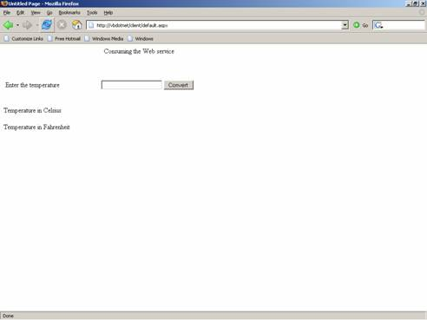

A value can be entered in the text box. This value is passed to the two methods defined in the web service. The value is considered as Fahrenheit and changed to Celsius by one method and vice versa in the other method. Now enter a value 200 in the text box and find the result:

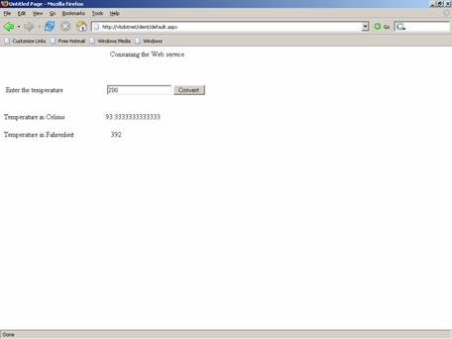

In this lesson we have covered all aspects of using Web services in the .NET framework. We have learnt how to create and deploy a web service. In the next lesson we shall look at some of the aspects of testing and debugging a Web application.

VB.NET 2005 Turorials : Testing a Web Application
In this tutorial you will learn about Testing a Web Application, Configuring ASP.NET Unit Tests Using Run Configuration, Creating and Removing Run Configurations, Subsequent run configurations, removing run configuration and editing run configuration.

An application is software is created to function efficiently given the necessary parameters. Developers are conscious that, even in the most efficiently created software, errors of a certain nature can occur and must be provided for at design time. Yet other errors could occur at runtime and therefore applications need to be tested and debugged at runtime too. Therefore testing and debugging applications are an important part of application development. Visual Studio.NET provides the developer with several tools that he can use for testing and debugging the applications within the Integrated development environment (IDE).

The number of ways in which the application can be tested and debugged in Visual studio.NET demands that the user create a test plan beforehand. The developer can add a test project. He can test for performance, international settings or an existing test can be opened. To this end he must chalk out:

1. What kind of tests are to be created?

2. What is the type of load test that will be required?

3. Will the developer be required to execute a manual test?

4. How will the tests be managed?

5. What will be measured in the test--functionality, validation, performance or others?

Once the test plan has been created unit tests can be executed.

Let us presume that we have a project that has both public methods and private methods. The project has to be opened and we have to create unit tests for public and private methods. The next task is to run the tests on the projects code; find and correct the errors.

ASP .NET test projects can be created in any of the two ways mentioned below:

(1) By generating the ASP.NET unit test.

(2) By configuring an existing unit test as an ASP.NET unit test.

Generating an ASP.NET Unit Test
1. Create an ASP.NET Web site within the Visual Studio solution.

2. Add a class to the Web site project, and

3. Finally, generate a unit test from that class.

4. We will use the existing Website to provide support for this.

5. Add a class to this project. To do this, in Solution Explorer, right-click the Web site and then click Add New Item.

6. In the Add New Item dialog box, click Class, and then click Add.

7. In the resulting Microsoft Visual Studio dialog box, click Yes.

Now we will generate an ASP.NET unit test.

(1) To do this, first open the new class file by double-clicking it in Solution Explorer.

(2) Right-click within the class in the class file. In the context menu and click on “Create Tests.”

(3) In the Unit Test Generation dialog box, click Generate.

The new ASP.NET unit test is added to a file in your test project.

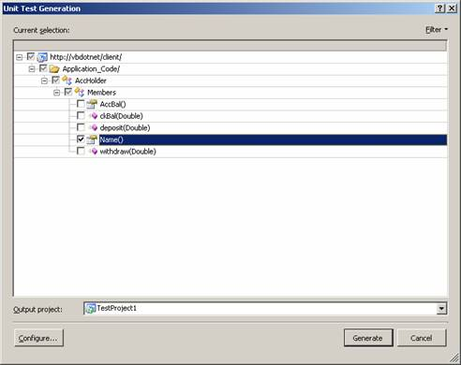

To see the unit test, open the test file and scroll to the end. The attributes that are necessary to run a unit test as an ASP.NET unit test have been automatically set. The content of the test file is given below:
Code
<?xml version="1.0" encoding="utf-8"?>
<Tests>
<TestRunConfiguration type="Microsoft.VisualStudio.QualityTools.Common.TestRunConfiguration, Microsoft.VisualStudio.QualityTools.Common, Version=8.0.1200.0, Culture=neutral, PublicKeyToken=b03f5f7f11d50a3a">
<id type="Microsoft.VisualStudio.QualityTools.Common.TestRunConfigurationId, Microsoft.VisualStudio.QualityTools.Common, Version=8.0.1200.0, Culture=neutral, PublicKeyToken=b03f5f7f11d50a3a">
<id type="System.Guid">1ed13b4a-9def-40a9-b12b-386b0bfa3598</id>
</id>
<name type="System.String">Local Test Run</name>
<description type="System.String">This is a template for test run configuration.</description>
<isCodeCoverageEnabled type="System.Boolean">False</isCodeCoverageEnabled>
<codeCoverageItems type="System.Collections.Generic.List`1[[Microsoft.VisualStudio.QualityTools.Common.CodeCoverageItem, Microsoft.VisualStudio.QualityTools.Common, Version=8.0.1200.0, Culture=neutral, PublicKeyToken=b03f5f7f11d50a3a]]">
<_size type="System.Int32">0</_size>
<_version type="System.Int32">0</_version>
</codeCoverageItems>
<aspNetProjectCoverageItems type="System.Collections.Generic.List`1[[Microsoft.VisualStudio.QualityTools.Common.AspNetProjectItem, Microsoft.VisualStudio.QualityTools.Common, Version=8.0.1200.0, Culture=neutral, PublicKeyToken=b03f5f7f11d50a3a]]">
<_size type="System.Int32">0</_size>
<_version type="System.Int32">0</_version>
</aspNetProjectCoverageItems>
<isExecutedRemotely type="System.Boolean">False</isExecutedRemotely>
<controllerName type="System.String" />
<plugins type="System.Collections.Generic.List`1[[System.String, mscorlib, Version=2.0.3600.0, Culture=neutral, PublicKeyToken=b77a5c561934e089]]">
<_size type="System.Int32">0</_size>
<_version type="System.Int32">0</_version>
</plugins>
<testTypeSpecificData type="System.Collections.Generic.Dictionary`2[[Microsoft.VisualStudio.QualityTools.Common.TestType, Microsoft.VisualStudio.QualityTools.Common, Version=8.0.1200.0, Culture=neutral, PublicKeyToken=b03f5f7f11d50a3a],[Microsoft.VisualStudio.QualityTools.Common.ITestTypeSpecificRunConfigurationData, Microsoft.VisualStudio.QualityTools.Common, Version=8.0.1200.0, Culture=neutral, PublicKeyToken=b03f5f7f11d50a3a]]">
<count type="System.Int32">0</count>
<version type="System.Int32">0</version>
<freeList type="System.Int32">0</freeList>
<freeCount type="System.Int32">0</freeCount>
<comparer type="System.Collections.Generic.ObjectComparer`1[[Microsoft.VisualStudio.QualityTools.Common.TestType, Microsoft.VisualStudio.QualityTools.Common, Version=8.0.1200.0, Culture=neutral, PublicKeyToken=b03f5f7f11d50a3a]]" />
</testTypeSpecificData>
<userDeploymentRoot type="System.String" />
<useDefaultDeploymentRoot type="System.Boolean">True</useDefaultDeploymentRoot>
<relativePathRoot type="System.String">C:\Documents and Settings\peter\My Documents\Visual Studio\Projects\client\</relativePathRoot>
<deploymentItems type="Microsoft.VisualStudio.QualityTools.Common.DeploymentItemCollection, Microsoft.VisualStudio.QualityTools.Common, Version=8.0.1200.0, Culture=neutral, PublicKeyToken=b03f5f7f11d50a3a" />
<testRunNamingScheme type="Microsoft.VisualStudio.QualityTools.Common.TestRunNamingScheme, Microsoft.VisualStudio.QualityTools.Common, Version=8.0.1200.0, Culture=neutral, PublicKeyToken=b03f5f7f11d50a3a">
<appendTimeStamp type="System.Boolean">True</appendTimeStamp>
<useDefault type="System.Boolean">True</useDefault>
</testRunNamingScheme>
<setupCommand type="System.String" />
<cleanupCommand type="System.String" />
<abortRunOnError type="System.Boolean">False</abortRunOnError>
<mapIPAddresses type="System.Boolean">False</mapIPAddresses>
<isExecutedOutOfProc type="System.Boolean">True</isExecutedOutOfProc>
<ignorePerTestAgentProperties type="System.Boolean">False</ignorePerTestAgentProperties>
<agentProperties type="System.Collections.Specialized.StringDictionary, System, Version=2.0.3600.0, Culture=neutral, PublicKeyToken=b77a5c561934e089" />
<hostData type="Microsoft.VisualStudio.QualityTools.Common.HostRunConfigurationData, Microsoft.VisualStudio.QualityTools.Common, Version=8.0.1200.0, Culture=neutral, PublicKeyToken=b03f5f7f11d50a3a">
<mapHostSpecificData type="System.Collections.Generic.Dictionary`2[[System.String, mscorlib, Version=2.0.3600.0, Culture=neutral, PublicKeyToken=b77a5c561934e089],[Microsoft.VisualStudio.QualityTools.Common.IHostSpecificRunConfigurationData, Microsoft.VisualStudio.QualityTools.Common, Version=8.0.1200.0, Culture=neutral, PublicKeyToken=b03f5f7f11d50a3a]]">
<count type="System.Int32">0</count>
<version type="System.Int32">0</version>
<freeList type="System.Int32">0</freeList>
<freeCount type="System.Int32">0</freeCount>
<comparer type="System.Collections.Generic.GenericComparer`1[[System.String, mscorlib, Version=2.0.3600.0, Culture=neutral, PublicKeyToken=b77a5c561934e089]]" />
</mapHostSpecificData>
</hostData>
<ignoredDependentAssemblies type="System.String" />
<apartmentState type="System.Threading.ApartmentState">
<value__ type="System.Int32">0</value__>
</apartmentState>
</TestRunConfiguration>
</Tests>

Deploying Windows Applications
In this tutorial you will learn how to Deploy a Windows-based Application, Create a Setup Project, Configuring Deployment Properties, Customizing a Setup Project, File System Editor, The Registry Editor, The File Types Editor, The User Interface Editor, The Custom Actions Editor and The Launch Conditions Editor

A number of different methodologies for deploying Windows based applications have been available since the first version of Visual Basic. In this lesson we shall briefly discuss the different technologies available and the evolution of this technology leading up to the creation of ClickOnce.

Windows Forms have traditionally been deployed in two ways—using the XCOPY deployment or the Windows installer.

XCOPY deployment describes an ideal deployment scenario that enables the copying of an entire directory structure to a computer on which the program is to be run. However, the current windows applications cannot be deployed in this manner as the installation process is a multi-step one. For instance applications using COM will have to copy the component to the user machine, register it, create dependencies between the component and the registry and then activate it.

Even simple applications would require other dependencies to be defined. The CLR, which tries to overcome the problem of coupling the registry with the component, has not completely eliminated the issue of multi-step deployment. Runtime issues, such as what files are required at runtime, also retard the achievement of the ideal.

The Windows Installer service, introduced as part of the Windows 2000 addressed some of the problems of existing installation programs. It is freely available to all Win9X and NT 4 platforms and is automatically installed with a number of Microsoft applications.

It is an Operating system component that implements all the required rules of setup and creates a file called a Windows installer package file(.msi). It divides the application in terms of the product to be installed, the feature (a unit of the product) to be installed and the component to be installed. This installer can be a single file or multiple files belonging together logically. The Windows Installer package file contains a list of actions and rules that need to be applied to these actions.

The implementation rules are not a part of this package. It also provides a rich API that can be used by developers to include features (eg. On demand installing) into their applications. A drawback of the Windows installer is that installation failure leaves the user system in an unstable condition. To circumvent this problem, the Windows installer provides a rollback option which rollbacks the system to its original state. Hence the Windows installer installation is referred to as transactional.

Visual Studio Installer(VSI) was an add on to the Visual Studio 6. VS.NET provided a set of project templates that helped the user set up the application and deploy it. The setup of the application involved creation of a process that would package up the application and define the mechanics by which the application can be deployed in another machine. Deployment of the application would imply the installation process on another machine.

VIB.NET 2005 Tutorials : Customizing a Setup Project
Deployment projects in Visual Studio.NET allow the specification of where and how the application will be deployed on the user system. Each of the setup editors contain a file system configuration editor. The setup can sometimes include Registry configuration options and options to check special conditions. This ability to customize the installer’s user interface is a handy tool. The number of editors which can be accessed through the view menu are:

File System Editor—Adds files and shortcuts, such as Start menu items, to the installation package
Registry Editor—Manipulate Registry entries on the target computer
File Types Editor—Associates file extensions with applications; useful in cases when your application uses custom file extensions and you want to associate a specific application with that file extension
User Interface Editor—Configures the dialogs that are shown during the installation
Custom Actions Editor—Starts external programs during installs and uninstalls
Launch Conditions Editor—Specifies the requirements for your application to be installed on the target computer

File System Editor

This editor is automatically displayed for your VS.NET’s document Window when the Setup Project is created. Though, this editor and the other editors available via the View-Editor menu option in the VS.NET IDE, the File System Editor is used to manage all the file system aspects of the installation including:

- Creating folders on the user’s machine
- Adding files to the folders defined
- Creating shortcuts
Basically, this is the editor is used to define what files need to installed and where they are installed on the use’s machine.

The File System split into two panes in the Document Window. The left hand pane shows a list of folders that have been created automatically for the project. When a folder is selected in the left pane, two things happen: firstly, the right-hand of the editor displays a list of the files that are to installed into the selected folder, and secondly, the properties windows will change to show the properties of the currently selected folder.

Adding Items to a folder

To add item that needs to be installed to a folder, right-click the folder in the left-hand pane and choose Add from the popup menu. Four options are available:

- Project output
- File
- Assembly
- Folder
The fourth option (Folder) allows the addition of a subfolder to the currently selected folder. This subfolder becomes a standard folder that can be used to add files. If any .NET component or executable is added, the dependencies of these components will also be added to the installation automatically.

Adding Special Folders

When we create a new deployment project, a set of standard folders will be created for us (listed in the desktop application section). if the folders created do not match our requirements, we can also use the File System to add special folders.

To add a special folder, right-click any where in the left-hand pane (other than on a folder) and you will be presented with a popup menu that has one item: AddSpecialFolder. Alternatively, it’s also available through the Action -> Add Special Folder menu option. This menu item expands to show you a list of folders that you can add to the installation (folder already added to the project will be grayed out).

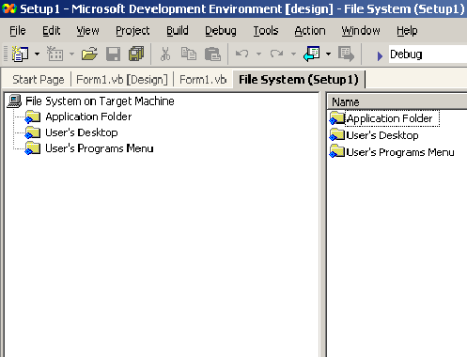

(Sample screenshot from older version)

VB.NET 2005 Tutorials : Shared Assembly
In this tutorial you will learn about Shared Assembly, how to Assign Strong name to an assembly, Microsoft Windows Installer 2.0, Using the Global Assembly Cache tool (Gacutil.exe), Removing an Assembly from the Global Assembly Cache, Referencing an Assembly from Global Assembly Cache, Creating a Setup project for distributing components and Creating a new merge module project.

Shared Assembly
Shared Assembly can be shared amongst several different applications that reside on the same server. This type of assembly can be used in situations where it is not necessary to install a version of an assembly for each application that uses it. For instance, it is not necessary to install the System.Windows.Forms.dll assembly for each application that uses it. It is far better to install a shared version of the assembly.

There are certain requirements that are placed upon shared assemblies. The assembly needs to have a globally unique name, which is not a requirement of application-private assemblies. Strong names are used to create a globally unique name for an assembly. As that assembly is shared, all references to the shared assembly are checked to ensure the correct version is being used by an application. Shared assemblies are stored in the Global Assembly Cache(GAC), which is usually located in the assembly folder in the windows directory( for example in Windows XP, C:\Windows\assembly).

Assigning Strong name to an assembly
Strong name is not a name as such but is, in fact, a public key that has been generated by the author of the assembly in order to uniquely identify the assembly. A strong name is what is used to ensure that your assembly has a unique signature compared to other assemblies that may have the same name. Strong names were introduced to combat the situation where a developer would have created a component and another developer releases a different assembly with the exactly the same name as the original component, and could be mistaken for being new version of the original component. Without strong names users would be confused and unable to identify the problem.
A strong name is based on public-private key encryption and creates a unique identity for the assembly. A key pair can be created and can be used to define a strong name by using the SN tool included in the .NET Framework SDK. The public key is stored in the identity section of the manifest. A signature of the file containing the assembly's manifest is created and stored in the resulting PE file. The .NET Framework uses these two signature when resolving type references to ensure that the correct assembly is loaded at runtime. A strong name is indicated in the manifest by the .publickey directive in the .assembly section.
To create a key pair
1) At the command prompt, type the following command:
sn -k 2) In this command, file name is the name of the output file containing the key pair.
3) The following example creates a key pair called sgKey.snk.
sn -k sgKey.snk
4) If you intend to delay sign an assembly and you control the whole key pair (which is unlikely outside test scenarios), you can use the following commands to generate a key pair and then extract the public key from it into a separate file. First, create the key pair:
sn -k keypair.snk
5) Next, extract the public key from the key pair and copy it to a separate file:
sn -p keypair.snk public.snk

Once the key pair is created, the developer must put the file where the strong name signing tools can find it. When signing an assembly with a strong name, the Assembly Linker (Al.exe) looks for the key file relative to the current directory and to the output directory. When using command-line compilers,the key can be copied to the current directory containing the code modules.

If an IDE, such as Visual Studio .NET is being used, to sign an assembly with a strong name, it is important to understand where the IDE looks for the key file. For example, Visual Basic .NET looks for the key file in the directory containing the Visual Studio Solution, whereas the C# compiler looks for the key file in the directory containing the binary. Put the key file in the appropriate project directory and set the file attribute as follows:

< Assembly: AssemblyKeyFileAttribute("key.snk") >

Assigning Strong Name to an Assembly
There are two ways to sign an assembly with a strong name:

- Using the Assembly Linker (Al.exe) provided by the .NET Framework SDK.
- Using assembly attributes to insert the strong name information in your code. The AssemblyKeyFileAttribute or the AssemblyKeyNameAttribute can be used, depending on where the key file to be used is located.
The developer must have a cryptographic key pair to sign an assembly with a strong name.

To create and sign an assembly with a strong name using the Assembly Linker

- At the command prompt, type the following command:
al /out:/keyfile:In this command, assembly name is the name of the assembly to sign with a strong name, module name is the name of the code module used to create the assembly, and file name is the name of the container or file that contains the key pair.
- The following example signs the assembly MyAssembly.dll with a strong name using the key file sgKey.snk.
al /out:MyAssembly.dll MyModule.netmodule /keyfile:sgKey.snk
To sign an assembly with a strong name using attributes

- In a code module, add the AssemblyKeyFileAttribute or the AssemblyKeyNameAttribute, specifying the name of the file or container that contains the key pair to use when signing the assembly with a strong name.
- The following code example uses the AssemblyKeyFileAttribute with a key file called sgKey.snk.
< Assembly:AssemblyKeyFileAttribute("sgKey.snk") >
- You can also delay sign an assembly when compiling.
- When signing an assembly with a strong name, the Assembly Linker (Al.exe) looks for the key file relative to the current directory and to the output directory. When using command-line compilers,copy the key to the current directory containing the code modules.
Adding an Assembly into the Global Assembly Cache

There are two ways to install an assembly into the global assembly cache:

Microsoft Windows Installer 2.0
This is the recommended and most common way to add assemblies to the global assembly cache. The installer provides reference counting of assemblies in the global assembly cache, plus other benefits.

Using the Global Assembly Cache tool (Gacutil.exe)

You can use Gacutil.exe to add strong-named assemblies to Adding predefined installation components to your project.the global assembly cache and to view the contents of the global assembly cache.

Note Gacutil.exe is only for development purposes and should not be used to install production assemblies into the global assembly cache.

To install a strong-named assembly into the global assembly cache

- At the command prompt, type the following command:
gacutil -I gacutil -i hello.dll
- The .NET Framework SDK also provides a Windows shell extension called the Assembly Cache Viewer (Shfusion.dll), which you can use to drag assemblies into the global assembly cache.
Removing an Assembly from the Global Assembly Cache

- Use the Global Assembly Cache tool (Gacutil.exe) to remove an assembly from the global assembly cache.
- To remove an assembly from the global assembly cache
- At the command prompt, type the following command:
gacutil -u gacutil -u hello
The .NET Framework SDK also provides a Windows shell extension called the Assembly Cache Viewer (Shfusion.dll), which can be used to remove assemblies from the global assembly cache.

RESUME

Name : Kanchan Ajay Gokhle
Address : “Udyogshakti Appt.” Block no-2,
Sutgirni chowk, Garkheda,
Aura ngabad 431001
Mob. No. 9272301495
Date of Birth : 17th September’1979
Martial status : Married
Educational Qualification :
Exam | Board/University | Year of passing | Division
S.S.C. | Pune Educational Board | 1994 | IInd
H.S.C. | Nasik Educational Board | 1996 | Ist
Arts Graduation (Eco) | Jalgaon University | 1999 | Ist

Other Qualification :

Certificate Course in Computer Operation – Course of Aurangabad Vocational Board secured 1st class
Certificate Course in Microsoft Office – Course of Aurangabad Vocational Board secure 1st Class
MS-CIT – Computer Course of Maharashtra State Government – Secured 1st Class
Typing – English 40WPM
Job Experience :
Suyash Metal Pressing Pvt. Ltd. – (July’2004 to June’2005)
As an office assistant, Managing front office of company.
Aurangabad Insurance Academy – (July’2005 to June’ 2006)
As coordinator and A/C assistant. Helping account head to data entry in Tally software. Preparation of various reports in MS-office.
Videocon International, Chitegaon

